CURRICILUM VITAE
Jaydee van Jaarsveld

About me:
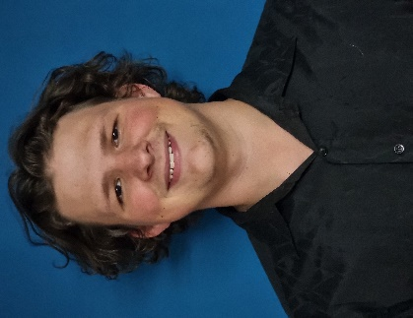
DOB: 4 November 2003
Location: Citrusdal,7340, South Africa
Availability: Immediately
Tel: +27 (0) 76 542 2705
Email : jaydeevj35@gmail.com
Nationality: South African
Visas: - No
Non-Smoker
No Tattoos
Languages: Fluent English and Afrikaans

PROFILE
I am a humble and considerate person that enjoys meeting new people and working in a positive and supportive environment. I am eager to learn new skills and take direction well. I see myself as a honest and loyal worker, I am cautious and not afraid to ask questions. I would love the opportunity to prove myself as a valuable part of the team.
INTERESTS/HOBBIES
I enjoy playing video games
Motorcycles and cars
Listening to music
Swimming
Going to the beach
Enjoy watching films and series
Enjoy exercise

Qualifications
YOA Deckhand
RYA PB2
RYA PWC
RYA VHF
STCW PDSD
STCW10 Basic Training exp.
Seafarer medical exp.
PADI Open Water Diver

EDUCATION
Outeniqua Highschool – Matric certificate

YACHT EXPERIENCE
None

WORK EXPERIENCE
Worked at a sports Bar on weekends

