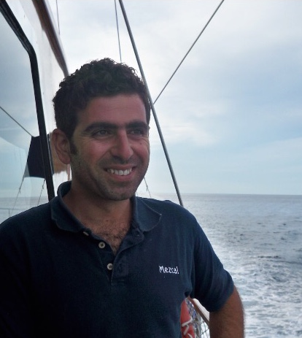




Seeking a permanent position on board a busy charter/private yacht where I can use my deck experience and skills with boat systems, equipment, and procedures, as well as my hospitality knowledge and experience to help deliver a quality guest experience and contribute as a new crew member with likeminded individuals.

S/Y MOM MARY- Temporal Contract-Delivery
CAPTAIN | 15 AUG 2022- 30 OCT 2022 | Catamaran Lagon 46
- From: Les Sables/ France Athen/Greece

M/Y KOŞAR_2 | 20M CLASSIC
CAPTAIN | JUL 2021-JUL 2022 | Mediterranean /Egean
- Crew menangement
- Maintained scheduled maintenance programs for water makers, macerator system, plumbing, air handlers, strainers, generators, main engines, fuel bunkering and oil transfers
- Duties included: managing the budget and experiences, managing contractors and vendors, maintain both the interior and exterior condition of the yacht
- Managed, maintained, and drove Regulator Tender, as well as set up for tow during trips
- Owners trip were to the mediterranean with 5 – 7guests
- Instructed and assisted guests with watersports equipment and activities

M/Y A-B | 22 M FEAIRLINE
CAPTAIN | May 2018- Dec2020| Mediterranean /Egean
- Crew menangement
- Maintained scheduled maintenance programs for water makers, macerator system, plumbing, air handlers, strainers, generators, main engines, fuel bunkering and oil transfers
- Duties included: managing the budget and experiences, managing contractors and vendors, maintain both the interior and exterior condition of the yacht
- Managed, maintained, and drove Regulator Tender, as well as set up for tow during trips
- Owners trip were to the the mediterranean with 4 – 6 guests
- Instructed and assisted guests with watersports equipment and activities

S/Y MEZCAL | 30M |S/Y MEZCAL 2 | 38M
CAPTAIN| Feb 2010-May 2017| California Gulf/BCS Mexico/Sea of Cortez
- Crew menangement
- Maintained scheduled maintenance programs for water makers, macerator system, plumbing, air handlers, strainers, generators, main engines, fuel bunkering and oil transfers
- Duties included: managing the budget and experiences, managing contractors and vendors, maintain both the interior and exterior condition of the yacht
- Managed, maintained, and drove 32’ Regulator Tender, as well as set up for tow during trips
- Owners trip were to California with 7 – 8 guests
CAPTAİN/MATE/BOSUN
OSMAN ARPACI
+905309529707
arpc21@yahoo.co.uk

STCW /ENG 1
OBSERVATION AND PLOTTING TRAINING CERTIFICATE
THE OPERATIONAL USE OF AUTOMATIC RADAR PLOTTING AIDS(ARPA) TRAINING CERTIFICATE
MEDICAL FIRST AID TRAINING CERTIFICATE
NAVIGATIONAL WATCHKEEPING CERTIFICATE

BARTENDING CERTIFICATION POWER BOAT II
CHART NAVIGATION
BARTENDING CERTIFICATION
DOB; JUN 26 1979 TURKEY Passport
Visa: B1/B2
No Tattoos
Single
Excellent Health

Sailing
Great eye for details
Watchstand
VHF Radio Operations
Tender Operator
Tender Towing
Lines and Fenders
Stainless
Sanding/painting/varnishing
Teak Repair
Anchoring
Self motiveted
Fishing
Jet Ski Flushing
Cmas Dıvıng Lısance

BENNY VERSANA (Sea- Alliance Yacht Manager)
Mail:sym@sea-alliance.com
Phone:+972542124610
Owner:Samy Naufi
Mail: sami@naufi.co.il
Phone:+972537391424

KOŞAR_2 İCON COMPANY:KERİM KOŞAR
PHONE:+905323051426
Mail:kerimkosar@hotmail.com

A-B (Furkan Toys LTD): Ali YÜKSEL
PHONE:+905322135945

EL MEZCAL LTD&BESAME MUCHO
NAME:MERT RİSVANOGLU
PHONE:+34645446368
Mail:mertbarcelonabcn@gmail.com

BELLATRIXS (Offer Brothers group company)
NAME: Capt. Mehmet UNCU
PHONE:+905324670971
MAİL: captainuncu@hotmail.com

ARTEMİS 5(Belsed Özgün yachting)
NAME:Capt. Orhan KURT
PHONE:+9053663688609

BELLATRIXS
BELLATRIXS

S/Y BESAME MUCHO | 30M
MATE | Dec 2004-May 2010 |Mediterranean/Adriatic
- Maintained scheduled maintenance programs for water makers, macerator system, plumbing, air handlers, strainers, generators, main engines, fuel bunkering and oil transfers
- Duties included: managing the budget and experiences, managing contractors and vendors, maintain both the interior and exterior condition of the yacht
- Managed, maintained, and drov’ Regulator Tender, as well as set up for tow during trips
- Owners trip were to the Mediterranean with 4 – 6 guests
- Instructed and assisted guests with watersports equipment and activities

S/Y BELLATRIXS | 25M
DECKHAND | APRIL 2001-May 2004 | Mediterranean/Egean
- Sole crew member when owners were not onboard
- Maintained scheduled maintenance programs for water makers, macerator system, plumbing, air handlers, strainers, generators, main engines, fuel bunkering and oil transfers
- Owners trip were to the egean with 4-6
- Instructed and assisted guests with watersports equipment and activities

S/Y ARTEMİS 5 | 25M
DECKHAND | march 1997- sept 1999 | Mediterranean
- Sole crew member when owners were not onboard
- Maintained scheduled maintenance programs for water makers, macerator system, plumbing, air handlers, strainers, generators, main engines, fuel bunkering and oil transfers
- Owner’s trip was to the Mediterranean with 6-8 guests

REFERENCES

