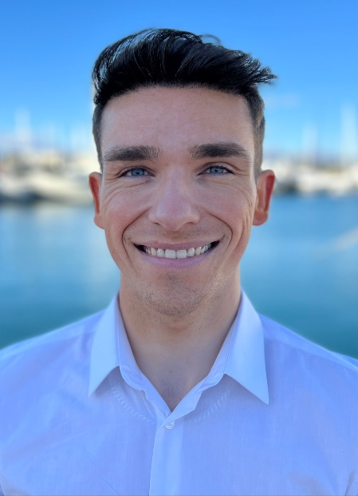
Christian Bogle – Steward/Deckhand

Mobile | +33 (0)7878 195047
Email Address | Christian.bogle1997@gmail.com
DOB | 30/09/1997
Language | Full English
Passport | British
Driving License | British
Vaccinations | Double Vaccinated
Smoker | No
Tattoos | No

Profile/Objective
I have worked for 5 years within a 4-star restaurant. I have natural talent with customer service.
Working in a high-end establishment, I have found to be adaptable to different on-going situation.
Working in a busy restaurant environment has taught me to work under pressure.
I pride myself on attention to detail. My personality, sense of humor and confidence puts me at ease with guests and crew.
Very well experienced with face-to-face customer service.
Barista trained, I am well experienced in bar tending, coffee making, wine pouring and cocktail making.
I am very professional and pay great attention to detail. I’m highly motivated and always go above and beyond my duties to complete any task. I am presentable, well-mannered and punctual.
I have the ability to take this high level of service into the Role of a deckhand.

Maritime Qualifications
. Basic STCW
. Power Boat Level 2
. ENG 1
. Food Hygiene Level 2
. PDSD

Land Based Experience
5 years - Silks Bistro & Champagne Bar – Waiter/Supervisor
This was my first job within hospitality, I had to learn everything from scratch. I quickly discovered that I had a natural talent with talking and communicating with the customers, and was able to provide an excellent service. I am a very quick learner and managed to pick everything up quite quickly.
I then received a promotion to supervisor which was very rewarding as I felt that my efforts and ability to do the job was paying off. As my new role as supervisor, I was very excited and determined to challenge myself and take on new jobs and responsibilities.
Whilst I was working here, a very well known tv show named DOC Martin were filming at the hotel. After serving them one evening after filming I was then told that I did a fantastic job and was picked to play as a waiter in the show, as the said I look the part and do a fantastic job.
I learned many skills here at the silks bistro & champagne bar, ranging from cutlery placement, to coffee making, to knowledge of different wines and foods, to running a service. Therefore, I feel that I have all that it takes to become a successful crew member onboard the yachts.
1.5 years - Newquay golf Club – Apprentice Greenkeeper
I was an apprentice greenkeeper so I had to learn how to cut all tees, greens, fairways and roughs correctly. I also learned how to rake and refill bunkers with new sand correctly. We would start at 6am every morning and had to be out in all weather conditions to complete each job.
1 year - Berties nightclub
Here my job role was to glass collect and to tidy up after the guests had left. I had the pleasure of meeting lots of nice people and it gave me a real inside of what it was like working with customers. I worked here during year 11 and stuck with it all through sixth form until I received my full-time job as an apprentice greenkeeper

References
Silks bistro & Champagne bar
Contact
- Nina Wilde +44 7548 8220
Email - silks@atlantichotelnewquay.co.uk

