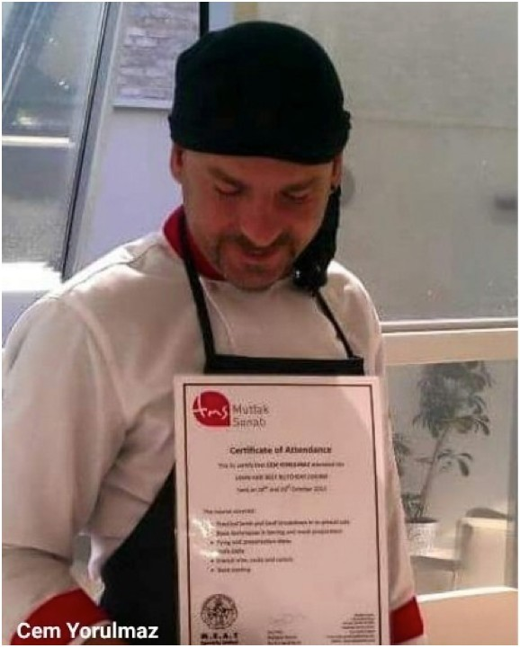

Https://youtu.be/pVq2THfSr7U
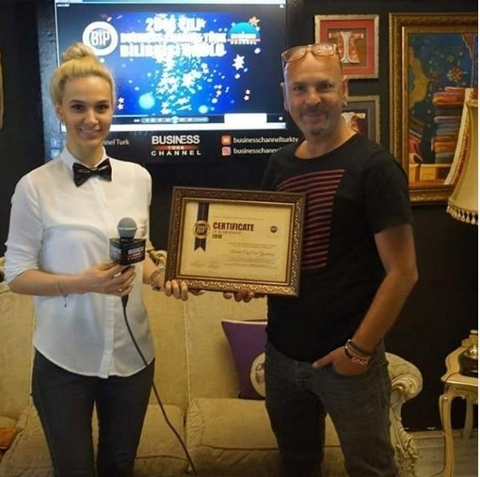

PERSONAL INFORMATION

Cem Yorulmaz ‘ Master Chef ‘
Adress: Bulmker strasse 133 45888 Gelsenkirchen
 + 49 163 8610906
+ 90 532 069 50 62
+ masterchefcem76@yahoo.com.tr
CEM YORULMAZ
 chef.cem
Marital Status: Divorced

WORK EXPERIENCE

Oct 2002 – Feb 2004: Kitchen Chef

Queen Marina Restaurant, Istanbul (Turkey)

Mar 2004–Nov 2005 Sous Chef

Taksim Plaza Hotel, Istanbul (Turkey)

May 2006–Oct 2007 Kitchen Chef

Club Nispet Etiler, Istanbul (Turkey)

Feb 2007–Apr 2009 Grill Chef

Virginia Steak House, Istanbul (Turkey)

Jun 2010–Dec 2012 Grill Chef

Ramiz Kofte Restaurant, Izmir (Turkey)

Feb 2013–Apr 2014 Sous Chef

The Wellesley, Motoryacht (Turkey)

May 2015- Oct 2015 Executive Chef
For Fun Yacht, Marmaris (Turkey)
Apr 2016–Nov 2016: Executive Chef
Zanziba Gullet, Napoli (Italy)

July 2017– October 2017: Executive Chef
Hazar Charter Boat (Greek)
Juni 2018– September 2018: Executive Chef
Shabby M/Y (France)
Juni 2019– October 2019 : Consept Management Manager
Agora Fish Restaurant

December 2019- Marz 2020: Consept Manager

Borsa 1860 Ottoman Couisin

EDUCATION AND TRAININGS

June 1993: Certificate of Vocational School for Tourism and Hotel Management
MEBApproved

September 1996 : Kazakhstan Farabi University Tourism and Hotel Management

September 1999 : Wine and Cigar Course, Kutman Vines

August 2007 : Wine and Cigar Course, Gestin Vine

June 20111 : Academy of CulinaryArt Professional cookeryAntalya

PERSONAL SKILLS
Mother Tongue : English
Languages Spoken: English, Deutsch
Communication Skills: Excellent
Communication skills gained through my working experience as a chef on boat and at restaurants. well communication skills with children and young guests
Ability: Using Sea Boat
Driving Licence : B
Computer Knowledge : Ms Office
Job-Related Skills: Meditteranean, Turkish cuisine , Sushi , Bakery and Pasty ,
Healty Food, Fine Dining, Fast Food – Pizza Fruit Carving

Qualifications and Certificates:
Seamans book STCW 95
Hygiene
Health Certificate

BURGER STEAK

-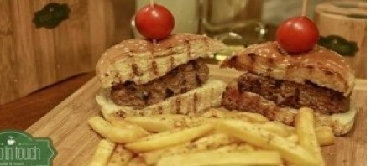
Ingredients
- 180 Gr veal
- Caramielized Onion
- Handmade Burger Breads
- Spicy Potato (Thyme, Salt ,Black Pepper and Red Pepper)
- Cherry Tomato

Grilleds Lamb´s liver
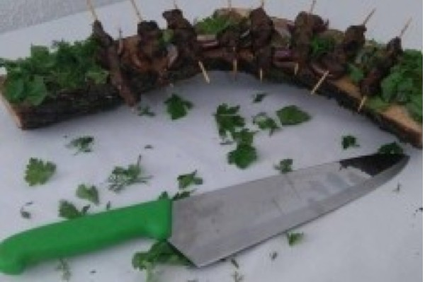
- 500 gr Lamb liver Red Onion
- Parsley
- Lamb Liver Souce ( Tablespoon Mustard, Half Lemon , Olive öl , Salt, Black Pepper , Mayonnaise, a clove of Garlic, Three tablesppon red vine )

Sultan`s delight
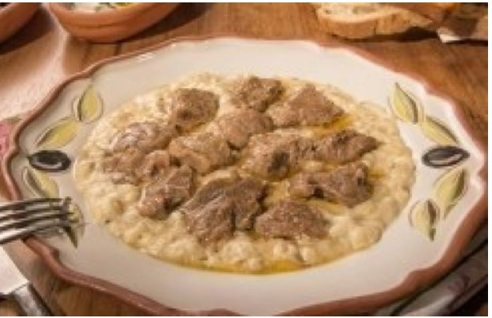

Ingredients
- 500 Gr Cubes
- Six Pieces egg Plant crushing
- 300 Gr Butter
- Salt, Black Pepper
- Grated Cheese

Special taglioni

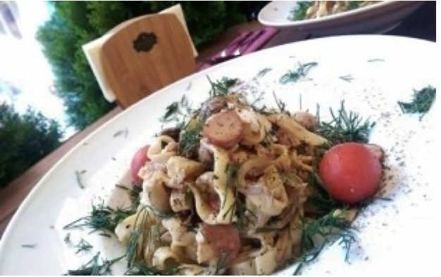

Ingredients

- 350 Gr Taglioni
- Two Tablespoon Salsa al curry
- 100 Gr Sauce, a pinch of dill , Cherry Tomato
- 25 Gr Butter
- Three Tablespoon olive öl , Salt, Black Pepper, Cumin

Crep Bowl
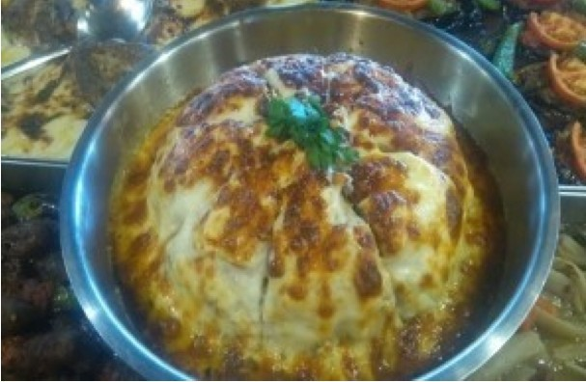

Ingredients

- 500 gr Mince
- Two pieces of Onion a Pinch of Parsley
- 2 Cups Of flour, Three Eggs
- 2 Cups of Milk
- Salt, Black Pepper, Red Pepper
- 350 Gr Chedar Cheese

Sauted Mussel

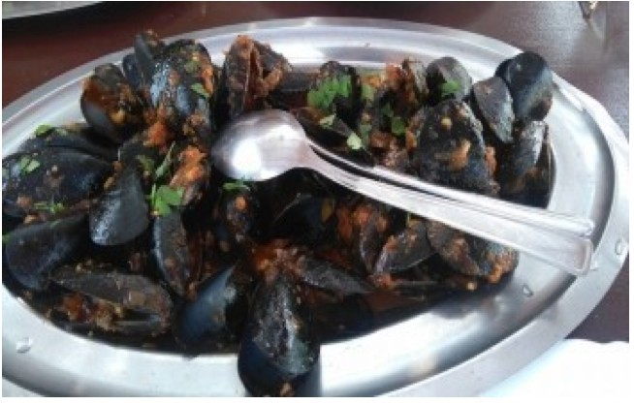
Ingredients

- 30 Pieces Of Mussel A Pinch of Parsley three cloves of garlic
- 40 Cl red Vine Tomato sauce
- 100 Gr Currant
- Salt, Black Pepper, Red Pepper 20 Cl curry sauce Lemon Juice

Sour bread tenderion

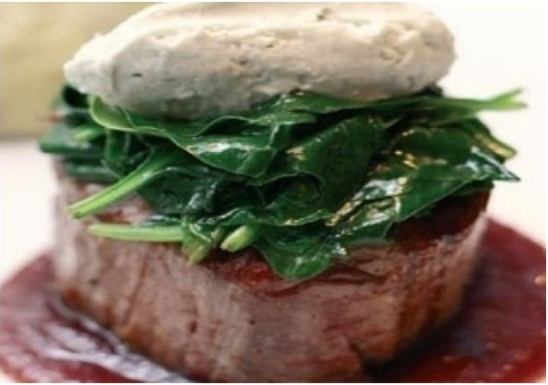
Ingredients

- 200 gr tenderloin
- 50 gr boiled spinach
- 100 Gr Currant
- Sour bread ( half lemon, five table spoon olive oil, thre cloves garlic, a tablespoon vinegar, 150 Gr crumb )
- Tenderloin sauce ( tomato sauce, chilli sauce, black pepper, red pepper, salt )

Oyster stuffing
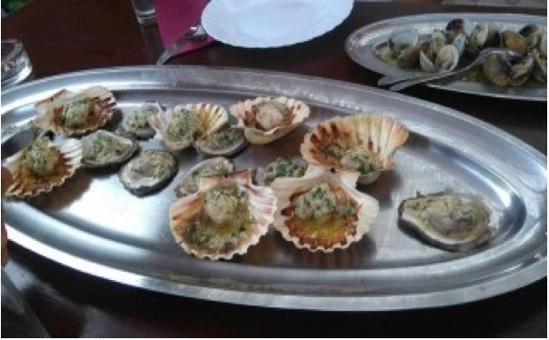

Ingredients

- 6-7 boiled pieces of oyster an onion roe
- 20 cl white vine thinly sliced dill salt

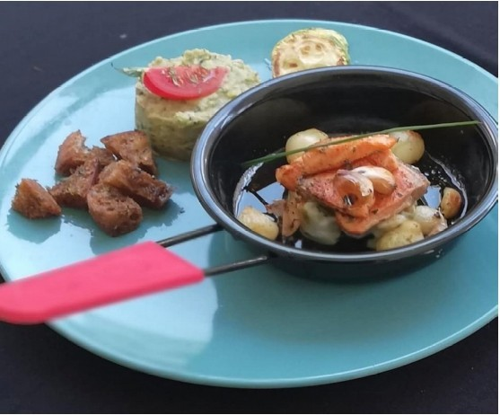
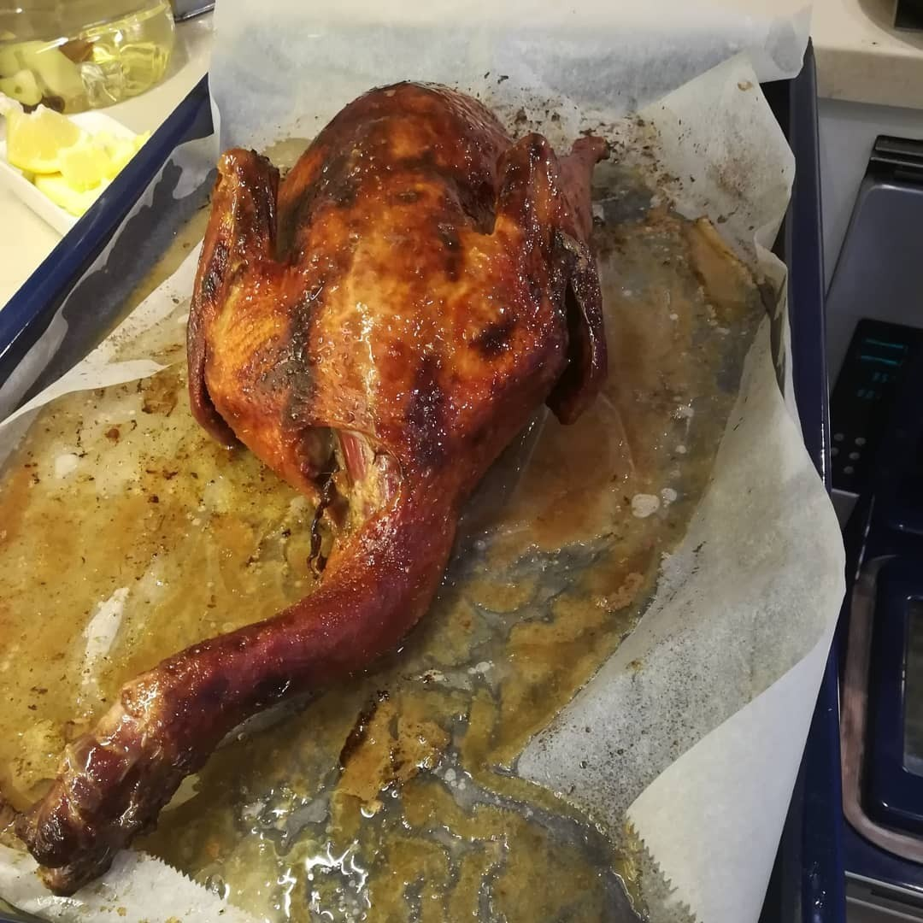

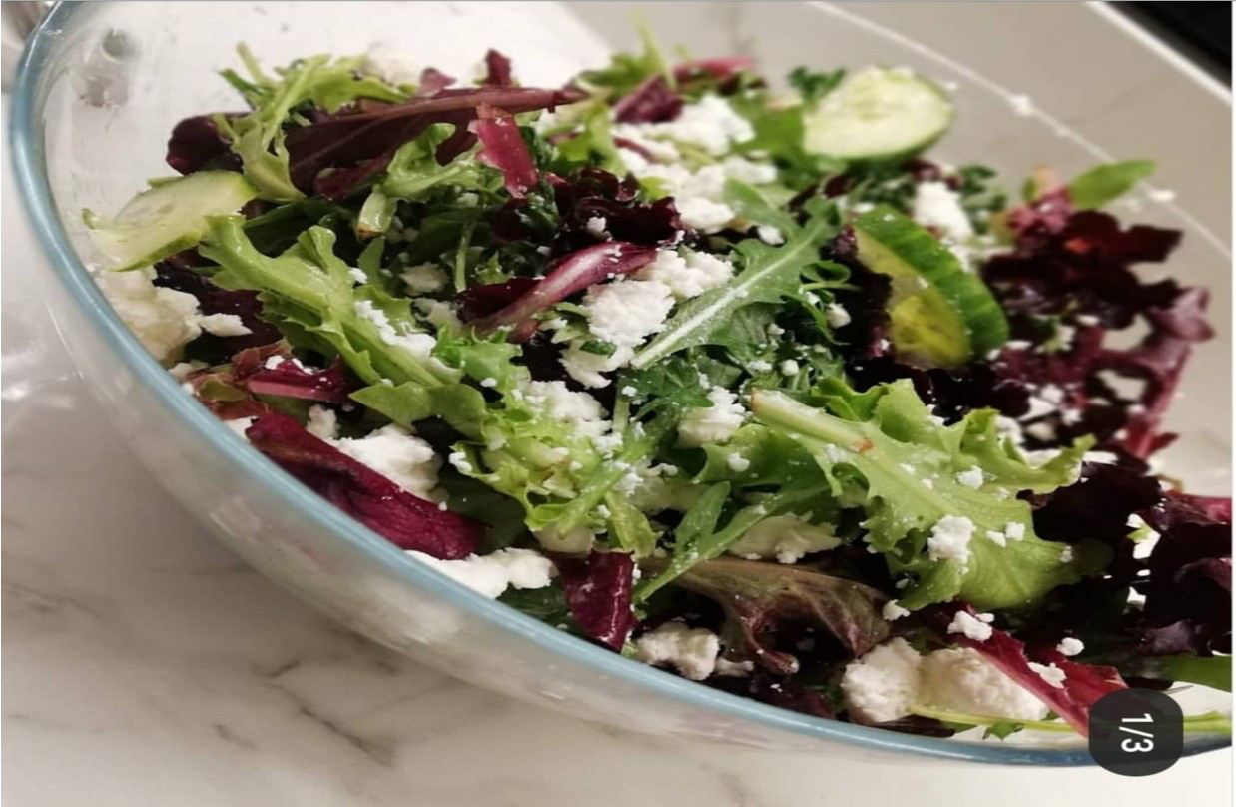

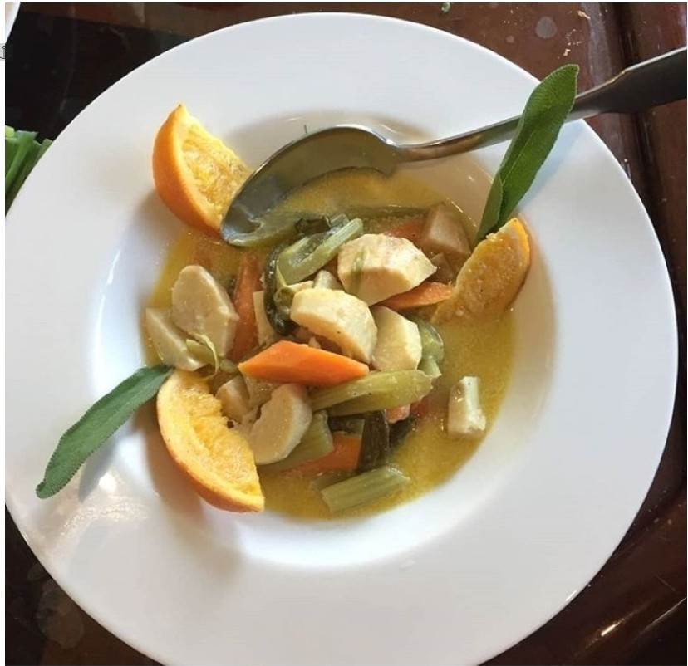
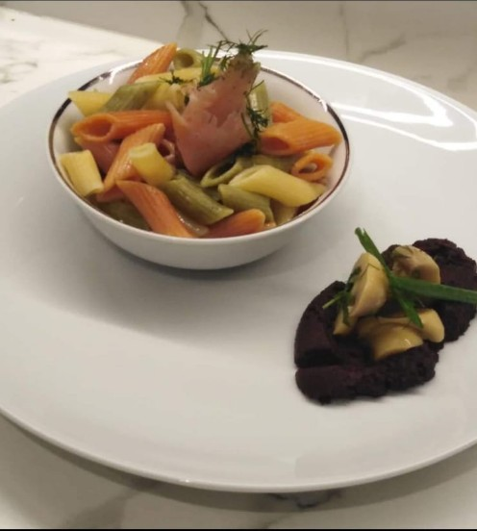

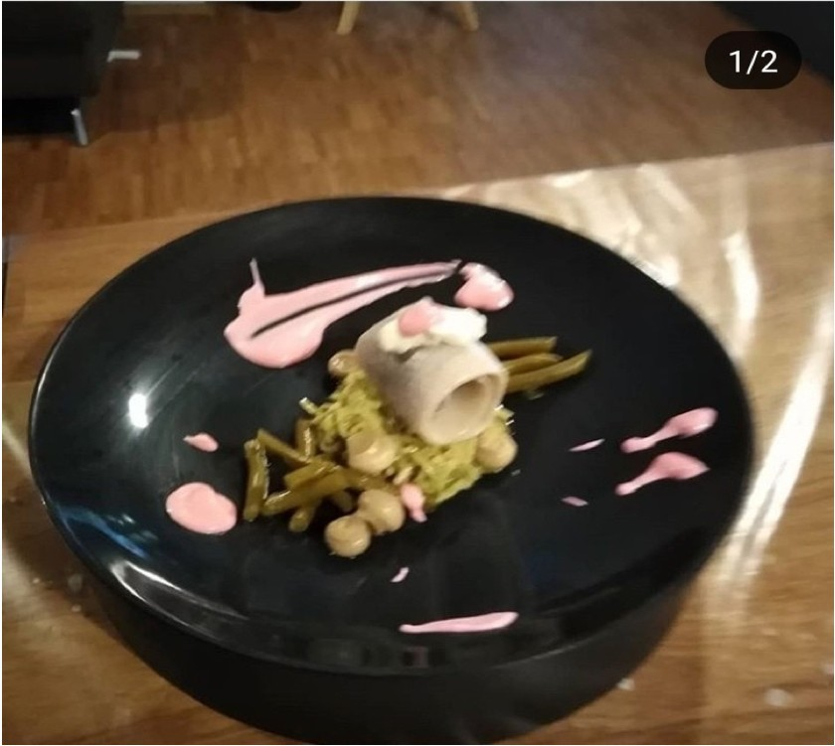
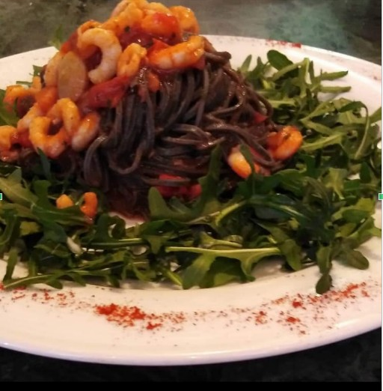

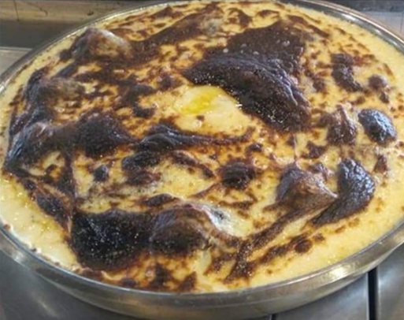

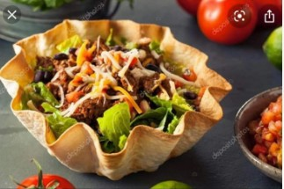

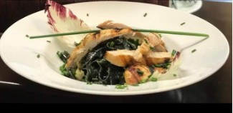

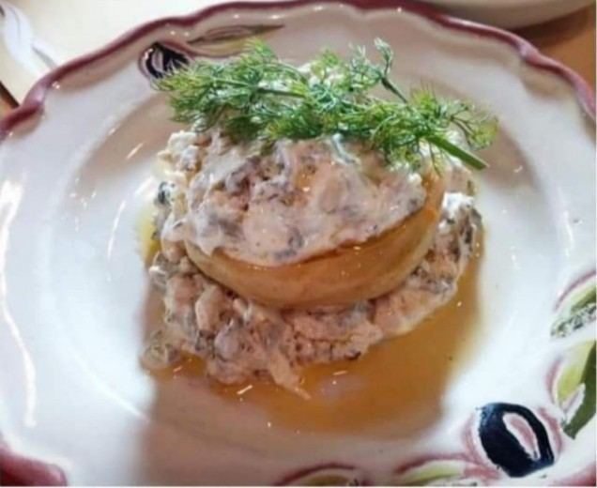

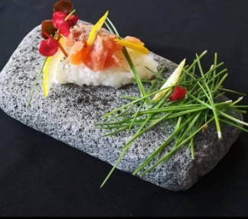

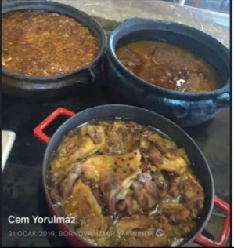

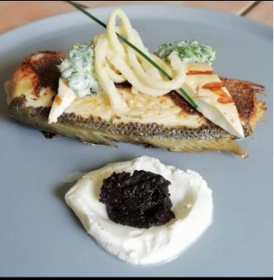

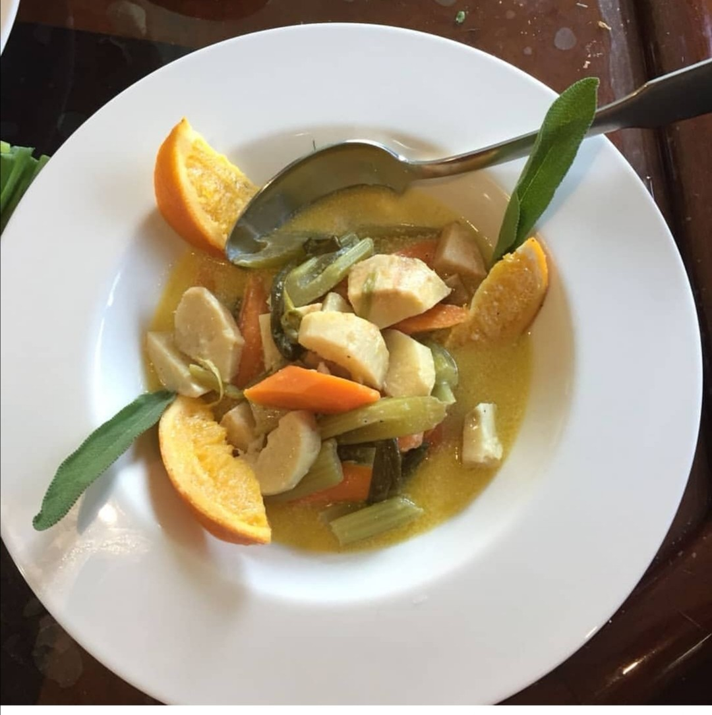

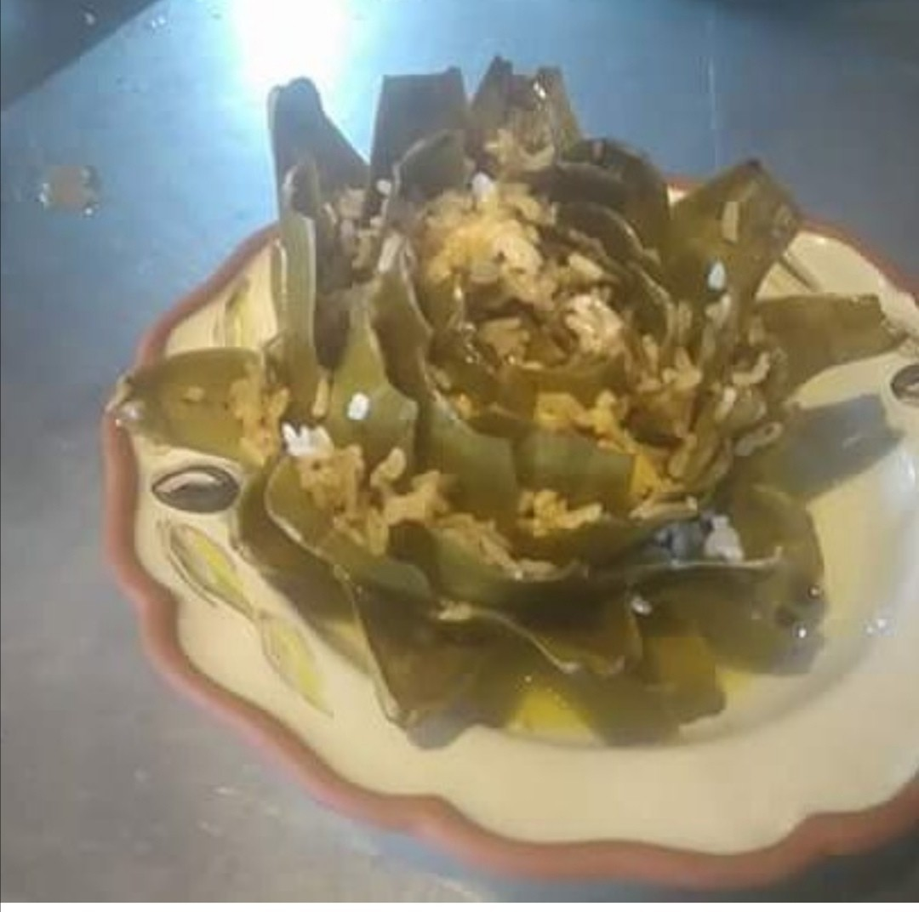

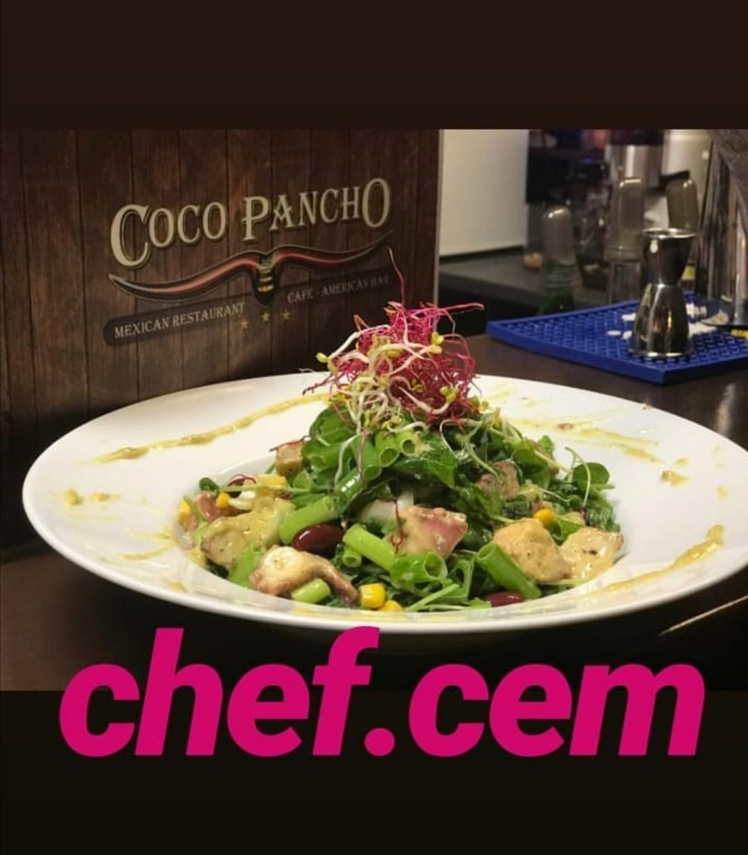

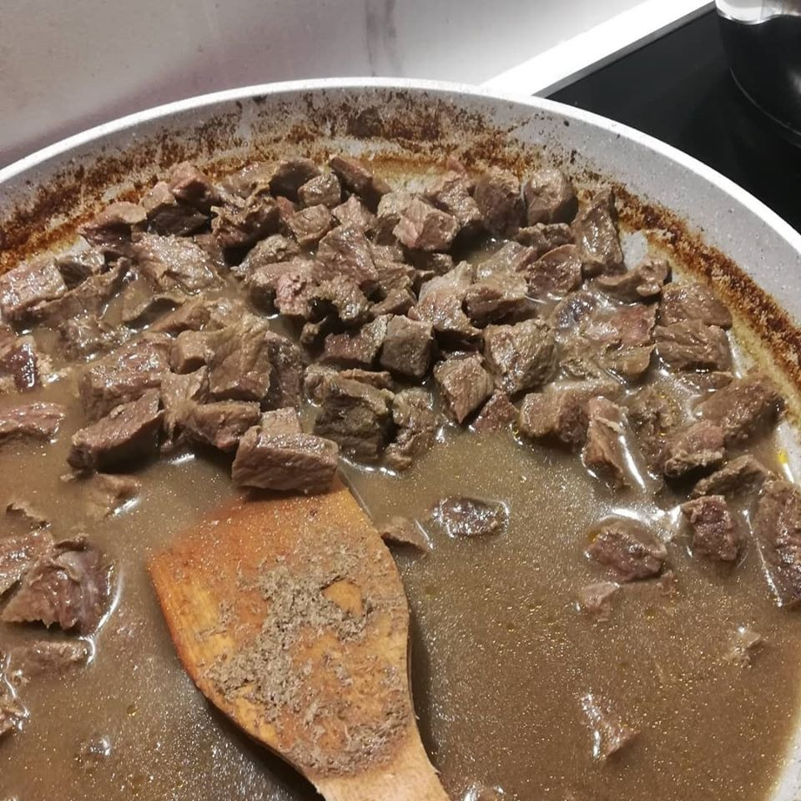

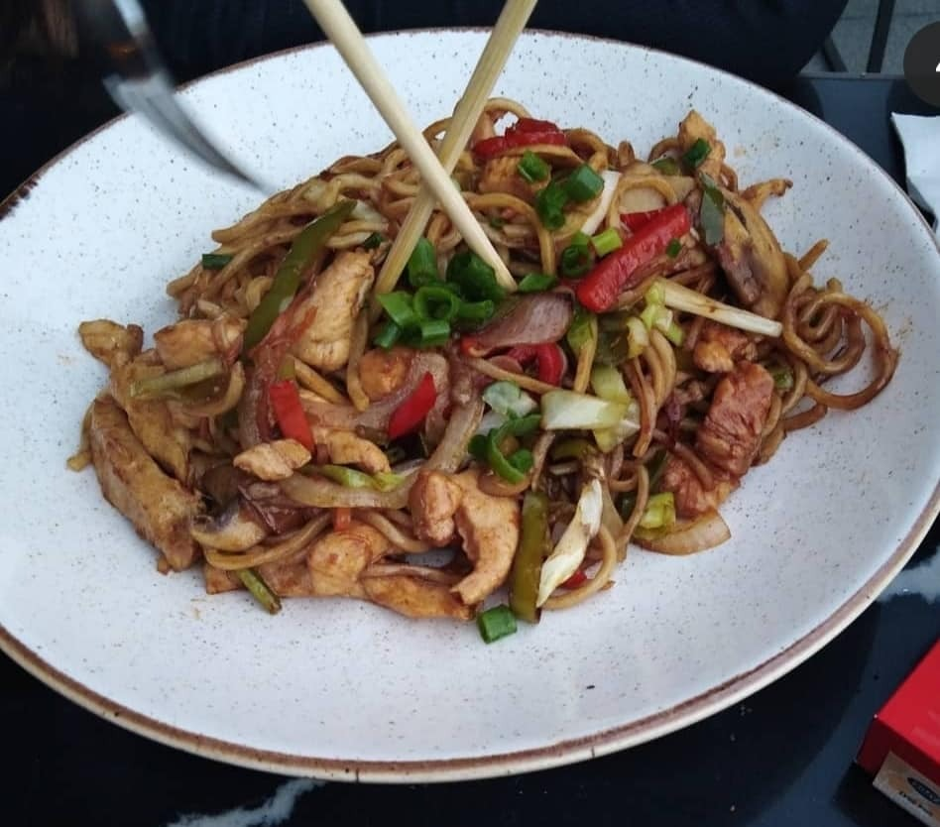

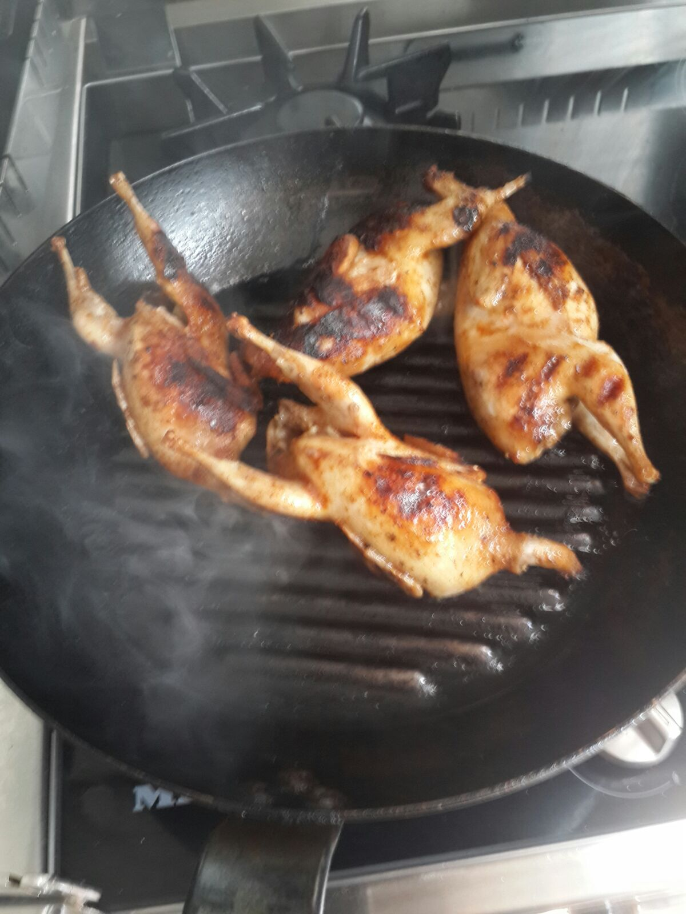

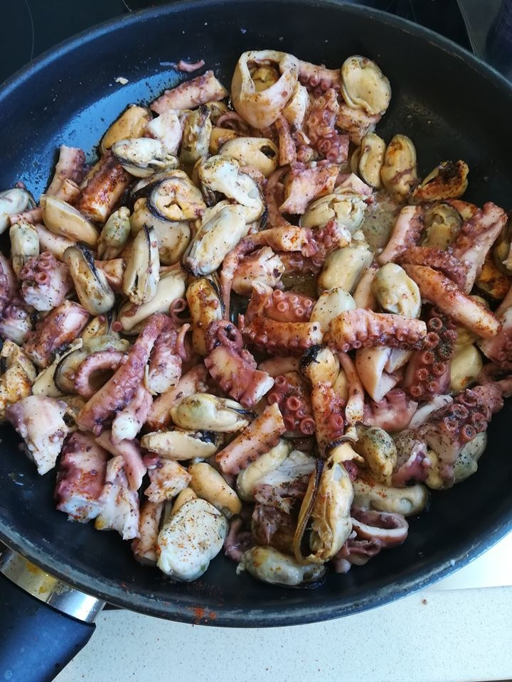

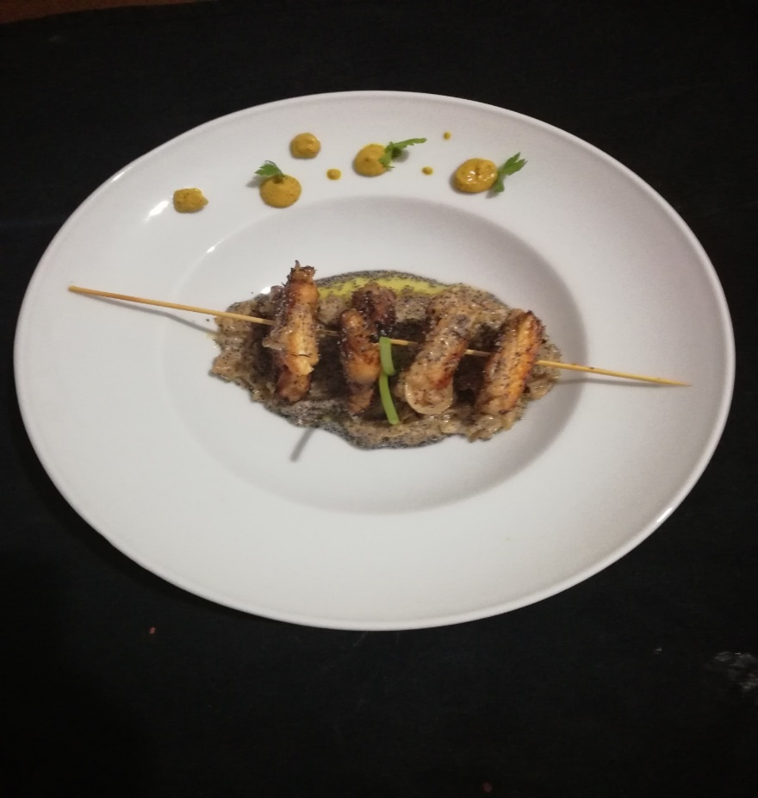

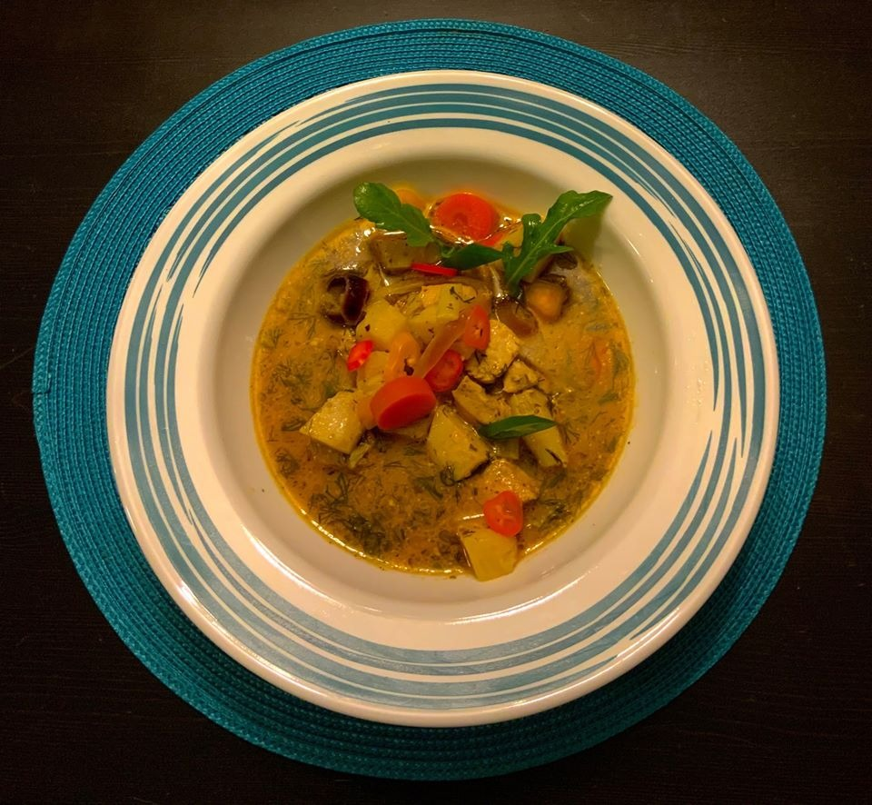

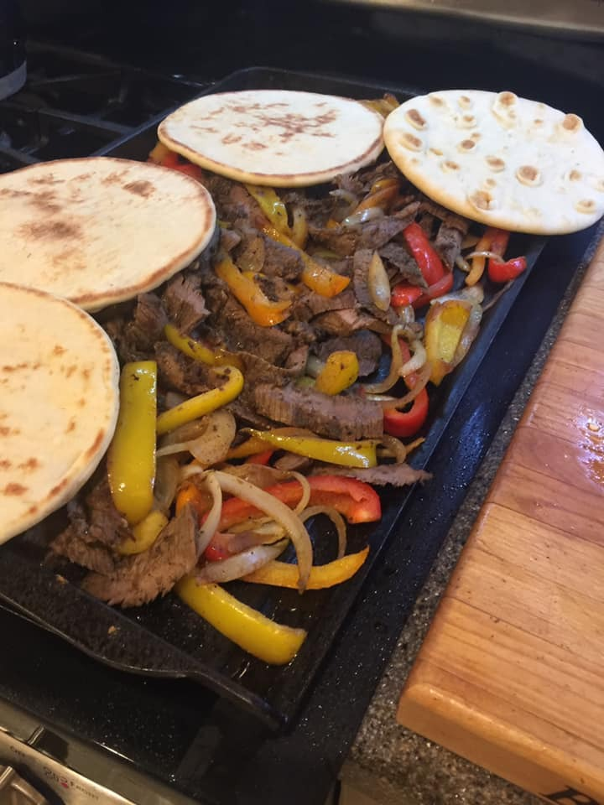
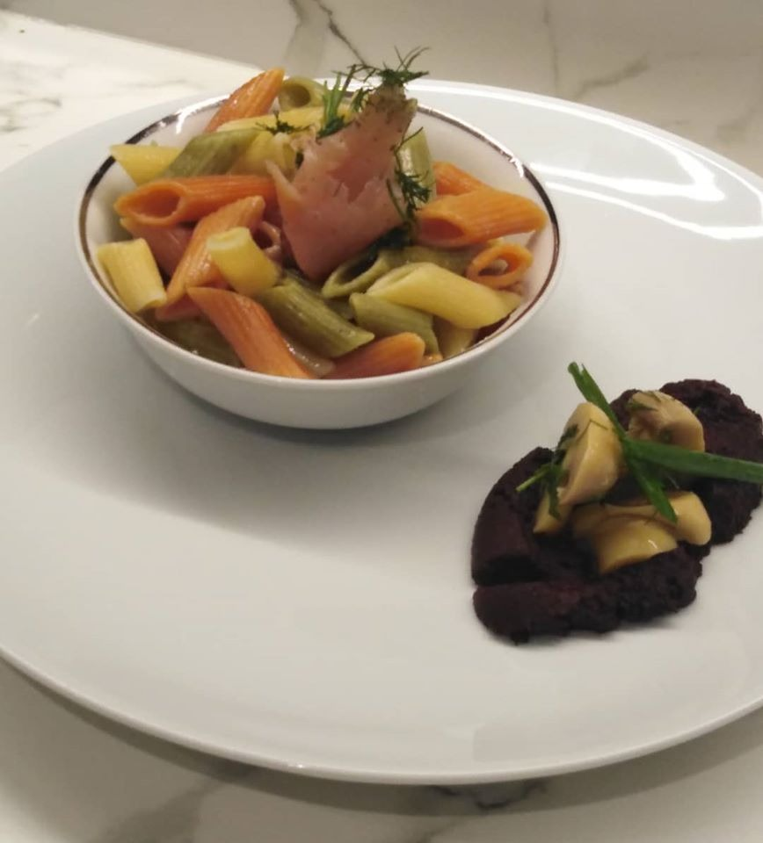

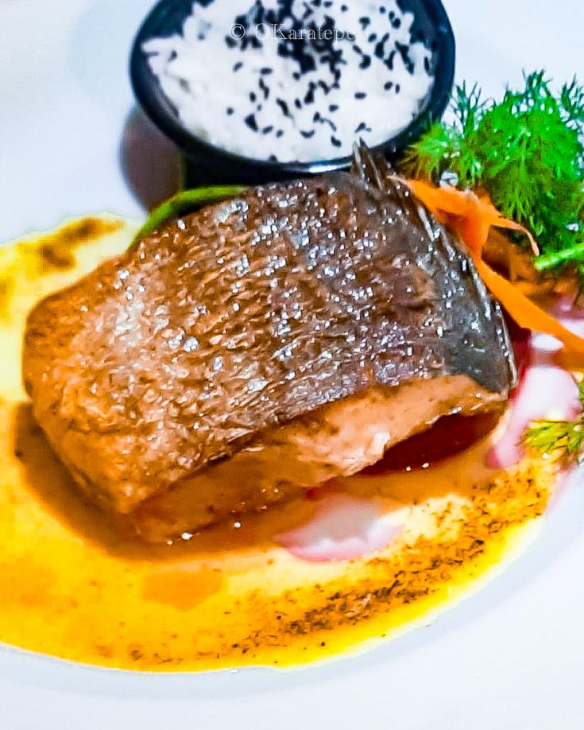

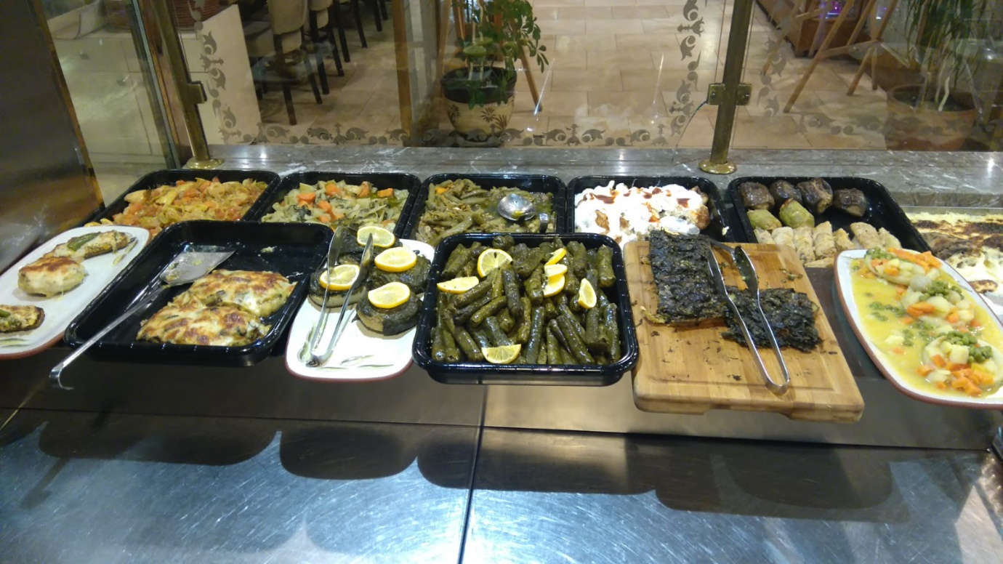

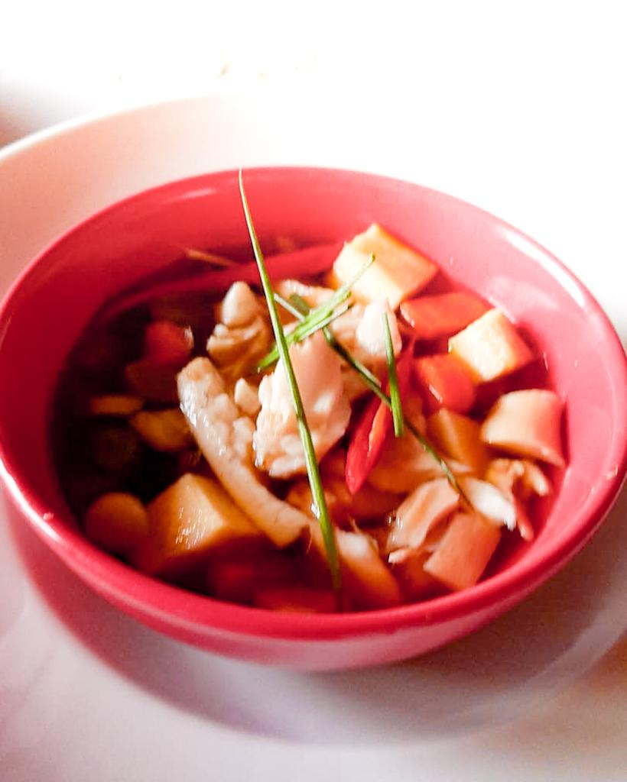

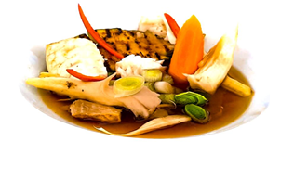

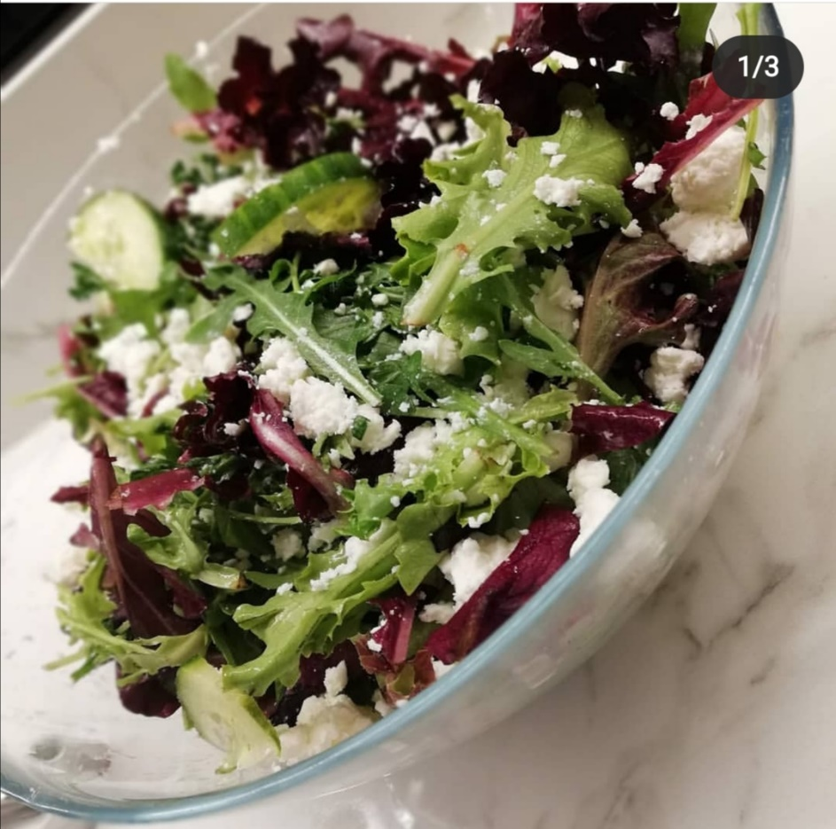

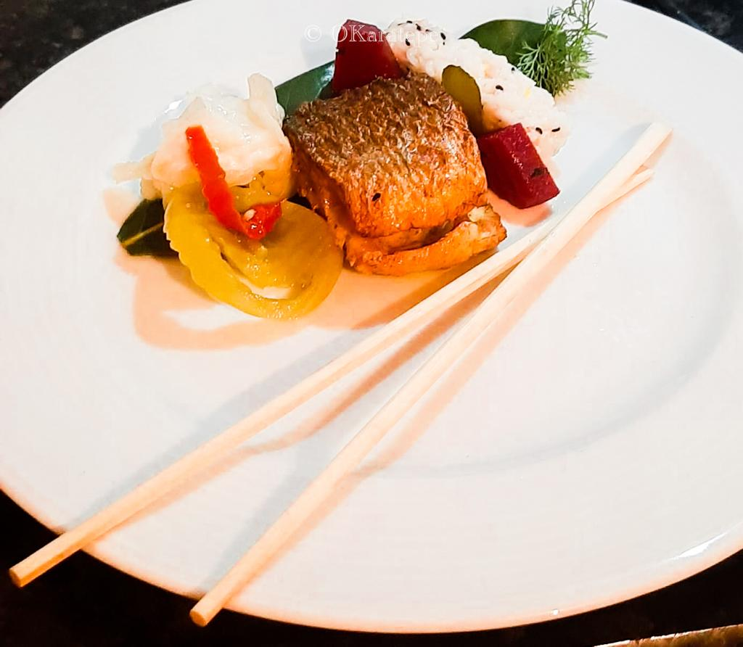

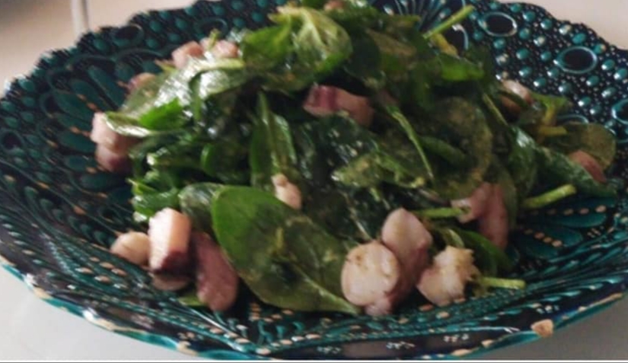

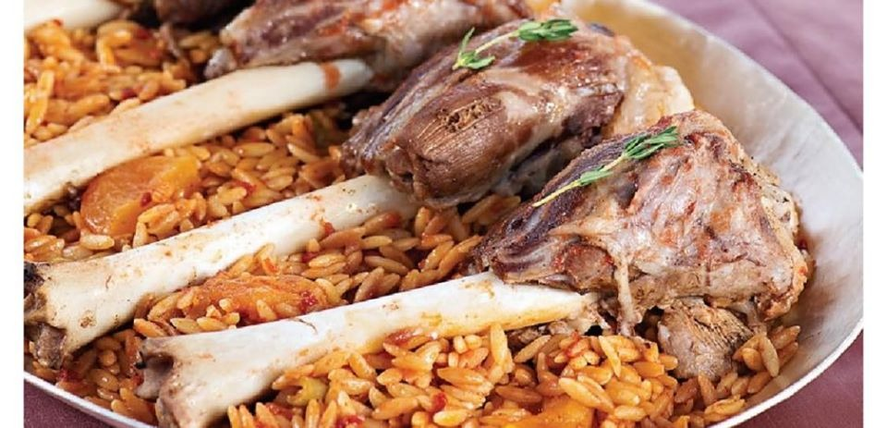

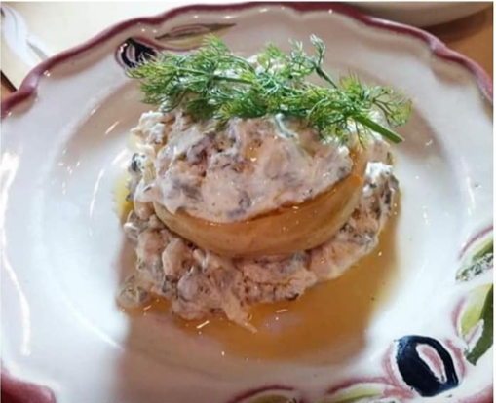

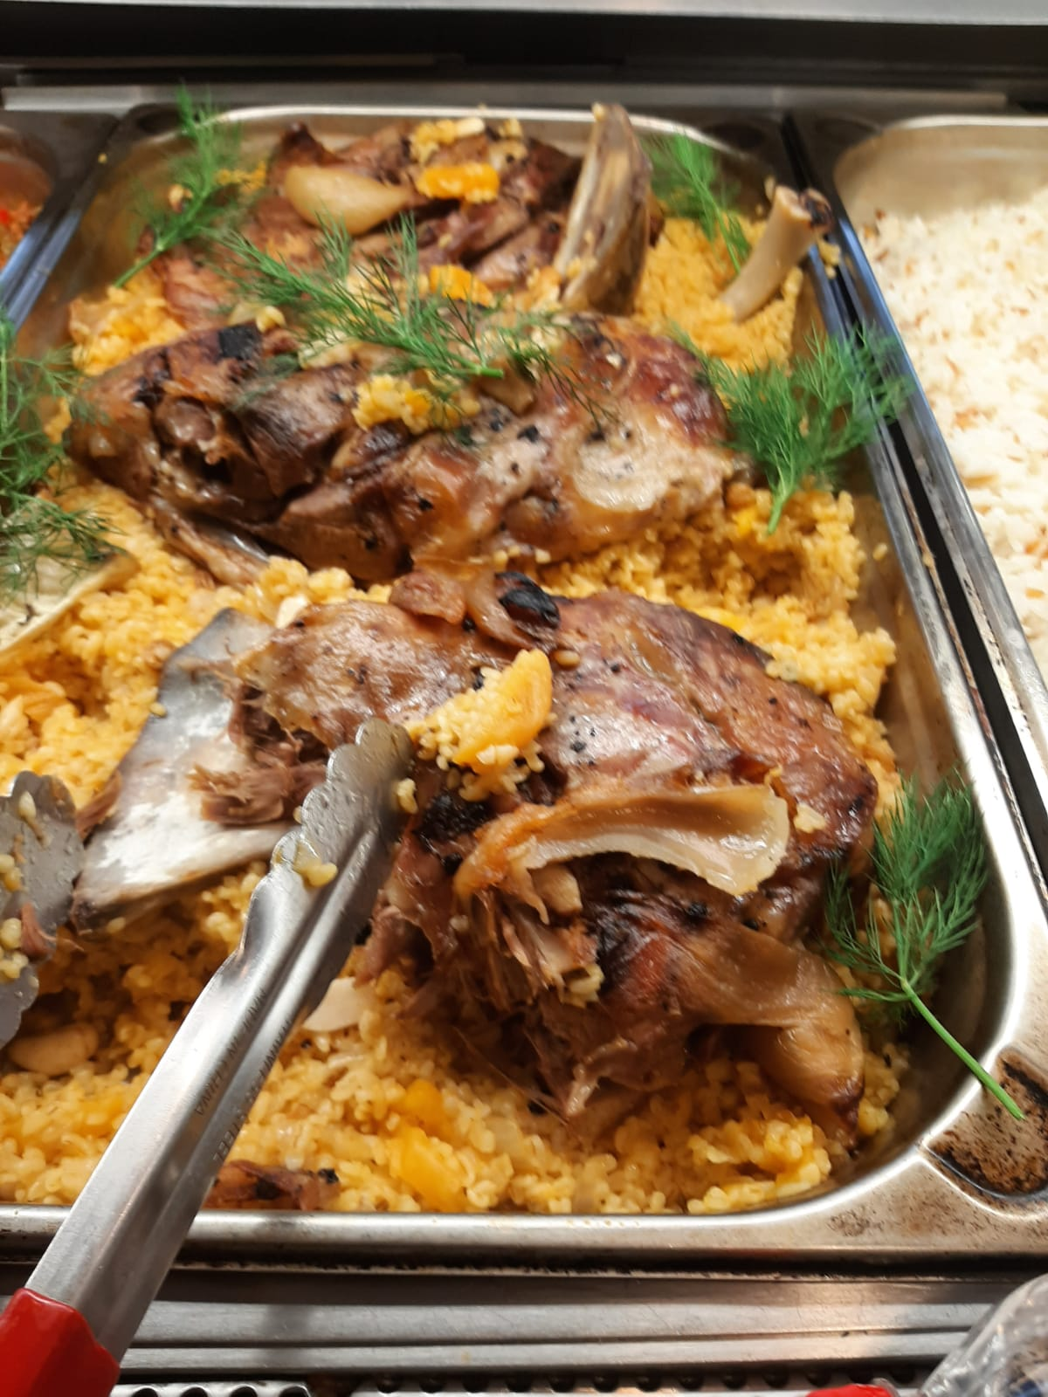

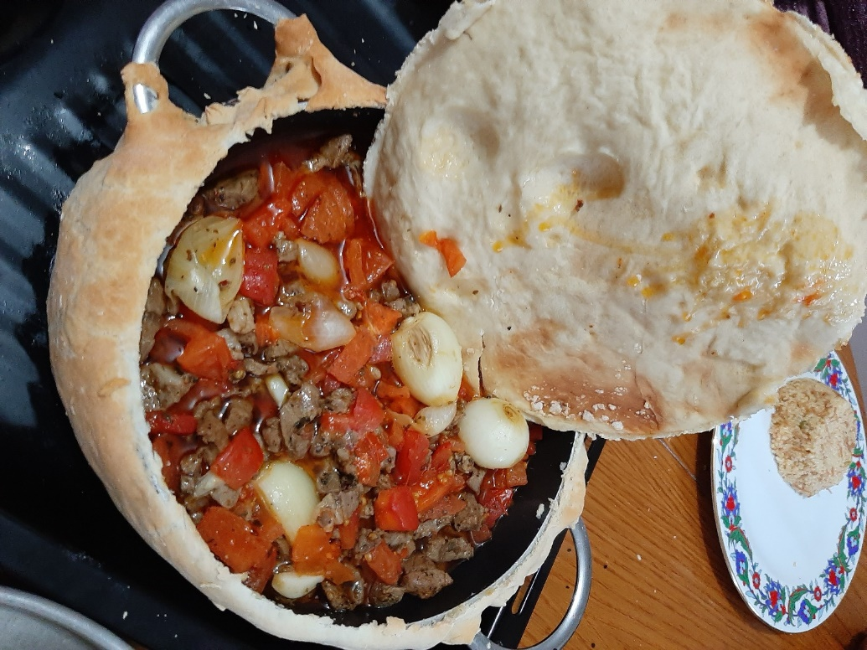

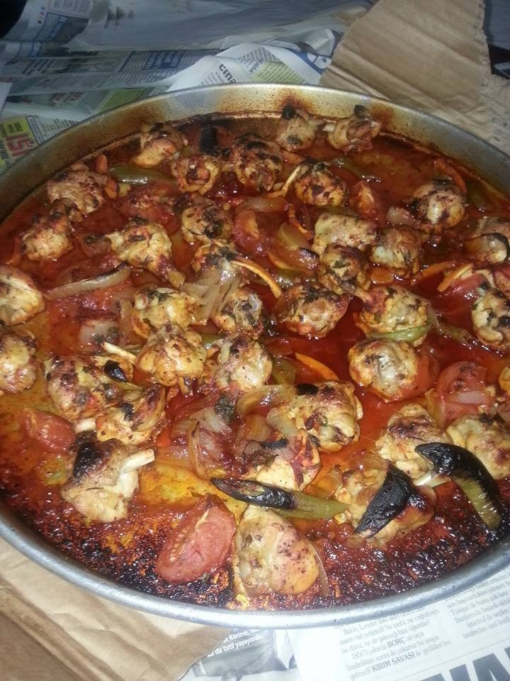
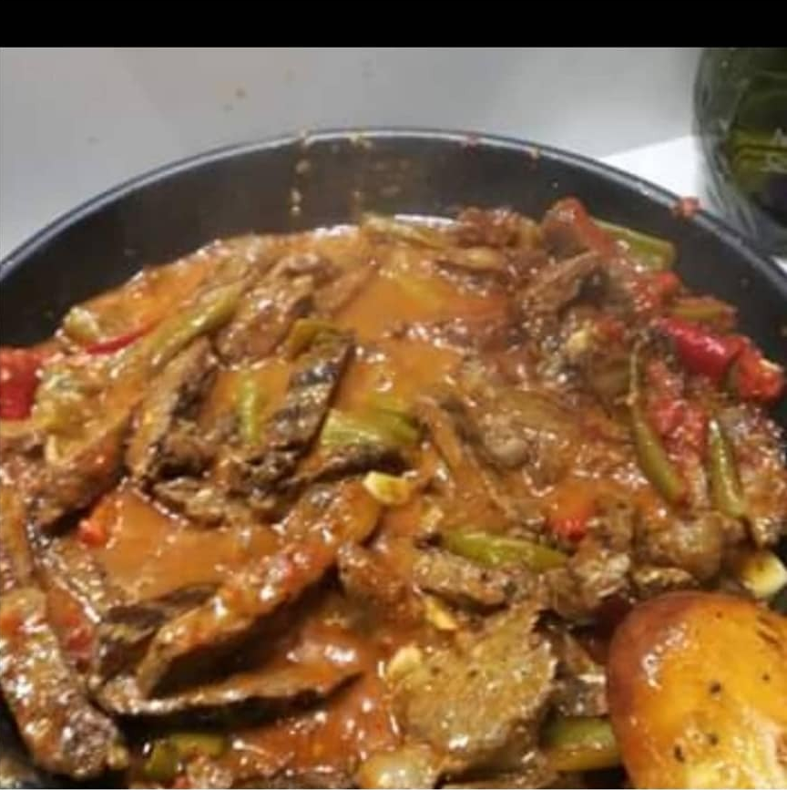

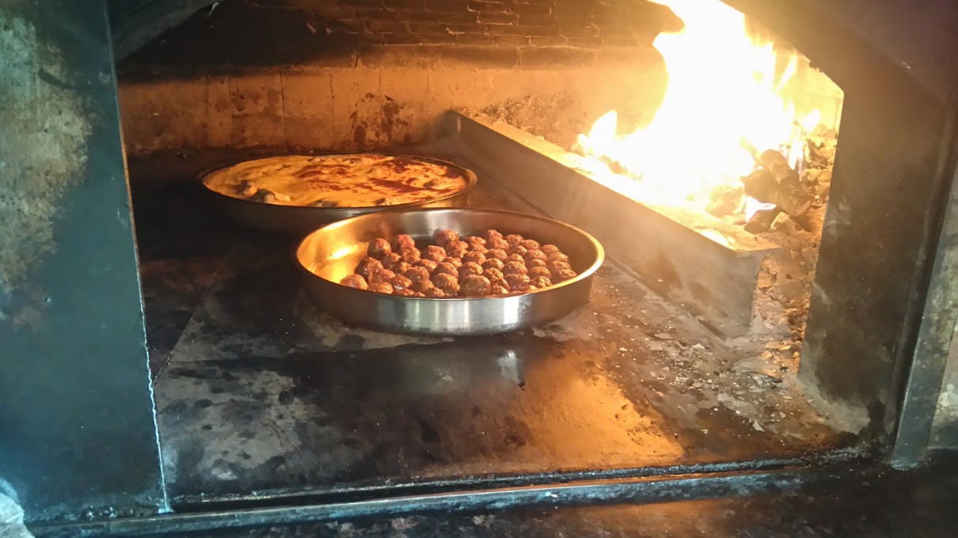

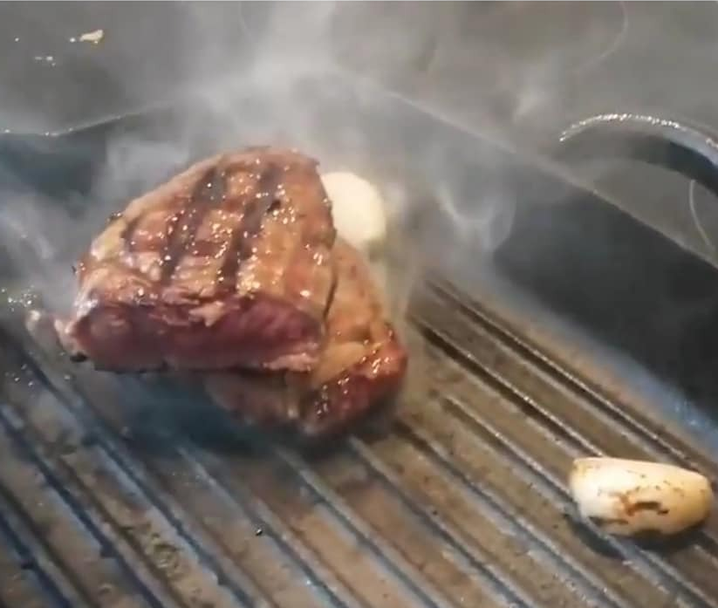
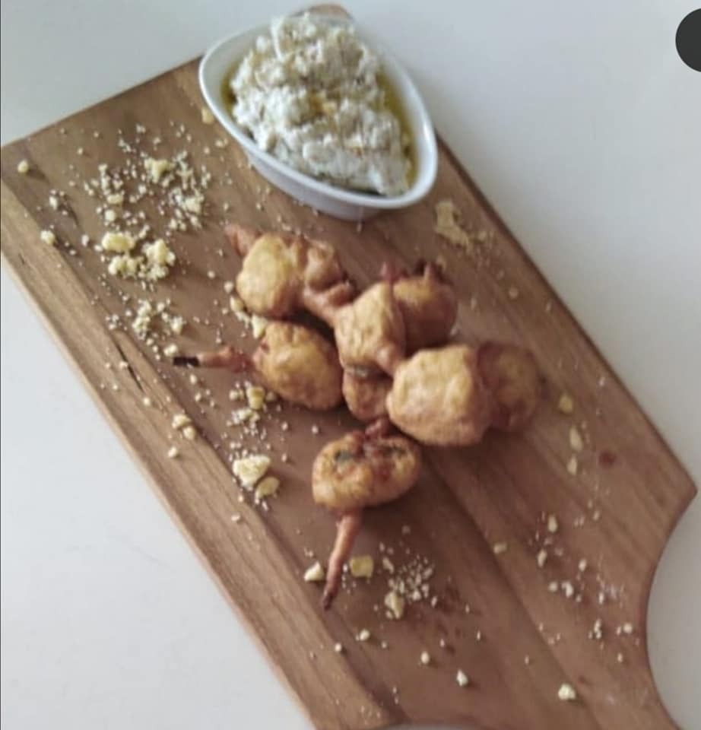

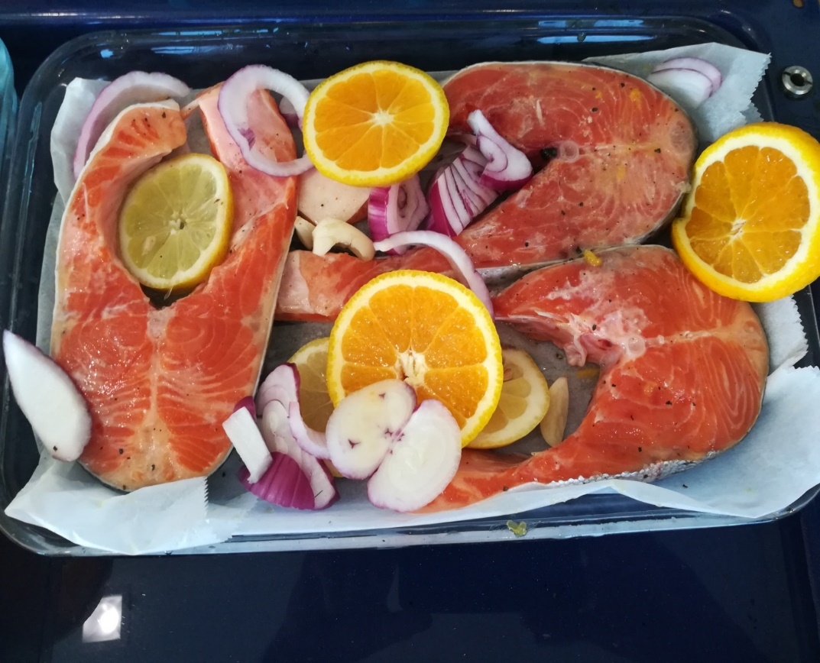

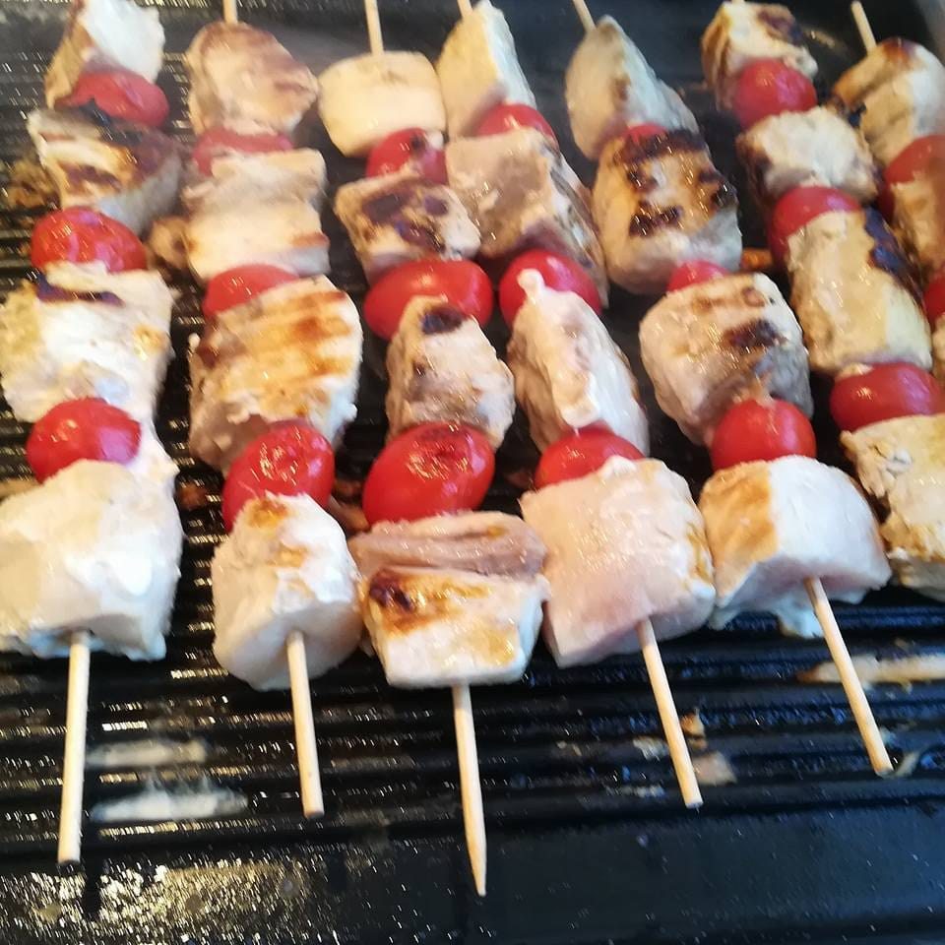

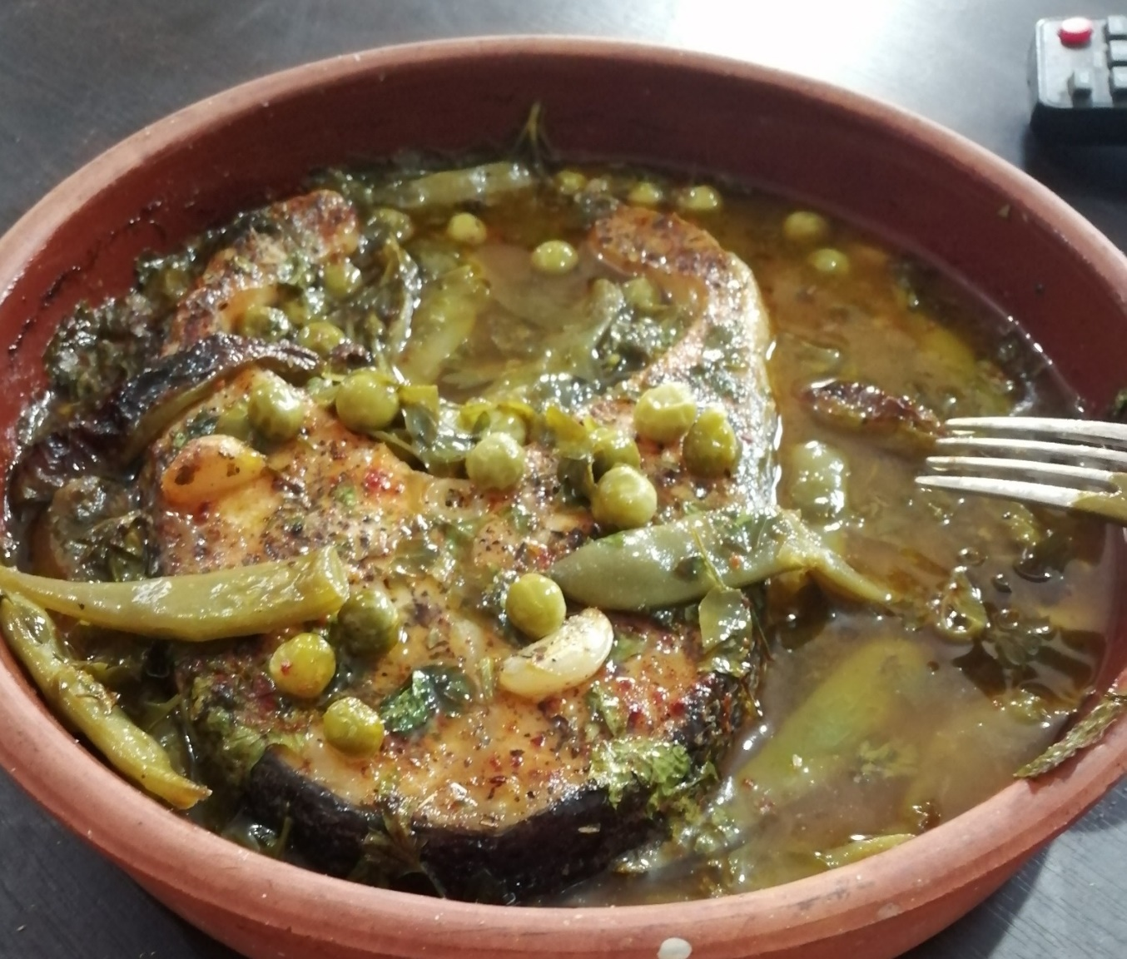

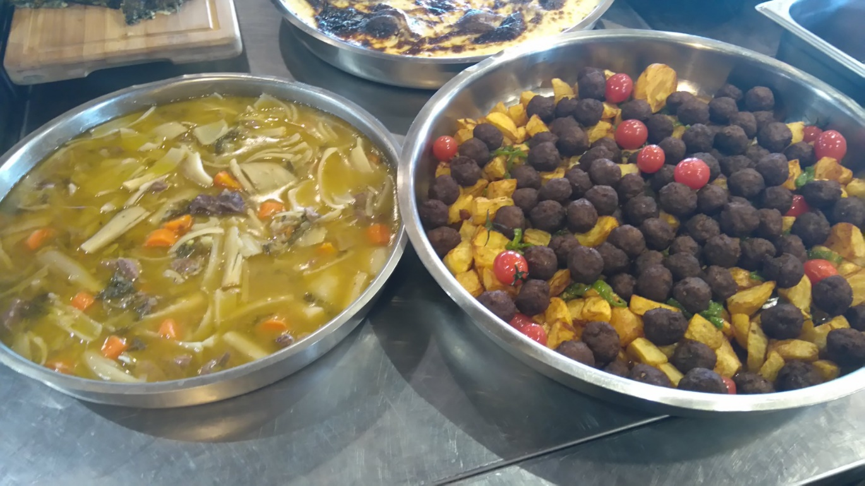

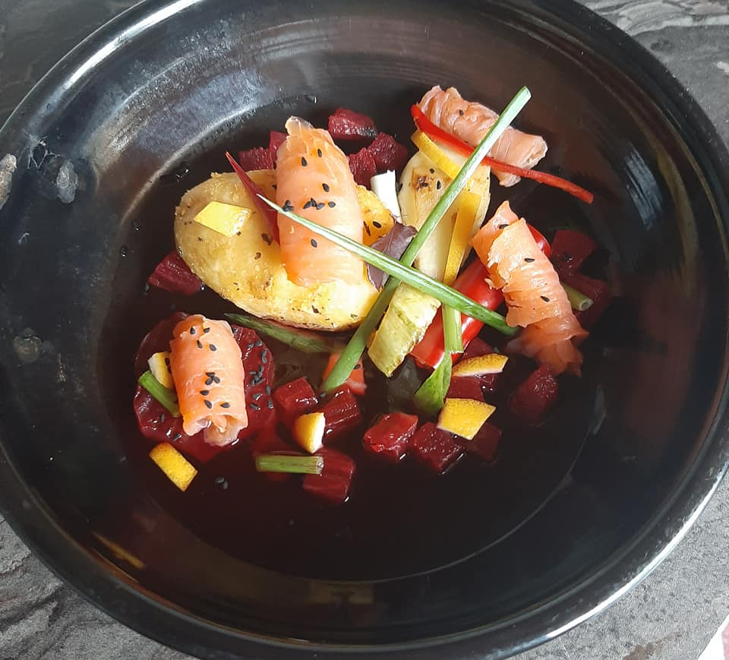

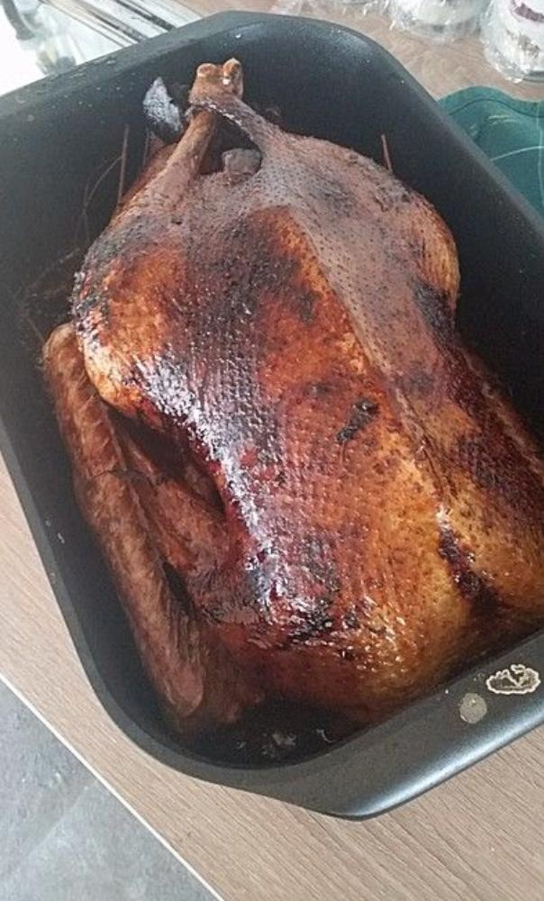

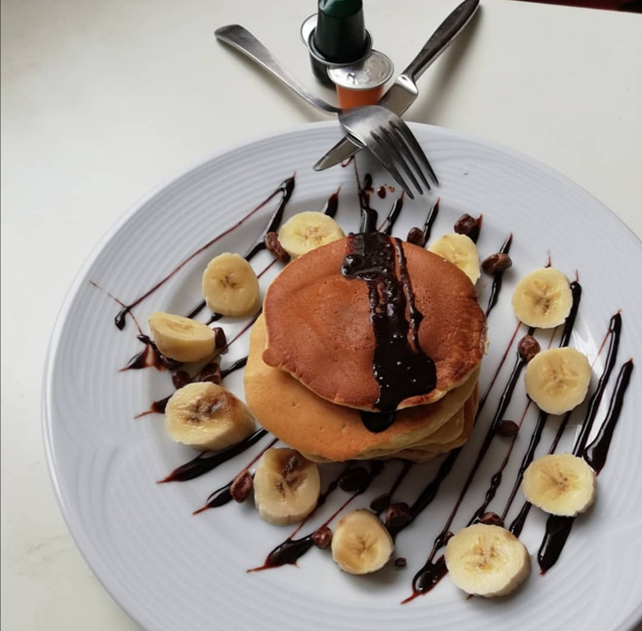

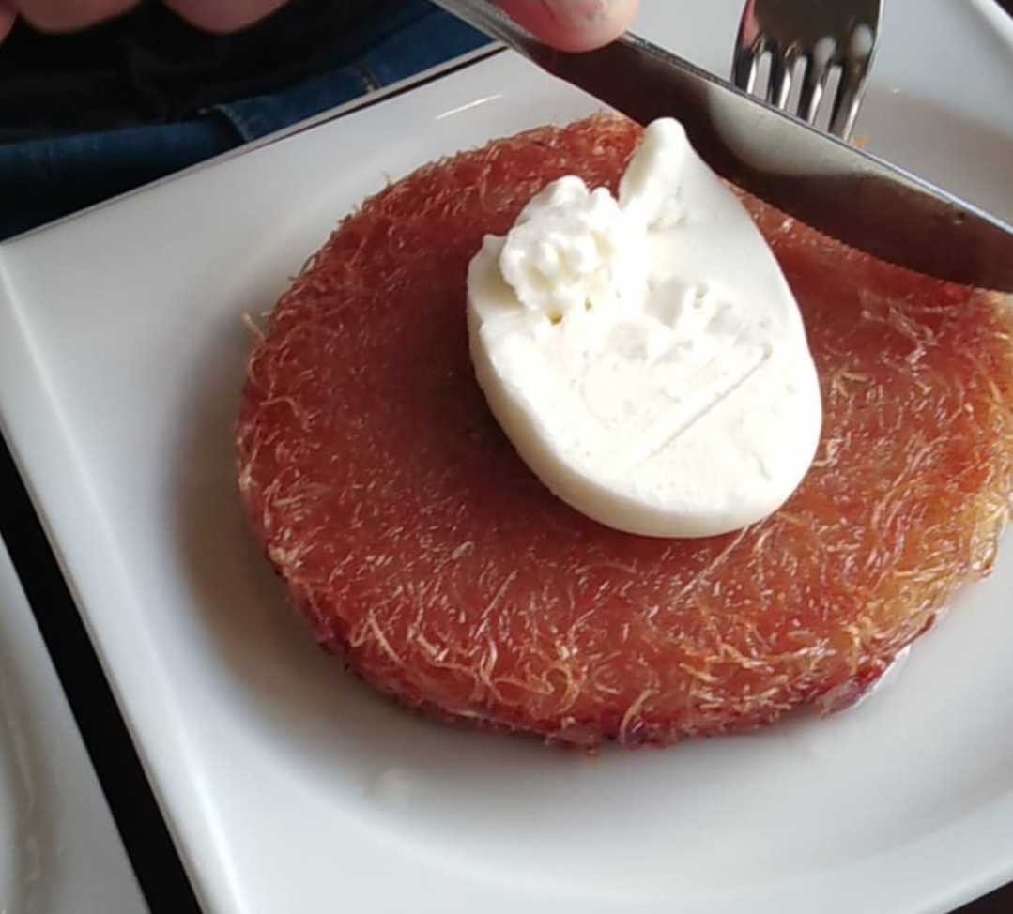

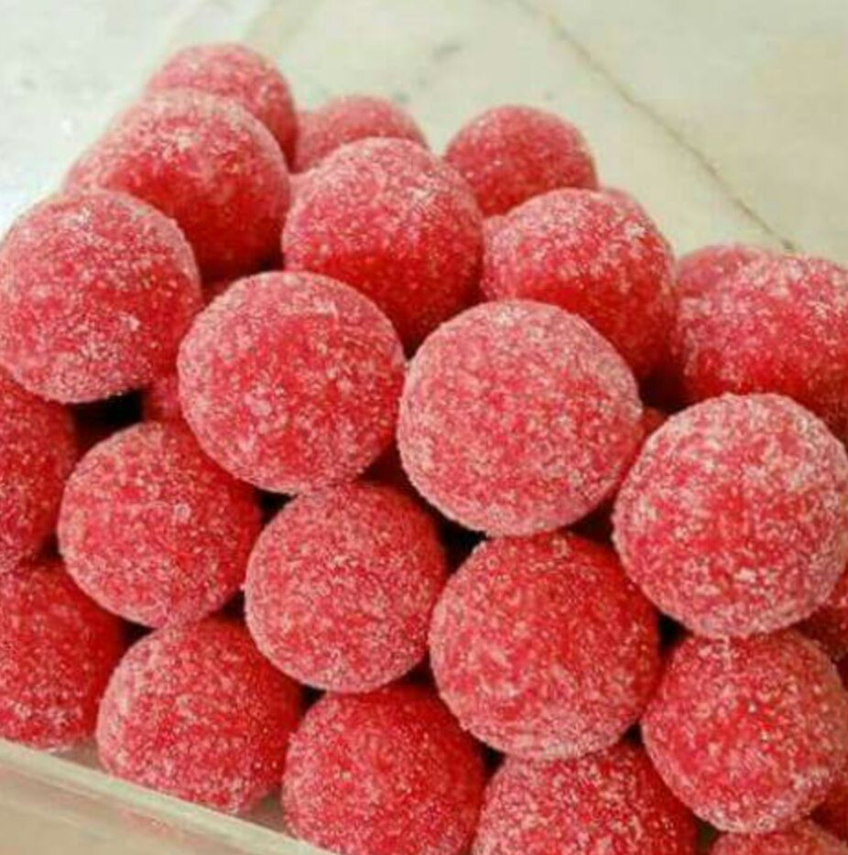

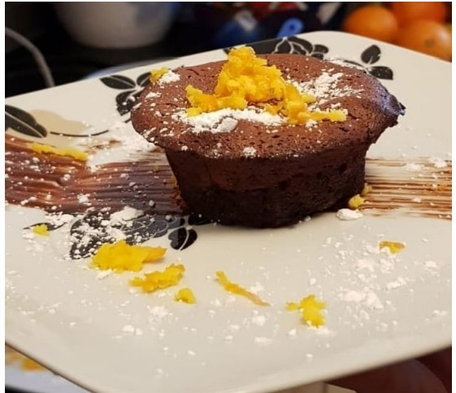
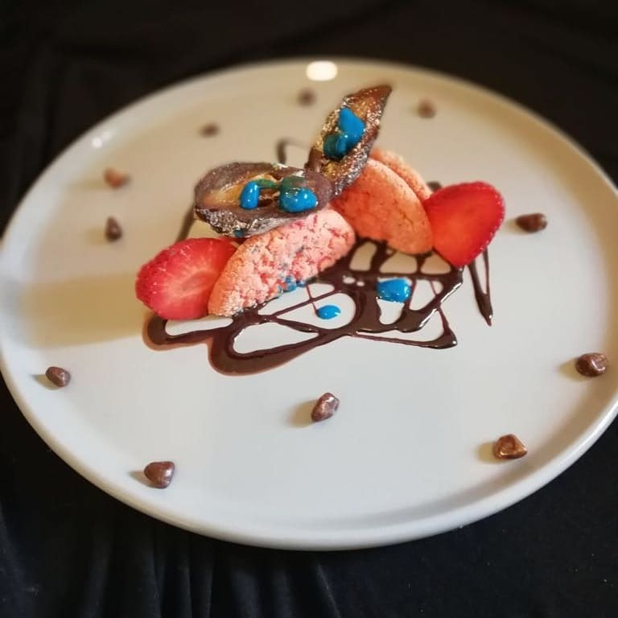
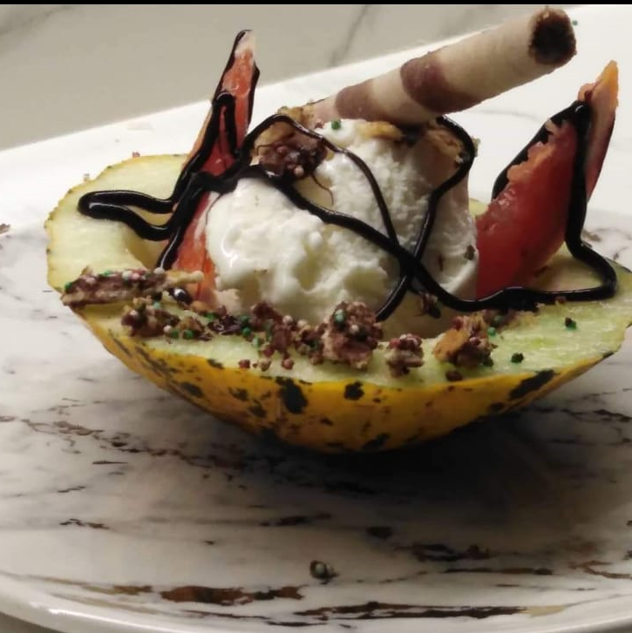

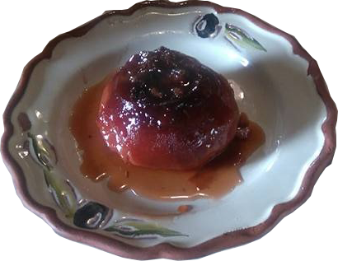

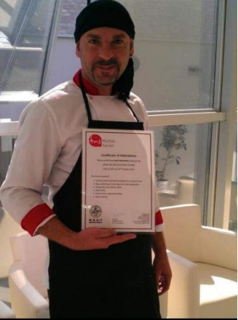

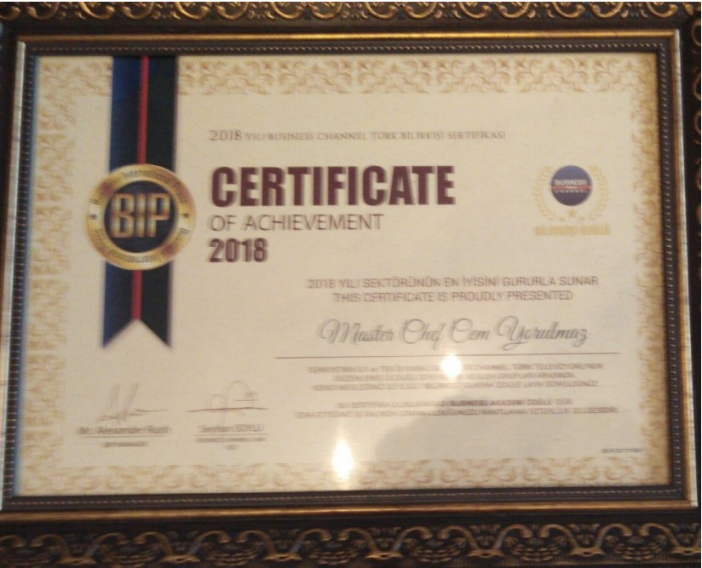
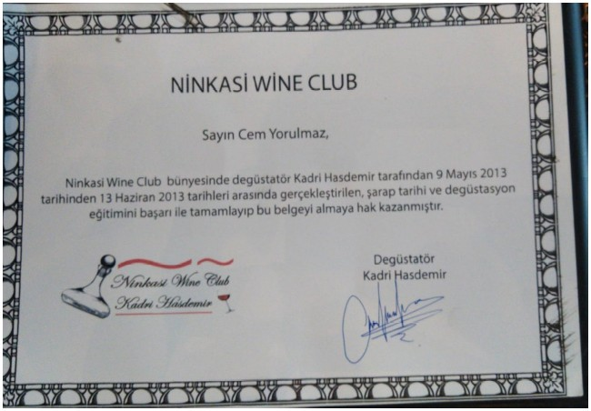
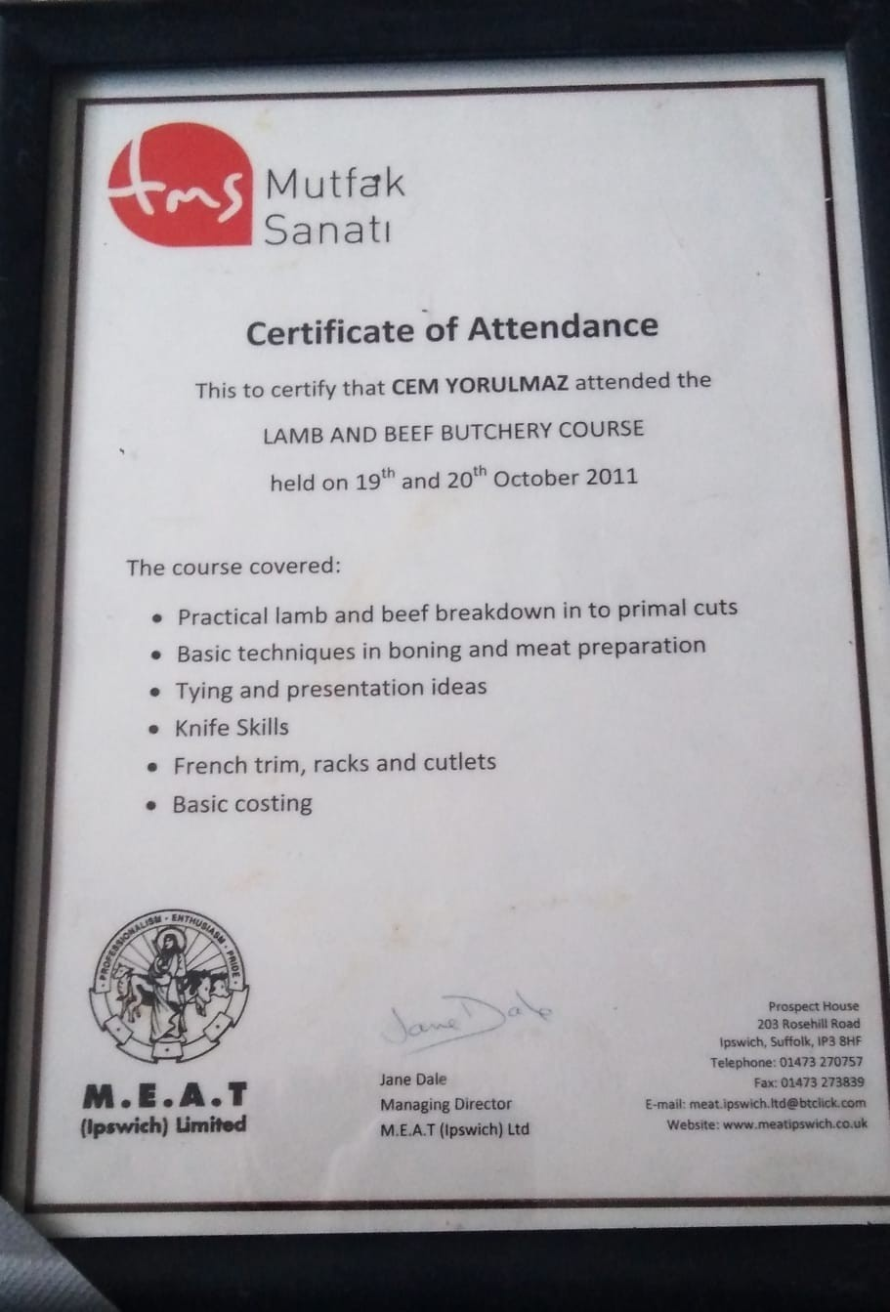
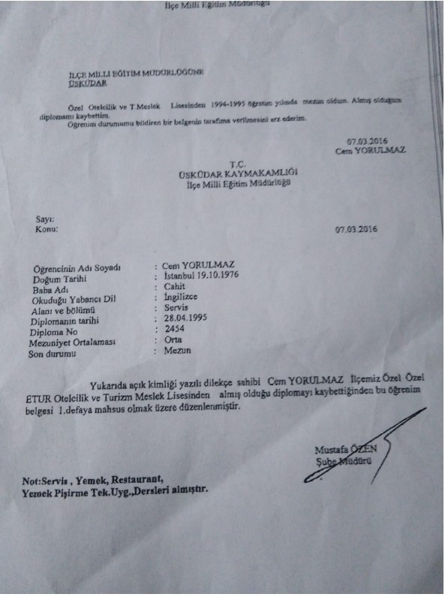

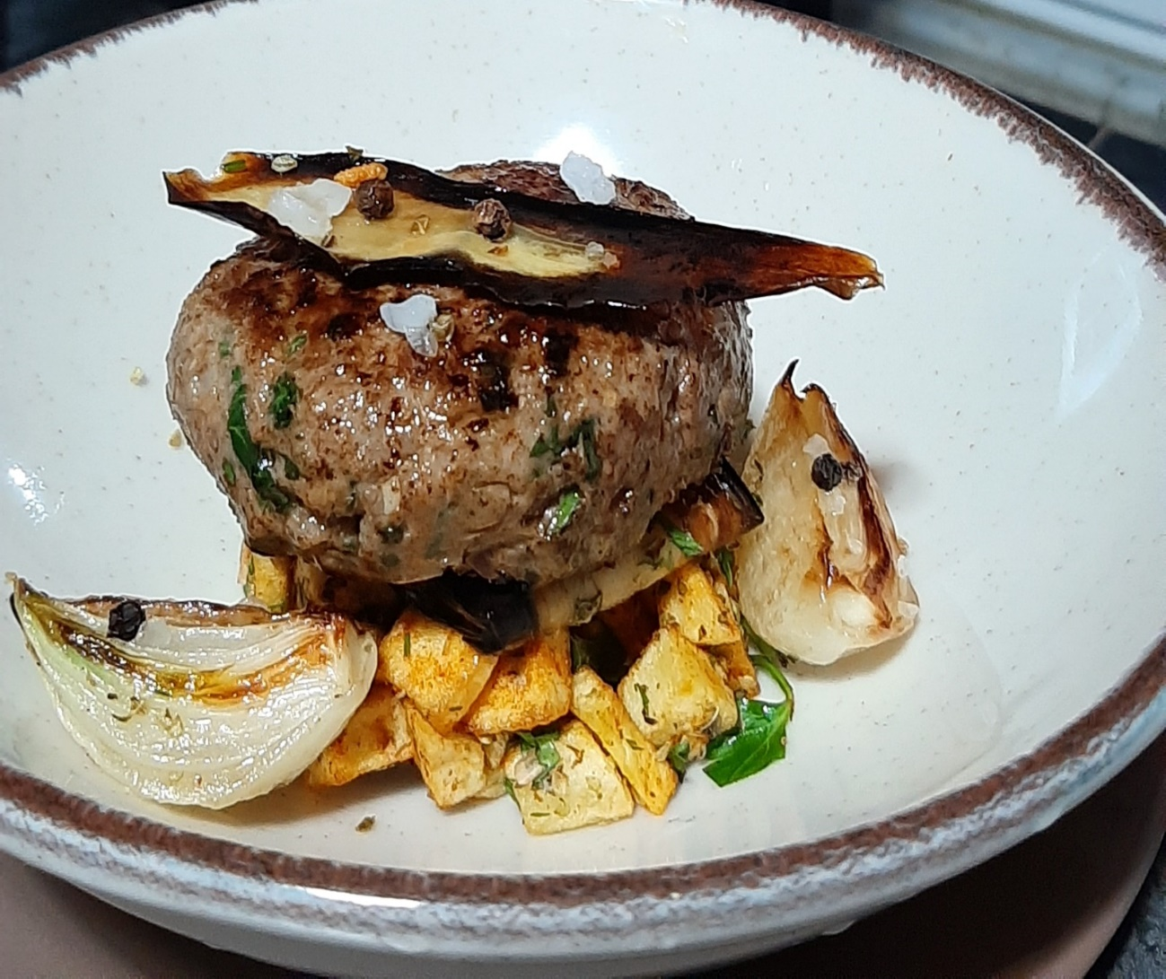

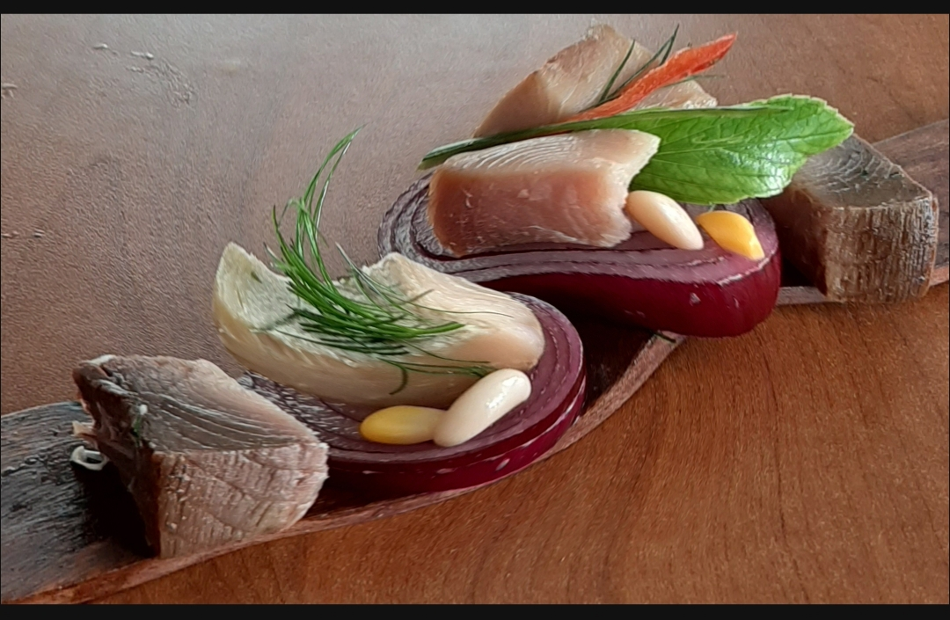

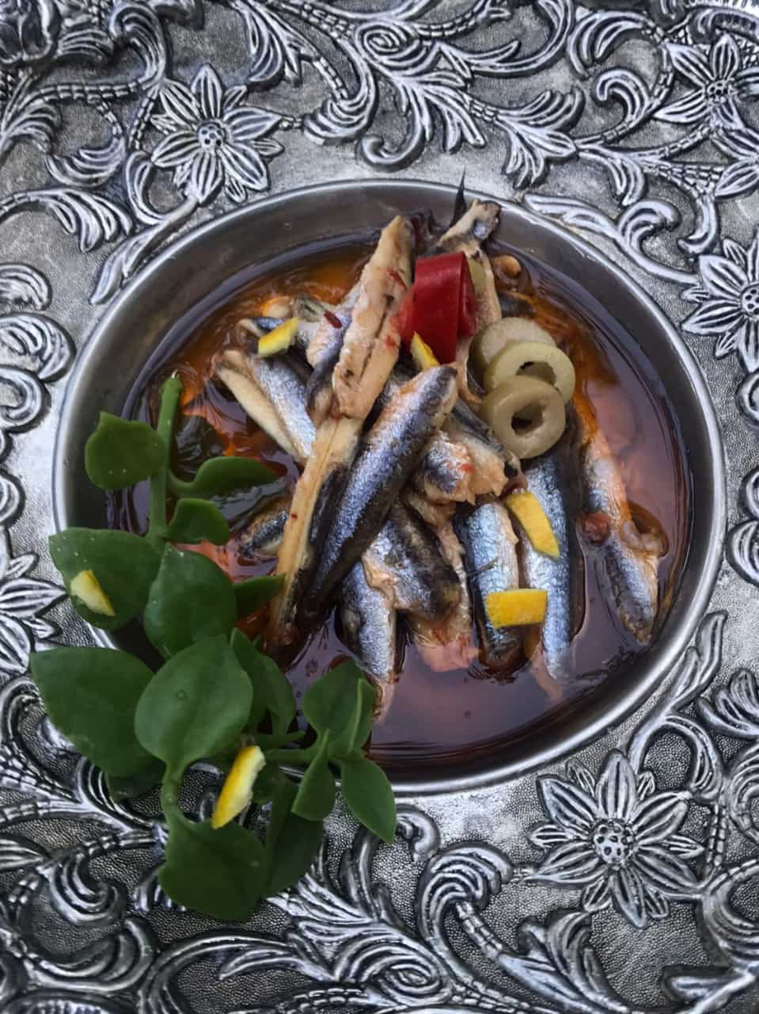

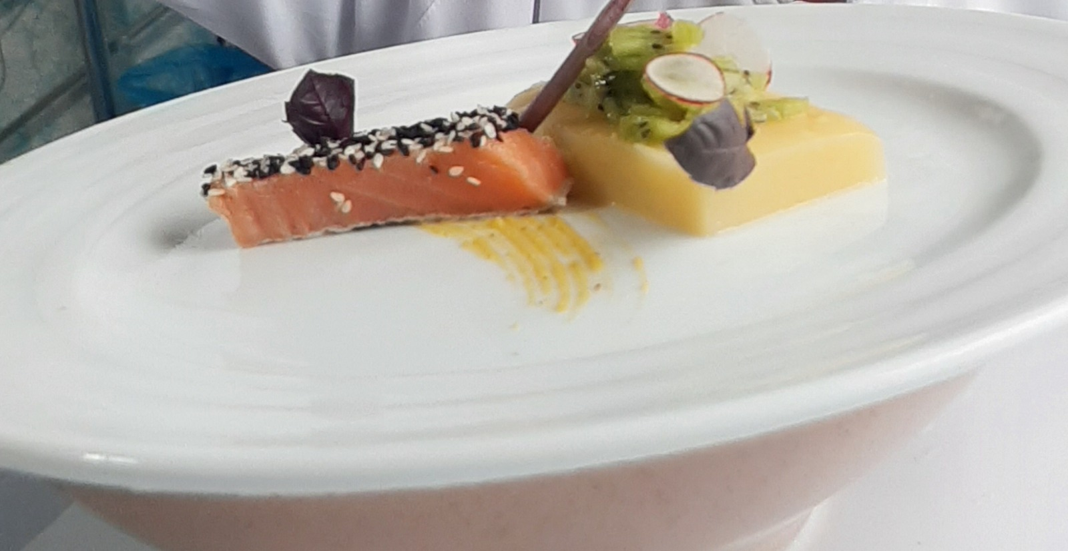

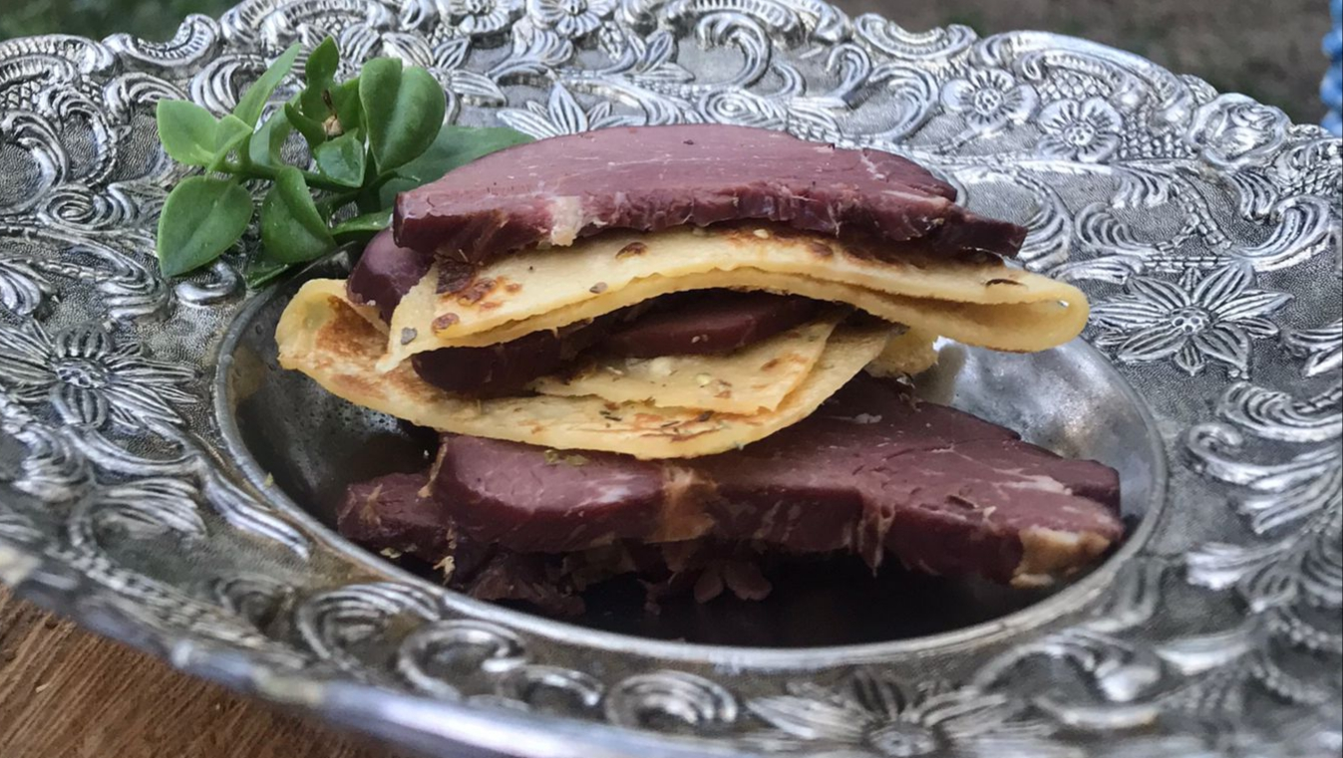

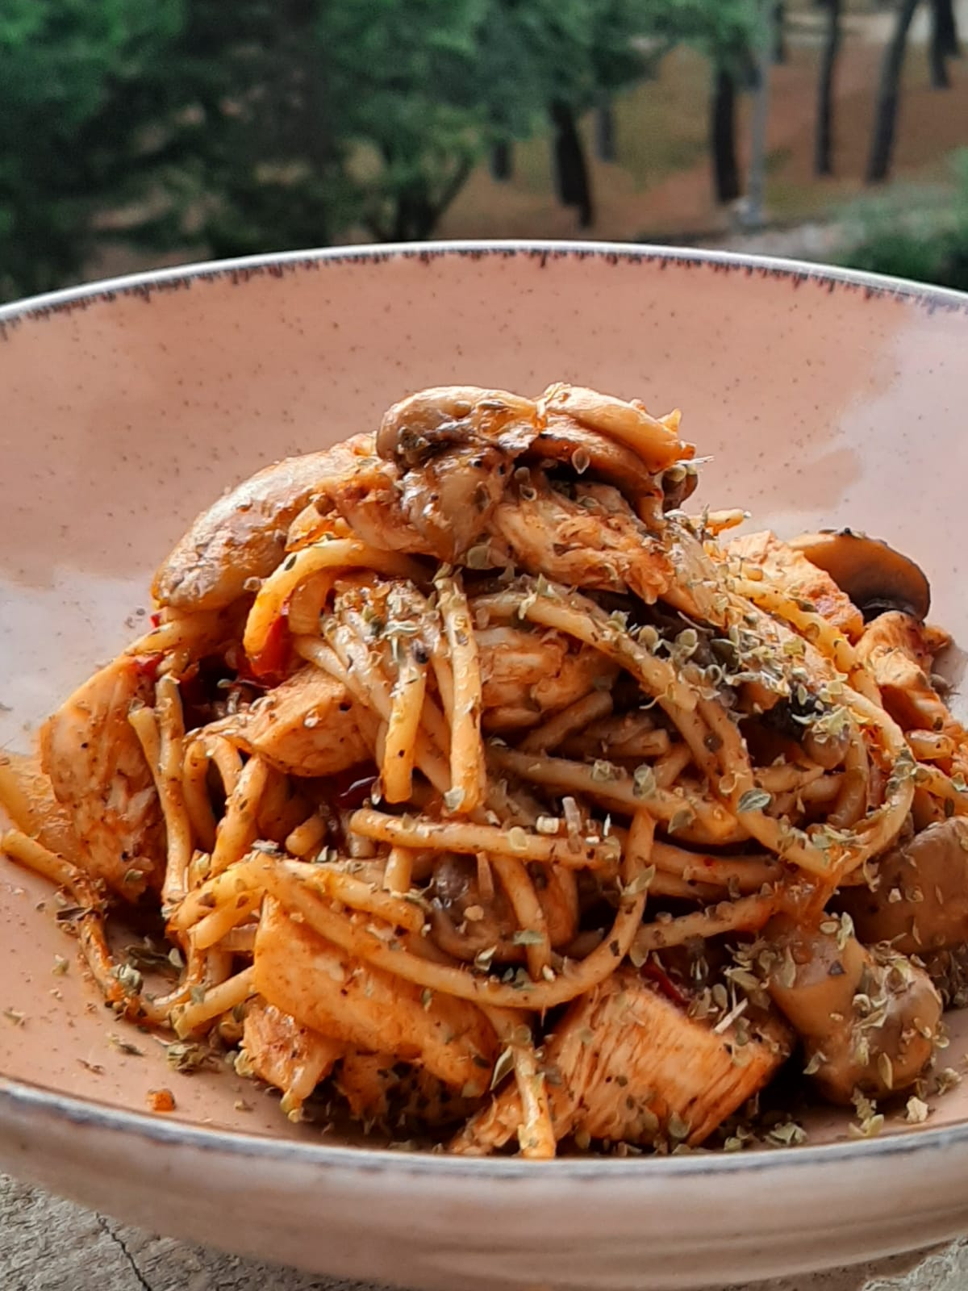

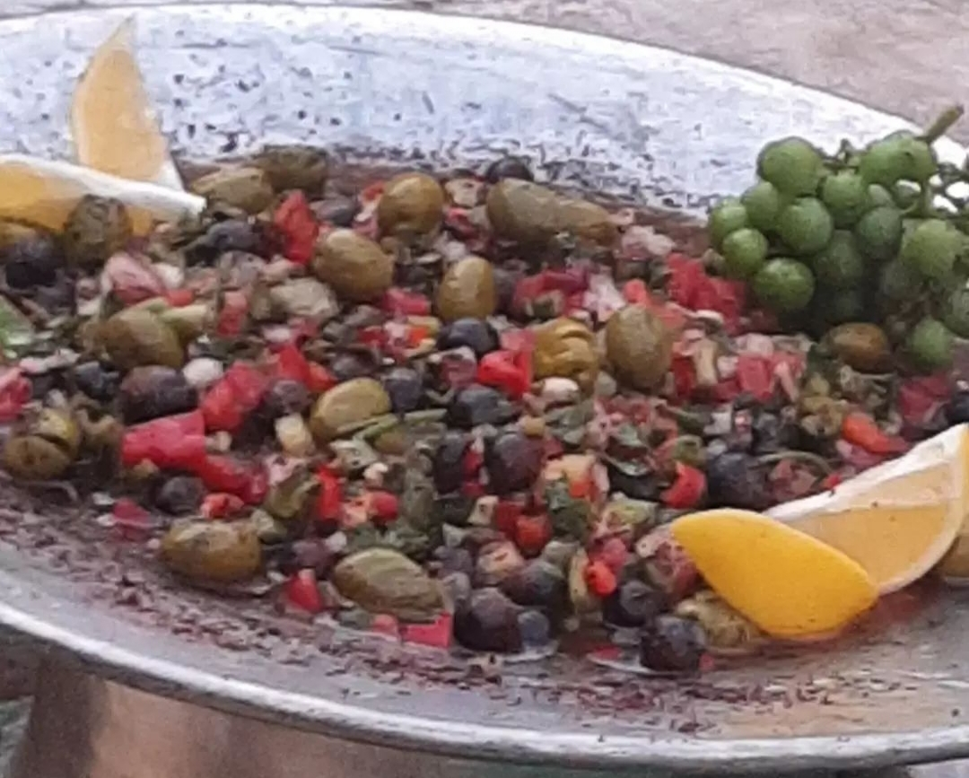

Refenreces

- Mr. Hakan KARAOGLU Master Chef : +90 553 086 53 95
- Mr. Ahmet KOL Chef : +90 537 232 79 98
- Mr. Remzi YORULMAZ Captain: +90 554 880 53 72
- Mr. Ramazan DOGAN Captain: +90 537 630 92 37

https://youtu.be/pVq2THfSr7U

