CODY DAVYD HING

JUNIOR DECKHAND
__________________________________________________________
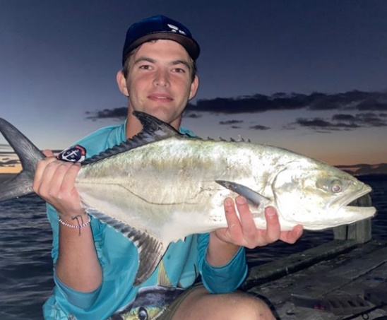
DATE OF BIRTH 12 October 2002
NATIONALITY South African
VISAS -
LANGUAGES English and Afrikaans (Fluent)
HEALTH Excellent, non-smoker, no visible tattoos
MARITAL STATUS Single, no dependents
EMAIL codyhing@gmail.com
CURRENT LOCATION Somerset West, Western Cape, South Africa
PHONE +27 78 217 6899

I am a young, very eager, and confident being that can see himself excel in the yachting industry. I have years of experience on supercat boats and have been a deckhand and fisherman for over 16yrs. I love water sports have extensive experience on jet skis, in general just love the water and outdoors.
I believe I would be a great asset to a professional yacht crew and look forward to being part of a team. I am available immediately and will work worldwide.

QUALIFICATIONS AND LICENSES

- ENG1 Medicals (Valid till 24/02/2024)
- Seaman’s Medical Certificate (Valid till 24/02/2023)
- STCW 95 – Complete Basic Training (Valid 2027)
- RYA PWC (Jet-Ski)
- RYA Powerboat Level 2
- PDSD
- Superyacht Deckhand Course
- SRC VHF Radio
- MCA Yacht Rating
- RYA Superyacht Tender Operator
- Seaman’s Discharge book
- Fully Vaccinated

MARITIME WORK EXPERIENCE

OCTOBER 2019 – 2022 3 YEARS 620 Supercat DAYWORK
Duties: Washdown, polishing

FEBRUARY 2022 1 DAY M/Y SHERILYN (21 METRES) DAYWORK
Duties: Washdown, polishing

TENDER DRIVING EXPERIENCE

620 Supercat, 90 Evinrude engine DROVE OVER 200 Nautical Miles 2006-2022

OTHER RELEVENT EXPERIENCE

JANUARY 2022 – FEBRUARY 2022 CERTIFIED SUPERYACHT ACADEMY Cape Town, RSA
STUDENT: Training on courses for Advanced Deckhand

NOVEMBER 2021 – DECEMBER 2021 HARLEY’S ON MAIN Somerset West, RSA BARMAN: Prepare alcohol or non-alcohol beverages/ Stay guest focused and nurture an excellent guest experience

SEPTEMBER 2007 – MAY 2022 CNCSTEELWORX/MAINTENANCT PROJECTS Somerset West, RSA
BOY/SITE HELPER: Mixing cement/lifting heavy objects/Cleaning sites after renovations/Carpentry/Training on welding/Building and maintenance on wooden decks

MAY 2022 – CURRENT THORHELICAL Somerset West, RSA
SITE FOREMAN: Screening/Crack re-enforcements on buildings/Machine operator

INTERESTS AND HOBBIES

I love to be outdoors, whether it is wake boarding, knee boarding, skiing, skate boarding playing rugby or cricket, I enjoy the sense of freedom. I am especially interested in fishing and being out at sea. I also take interest in reading peoples’ success stories and how they accomplished what they did.

REFERENCES

DANIEL FERREZUELO CERTIFIED SUPERYACHT ACADEMY OPERATIONAL MANAGER
daniel@certifiedtraining.co.za +27 (0) 21 023 0622

GRAHAM LIDBETTER HARLEY’S ON MAIN/THORHELICAL OWNER
+27 66 239 8966

SHAUN HING CNCSTEELWORX/MAINTENANCE OWNER
shaunhing@cncsteelworx.co.za +27 73 078 5454

