ANASTASIIA CHUMACHENKO
STEWARDESS
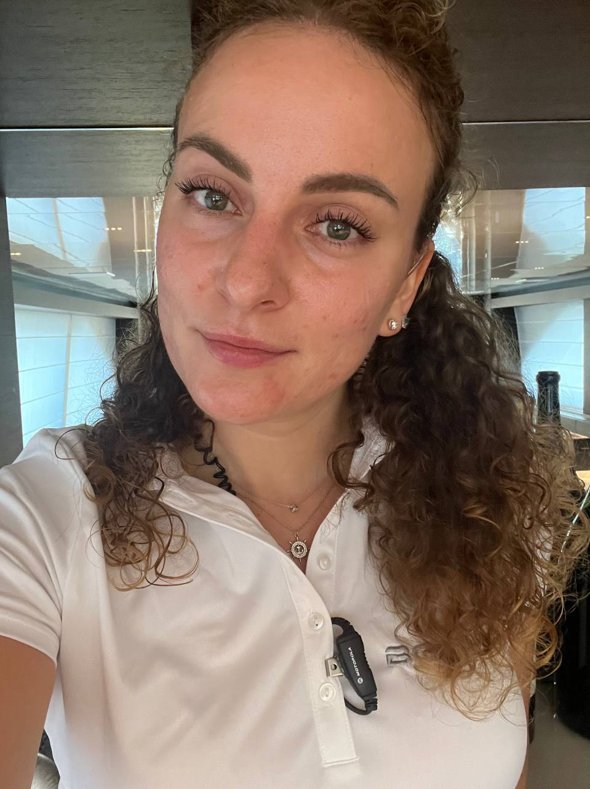 | Date of birth: 31.05.1996  Nationality: Ukrainian  Marital Status: Single  Height:182cm  Weight:70kg  Fully Vaccinated  VISA  Schengen exp. 28.09.2028  NON-SMOKER  NO TATTOOS  anastasia.gennadievnaa@gmail.com  + 380 93 074 15 28
I am looking for a Chief Stewardess position on charter/private M/Y. I have 5 years experience on Yachts starting from 43 m up to over 100m.
I am confident in different kinds of service, as well as in housekeeping and laundry.
I know how to be a team player and always ready to go extra mile. Being motivated, focused and hardworking, I do my best to deliver high standards of service to my guests. I’m candidates with proven leadership skills and I want to step up in my yacht career.
I have positive attitude every day. NO drama.
All my documents and certificates are up to date.

EDUCATION | EXPERIENCE
2014 – 2018  Odessa National Economics University  2011 – 2014  Odessa College of Economics, Law, Hotel and Restaurant Business  PERSONALITY  Great attention to detail  Team player  Energetic  Outgoing  Hardworking  Leadership skills  LANGUAGES  Ukrainian-native  Russian-native  English-fluent  SOFTWARE  Microsoft Word  Microsoft Excel  SKILLS  - Guest service, silver service  - Floral arrangements and decorations  - Table setting and decoration  - Barista and bartending  - Napkin folding  - Housekeeping  - Hospitality  - Laundry  HOBBY  Fitness is a very important part of me, I’m dynamic person. I have a strong interest in keeping fit and interests in:  - HIIT  - running  - cycling  - hiking  - yoga  - ski  REFERENCE  - Mega Yacht “AL SALAMAH”  Chief Stewardess  Stivaktas Georgios  +30 698 8946039  - MY «Gloria Teresa» 43 m.  Captain  Novak Igor  +385 99 666 1666  Chief Stewardess  Shetty Yana  +380664962482  • Charter Yacht «Christina O » 99 m.  Chief Stew  IULIAN GHITA  +40 723130826  Operations Manager  Florin Belciug  +33 620621404  operationsmanager@mychristinao.com  Captain  Ionut Poetas  +40 723 410 465  captain@mychristinao.com  - Charter Yacht «Orient Star»  Captain  Onur  +90 5320637771  Chief Stewardess  Elena Pelin  +380 684001708  - Private Yacht «Botti»  Captain Nicolo Ghione  +39 348 904 5175  captainbotti@gmail.com | July 2022-October 2022  Private Yacht «Botti» 42 m  Chief Stewardess  May 2022- July 2022  Charter Yacht «Orient Star» 47 m  2nd Stewardess  June 2021- May 2022  Charter Yacht «Christina O» 99 m  Service Stewardess  - Set up breakfast, lunch and dinner for 20-35 guests.  - Provide silver service, family style service, barbecue service  - Make coffee and cocktails, serving wine, helped the bartender  - Collaborate with the chef regarding meal service for the guests.  - Provide personal assistance to all guests in a friendly and helpful manner.  - Organize a different party for guests  - Organize an outdoor barbecue on the beach,  - Escorting guests to outside  - Help housekeeping to clean the guest area  July 2020 – October 2020  Private Yacht «Gloria Teresa» 43 m.  2nd Stewardess  - Provide service and set up table for breakfast, lunch and dinner.  - Responsible for all cabins and laundry.  - Make cocktails, tea, coffee during the day.  - Responsible for purchasing detergents and of crew food.  - Maintain the cleanliness of yacht’s interior.  - Take care of flowers and guinea pig.  March 2019 – December 2019  Private Mega Yacht “AL SALAMAH” 139 m  Service Stewardess  - Make tables by setting up table runners, cutlery, glasses and napkins.  - Collaborate with the chef regarding meal service for the guests.  - Provide silver service and bartender or barista duties when needed.  - Provide personal assistance to all guests in a friendly and helpful manner.  - Stay with the guests during the meals service.  - Serve meals and beverages to the guests.  - Maintain the cleanliness of yacht’s interior.  - Assistance to other stewardesses in housekeeping duties.  - Organize flower arrangements for events.
  CERTIFICATES PASSPORTS
  - STWS 95 exp. 17.09.2023
  - ENG1 18.04.2024
  - PDSD
  - Training for Personnel Serving exp. 17.09.2023
  - Security Awareness Training for all Seafarers
  - Certificate of Proficiency–Steward
  - Food Safety Level 2 20.10.2023
  - Seaman`s Book exp. 23.11.2023
  - Travel Passport exp. 28.09.2028
  - Yellow Fever exp. 19.03.2029
  - Driving license B exp. 14.07.2047

