CURRICULUM VIT AE

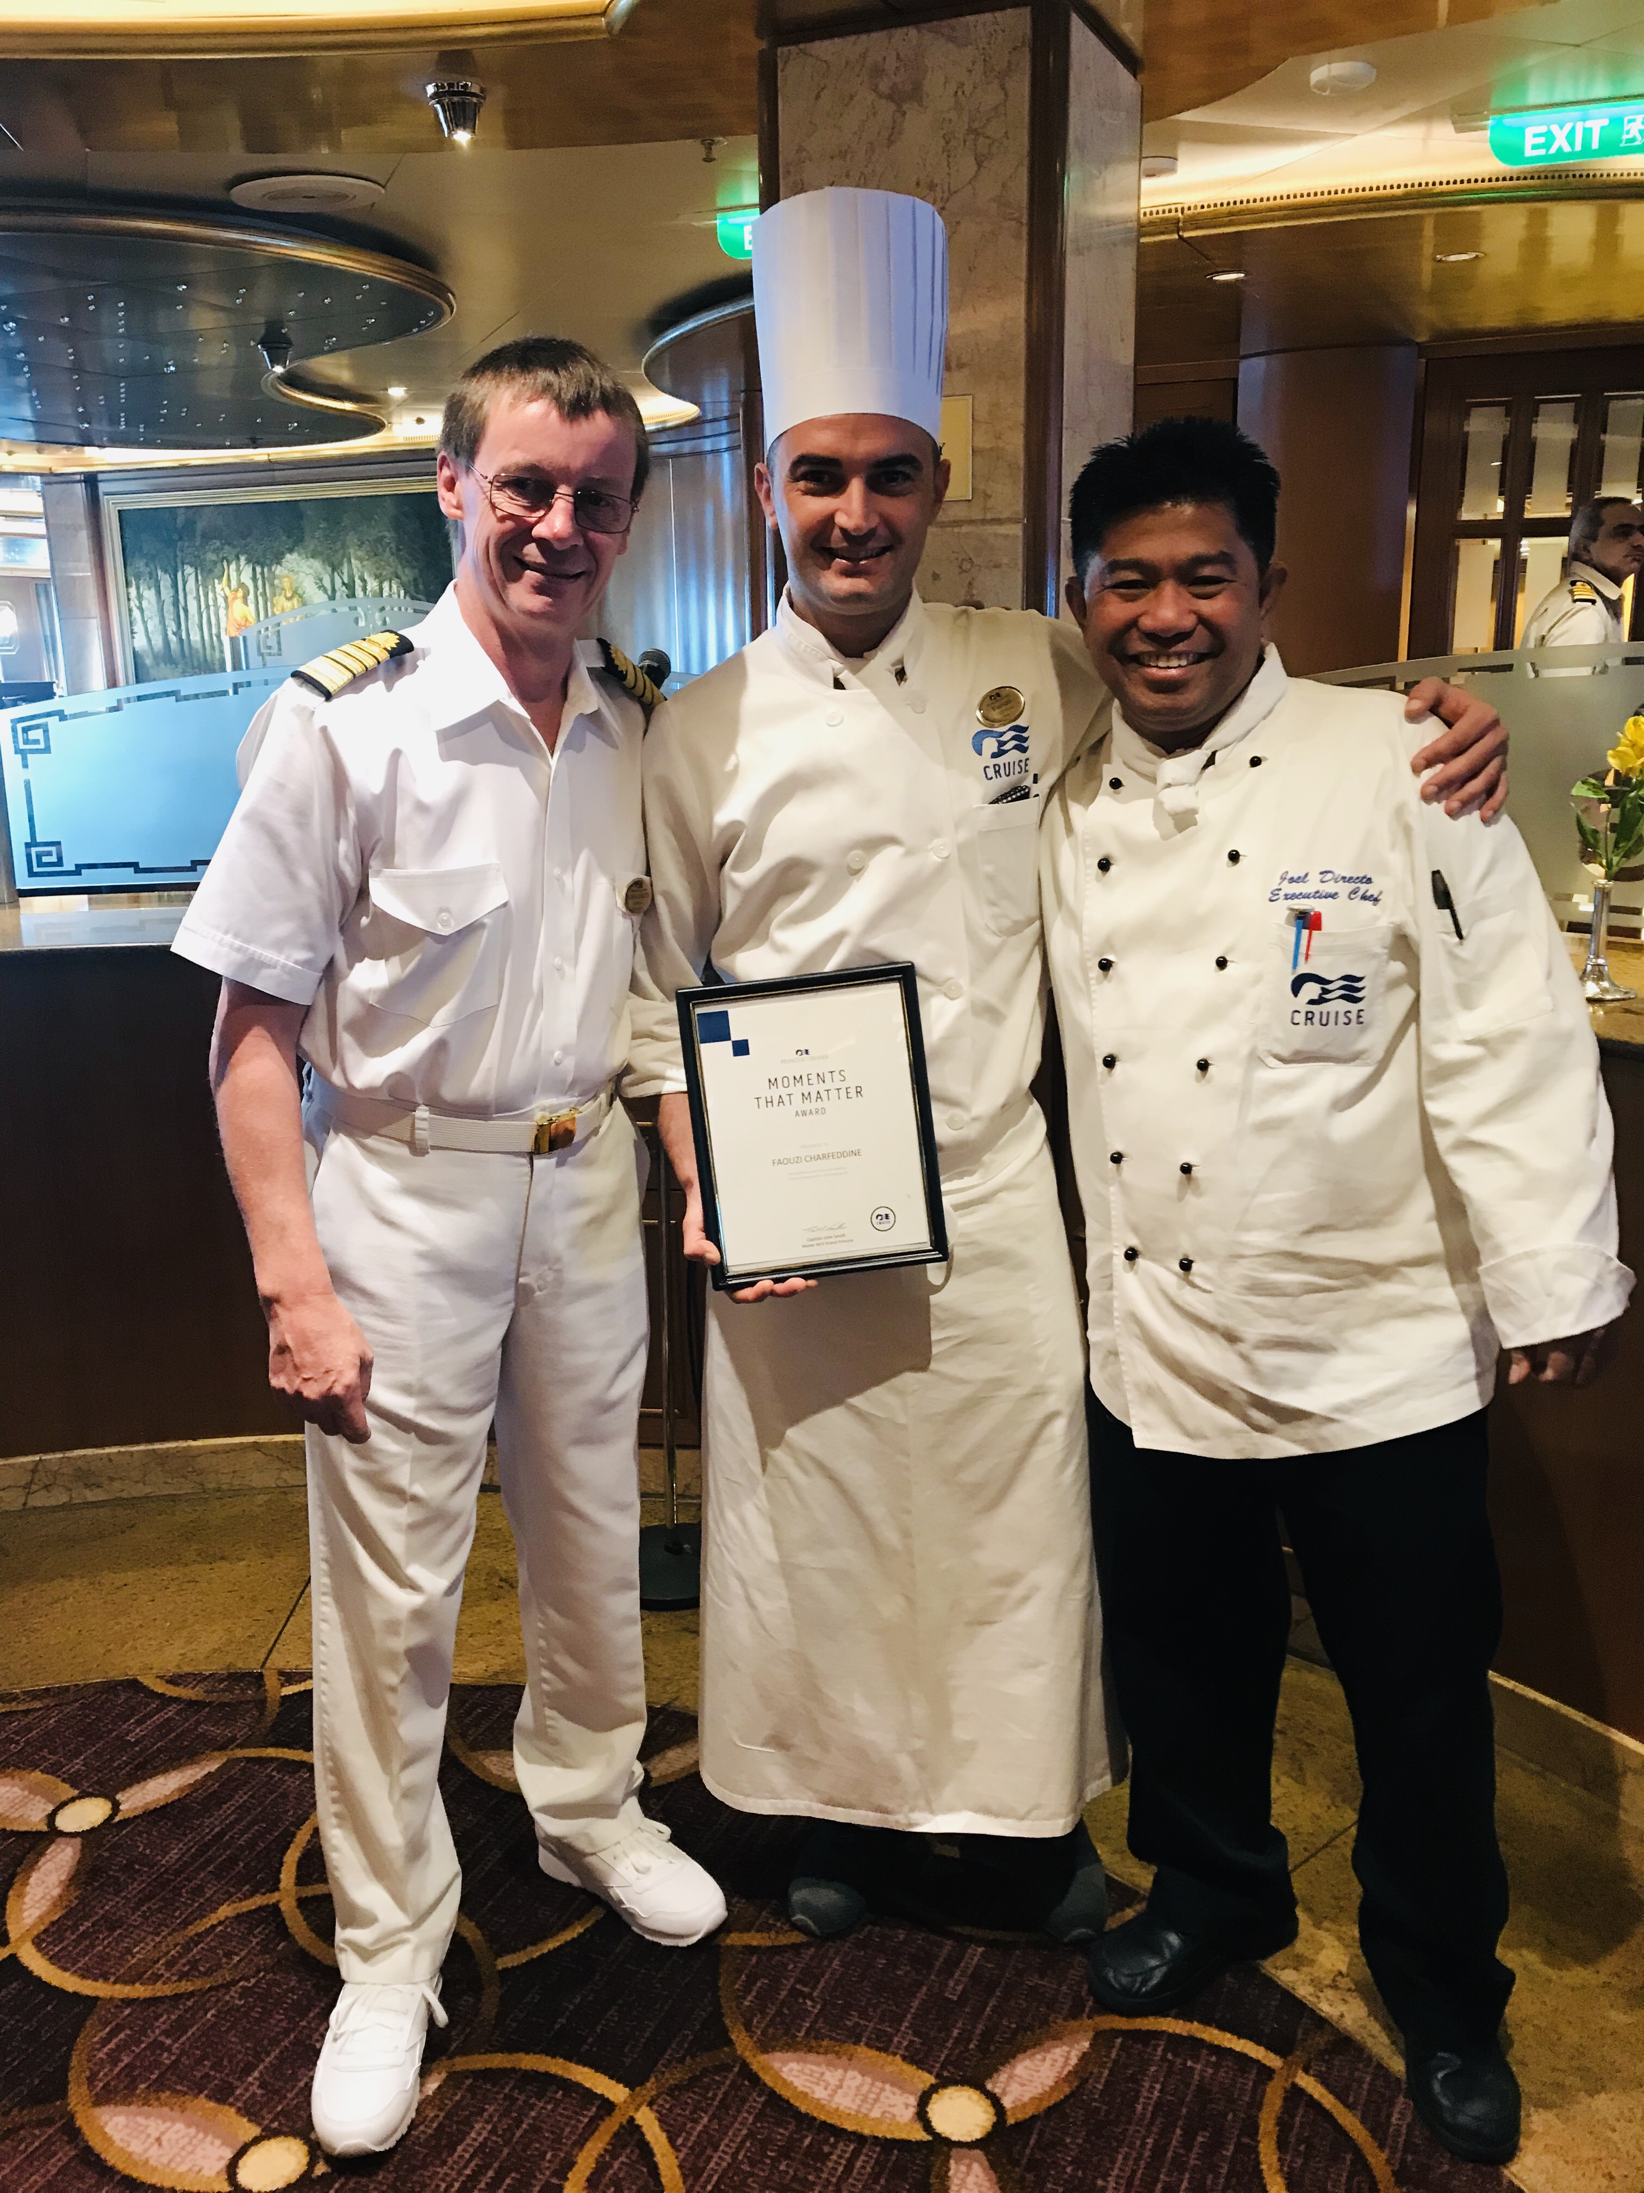

Professional Chef with 20 years of extensive experience national and international….
More than important international experiences abroad: one in Dubai and other in Australia, booth of around 2 years each but for me the most important experience it was on board off Princess cruises
Capable of managing dining services while managing and motivating staff to perform to best of abilities across every service. Expertise in planning menus, standardizing recipes, preparing multi-cultural dishes, and managing purchasing. Committed to controlling costs by reducing or eliminating waste, and effectively forecasting consumption rates.

Personal information:

Name Surname FAOUZI CHARFEDDINE

Address VIA CESENATICO 5734 , 47521 CESENA - ITALY
Date of birth 29/05/1985
E-mail Cheffino85@hotmail.it

Mobile
Nationality

+39 331 9448036
ITALIAN

Main work experiences:
From July 2019 to January 11 /10/2021
Main
Responsibilities Description:

Prepares the pizza and pasta. according Company standard and following Guest orders request in order to provide consistently speedy, professional and courteous service Continually trains staff in and always ensures compliance with Company, safety, environmental,

Prepares the daily food requisition for approval by the Executive Chef in order to assure
excellence in pizza and pasta production, as per operational manual
Help in maintaining the production cost in within the given budget, avoiding unnecessary
wastage, spoilage and food overproduction in order to assist the Executive chef

Ensures a flawless presentation of the prepared items, displayed and served in order to
fully satisfy Guests according to Company standard and policies

Cleans and sanitises the station according to Company sanitation standards

Completes inspection forms before every port and submits to the Executive Chef

Proposes new ideas and initiative

- October 2017 to April 2019
Employer Name: PIZZERIA DA NEO Cesena
www.pizzeriadaneo.it

Main tasks and responsibilities:
preparation of a dough long leavening
Recognizes superior quality products
Assists in developing daily and seasonal Pizza flavor

- From November 2015 to July 2017
Employer Name: GEMELLE RESTORANT **** AUSTRALIA
www.gemelle.com.au - LILLYS FUNCTION RESTORANT www.lillys.net.au
Only Italian cuisine - high quality raw materials, speed of preparation, cooking and packaging.

Main tasks and responsibilities:
Head of the first courses, control of food safety, control and calculation of food costs
Daily kitchen meetings to discuss tasks and agendas.
Maintains food preparation handling and correct storage standards

- From March 2013 to July 2015
Employer Name: RISTORANTE FLB *** DUBAI (UAE)
www.fratellilabufala.au
Italian restaurant

Main tasks and responsibilities:
Prepare meals for lunch and dining services
Manage food preparation processes
Manage relationships with vendors, negotiating prices of ingredients
Weekly meetings with management for the periodic check of entries and exits and of the food cost
Collaborated with Head Chef in menu design and innovative recipes

- From November 2012 to February 2013
and from July 2015 to October 2015
Employer Name: RISTORANTE QUEL CASTELLO DI DIEGARO *** ITALY
www.quelcastello.it

Main tasks and responsibilities:
Managing daily kitchen operations with 12 staff members
Creation of new dishes and periodic change of the menus considering the season and the various products available: menu based on local products.
Checking stock levels

- From May 2012 to October 2012
Employer Name: Hotel Parador residence- - Cesenatico - ITALY
Seasonal Hotel

Main tasks and responsibilities:
Chef 4th Level, Sous- chef (Chef Tournant)
Responsible of main courses

- From November 2011 to April 2012
Employer Name: Hotel Amerikan (4 stars ) Livigno - ITALY
Seasonal Hotel

Main tasks and responsibilities:
Helping the sous chef and head chef to develop new dishes and menus
Monitoring food portions and waste control to maintain profit margins

- From May 2009 to November 2011
Employer Name:Riviera Golf Resort Riccione - ITALY
http://www.rivieragolfresort.com

Main tasks and responsibilities:
Chef 4th Level, Sous- chef (Chef Tournant)
Responsible of main courses

From May 2005 to February 2009 I worked in some seasonal hotels in Cesenatico and Riccione (Adriatic coast Italy )

Education:

MAY 2005: Certificate of restaurant attendant issued by the Regional School of Catering Emilia-Romagna. ITALY
Principal subjects and professional skills covered during the study: Cooking practice, food costing, preparations, menus, marketing, buffets ....

MAY 2004: '' LOLLI LUCA '' Trophy Award for the Best Kitchen Student at the IALL in Cesenatico.
THIRD CLASSIFIED in the region and SECOND CLASSIFIED in the course of specialization in creative cooking and pastry.

MOTHER TONGUES: ITALIAN

OTHER LANGUAGES:

FRENCH: understanding, speaking and writing good level ARABIC : understanding, speaking and writing good level ENGLISH: understanding, speaking and writing good level thanks to international experiences in Australia and Dubai

Driving licences A/B

