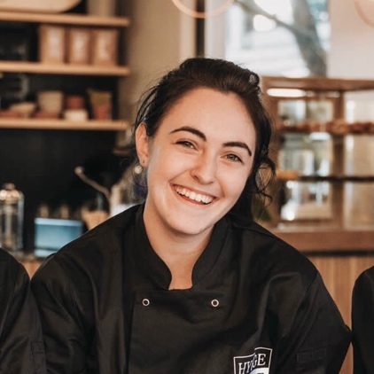
M a d i s o n S h a r p l e s
Junior Stewardess
I am an aspirational and determined person who always puts her head down to get the job done. Working with people, attention to detail, and focus are some of my top strengths. I consider myself a good listener and am always willing and wanting critique to improve my skills, to reach and go above and beyond expectations. If employed by you I guarantee to be a beneficial, fun, and drama-free addition to your team.

Personal Information
Mobile
+27 74 585 0000
Email
madison.kim.stew@gmail.com
Instagram
Personal
@m2disonkim
Yachting
@madison.greentogoldstew
Current location
Fort Lauderdale, USA
Passport expiry
February 2032
Visas
B1/B2
Nationality
South African
Date of Birth
22/02/2000
Health
Non-smoker
Visible tattoos
Vaccinated
COVID19 - Johnson & Johnson

Qualifications / Certifications
Yachting
Full STCW
PST – exp. 2027-07-16
FPFF – exp. 2027-07-20
ENG1 – exp. 2024-07-14
Food and Hygiene Level II
Green to Gold Stewardess Course
Tertiary
2019 – 2021: Occupational Chef Diploma (NQF 5) at CTIA, Stellenbosch
Additional Qualifications
2020: Diploma in Nutrition with Udemy, online course
2020: Diploma in Diet Planning with Udemy, online course
2021: Preliminary Wine Course with Cape Wine Academy, Stellenbosch
2020 – 2022: Personal Fitness Trainer with FitPro - Fitness Education, online course
Other Skills
Barista
Yoga
Work Experience
Restaurant Service Manager
Val de Vine, Western Cape | October 2022
Opening and closing the restaurant for breakfast, lunch and dinner services, doing cash ups, allocating tips, supervising and overseeing staff, creating shift lists and allocating staff duties, guest interaction – to ensure quality control and satisfaction.

Restaurant Supervisor
Brampton Wine Studio, Western Cape | February 2022 – September 2022
Opening and closing the restaurant, doing cash ups, supervising and training staff, guest interaction, listening to critique and compliments for the staff – able to handle staff issues. Answering phones – phone etiquette

Bartender
Bohemia, Western Cape | 2021 – 2022
Promoted from waitress – first and only female bartender. Taking orders, communicating with the waiters, free/speed pouring drinks, moving in sync with other bartenders, stock take daily (fast moving stock) great guest interaction.

Waitress
Bohemia, Western Cape | 2020 - 2021
Taking orders, working with a POS system, carrying multiple drinks and food items, multitasking, communicating with other staff, great guest interaction

Bartender
Amics Restaurant and Bar, Western Cape | 2020
Taking orders, making drinks, using a POS system, upselling products, multiple types of guest interactions

Chef, Pastry Internship – Fine Dining
Overture Restaurant, Western Cape | June 2021 - September 2021
Shadowing and working in pastry section the whole internship period. Writing prep lists. Preparing pastry and dessert dishes for service. Plating and assisting all sections during service. Performing bread service for all guests. Weekly deep clean and kitchen detailing. Occasionally helping front of house with running plates and serving guests

Chef Internship – Café
Hygge Hygge, Western Cape | March 2021 - May 2021
Running the pass. Calling orders. Plating dishes. Helping preparation of dishes. Stock take and kitchen organisation

Chef Internship – Fine Dining
Tokara Restaurant, Western Cape | September 2019 – January 2020
Shadowing all kitchen sections. Completing stock takes weekly and monthly. Running canape section in the last month. Assisting in plating dishes. Gaining knowledge of fine dining service

References – Hygge Hygge - Andries VDM – andreis.vdm@gmail.com || +27 763984994
Bohemia – Henry Doyle – info@bohemia.co.za || +27 210071219
Brampton - Nico Havenga – nicoh@dgb.co.za || +27 711460014
Val de Vine – Glen Odenndal – restaurant@valdevine.co.za || +27 662479483
Green to Gold – Claire – claire@greentogold.co.za || +27 843235100

