CURRICULUM VITAE
NAME AND SURNAME:
FRANCISCO LUIS CORBACHO SAMPEDRO
______________________________________________________
ID NUMBER : DNI 35312817 C
_____________________________________________________________________
Nacionalidad: ESPANISH
BIRTH DAY: 20/11/1968 PLACE BIRTH: MOAÑA (PONTEVEDRA)

CURRICULUM
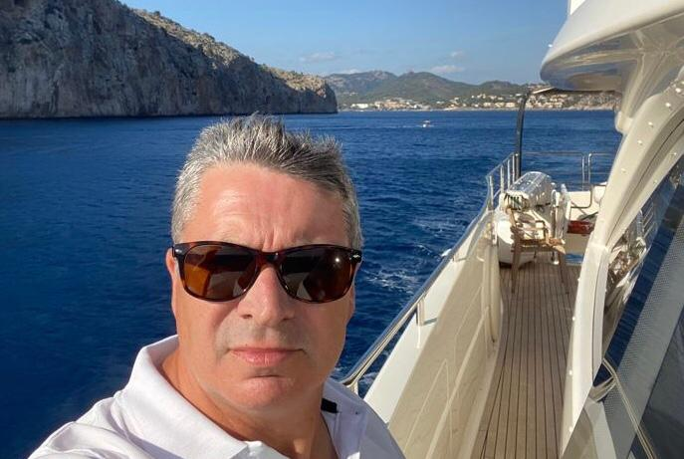
Adress Galicia: Avda Monterrreal, 1 36300 Baiona
Adress Baleares: Son Orlandis D´amunt 77 , S´Hostalot,
Palma de Mallorca
T: +34 609 834 414
email: luis@estelas.net

Academic formation:
SPECIALTY DEGREES AND CERTIFICATES
1.- COASTAL FISHING SKIPPER
2.- DEEP SEA FISHING SKIPPER
3.-CABOTAGE SKIPPER
4.- PROFESIONAL SKIPPER OF RECREATIONAL BOATS
5.-GMDSS GENERAL OPERATOR

ANOTHER COURSES OF INTEREST:
- NAUTICAL SURVEYOR : March 2017
- Insurance mediator course Metrópolis: June 2016
- Introduction to safety and fish elctric technics : April 2013
- Course underwater Teledetection with side scan sonar: July 2013
- Básic course in occupational risk prevention: July 2011
- Advanced firefighting course : Noviembre 2013

PROFESIONAL EXPERIENCE
- Experience with fishing vessels in the following fishing grounds:
- Galician coastal waters since 1983 with my father´s boat at different stages.

- CANARIAN-SAHARA FISHING GROUNDS
In freezer trawlers of the canary islands:
Playa de Areamilla, four months as a seaman
Ciudad de Telde, four months as a second skipper
Myrdoma B, four months as a second skipper

- NAMIBIA
Freezer trawler called Leirachan, of 76 meters lenght

- GRAND SOLE, PORCUPINE, IRELAND AND ESCOTLAND
Few years like second and main skipper in the next boats
MOUNT EDEN, from Aberdeen
CASUAL from Plymouth
REVELLIN from Marín
HERMOSO VERANO, from Marín
Years from 92 to 95

- MANAGER AND ADMINISTRATOR of the nautical company ESTELAS from december 1997 till june 2017

- Captain of a 17 meters YACHT “RIO BATEL” from 1997 to 2012

- Captain, and management of a 26 meters YATCH “ FIU” from 2001 to july 2014, combinated with the previous work in the Rio batel yacht

- Director - Professor of the ESTELAS NAUTICAL ACADEMY from 2000 to the present ,with bases in Galicia and Balearics Islands

- Profesional Broker from 1999. Units sold up 90 feet

- PROJECT MANAGER , refittings responsable from clean hull of units larger from 50 feet.

- Professor of navigation practics since 1997, also with comunications procedures of global maritime distress sistem security GMDSS

- Writer, editor and author of several nautical training manuals (WWW.QUIEROSERPATRON.COM)

- Captain of Azimut 75 called Disparate of 23 meters from March 2014 to May 2021

- Captain of Yacht Navetta custom-line of 26 meters DISPARATE – SAUDADES from January 2020 to July 2022.

- From the sale of Navetta untill now 5th october I was working helping to sale a Sunseeker 72 called SPLENDIDO and in a Italversil Superphamtom 80

- The Italversil , called PALADIO underwent a major restoration process under my suopervision ,including a change of main engines in July, and this boat leave to Canary island at end of october.

- Judicial expert of boats ,with extensive experience in processing accidents and appeals against insurances.

OTHER DATA OF INTEREST:
- Medical certificate to fit boarding

