FRAZER WOOD
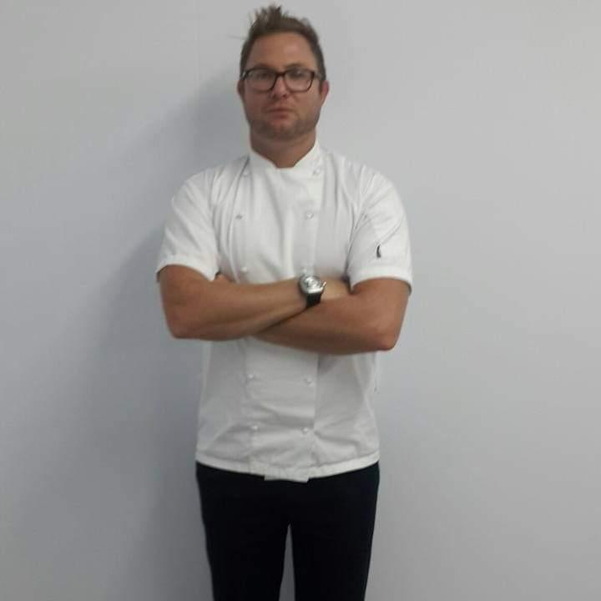
HEAD CHEF/
Nationality-British

VISAS AND DOCUMENTS
British Passport / Indonesian temporary residency
Seaman Discharge Book

CONTACT DETAILS
Location- London
U.K- +44 7538988083 call/whatsapp
Skype- frazerwood
e-mail - frazerwood@yahoo.co.uk

QUALIFICATIONS
NVQ Level 2 food preperation and cooking
Application of Number level II
Communications Level II
Basic Food Hygiene level II
Health and Safety level II
ENG 1
STCW 95

EDUCATION
Cornwall College-Cambourne 2006
MATRIC GRADE 12 with exemption and merit- John Ross College 2001

FOOD COMPETENCY
French, Asian, British, European, Kosher, Fusion, Indian, Pan Pacific, Japanese, Italian, Thai, Vietnamese, gluten free, Raw food, Mediterranean, healthy, international breakfast, raw diets, food intolerance cooking, dessert making and pastry

March 2014- April 2022 executive chef / owner- (blue water creations- Bali )
Owner/director of blue water creations which consists of multiple f&b locations in bali, responsible for all new menu’s, costing’s and implementation, staff training, financial systems and spreadsheets, multiple cuisines and cooking techniques and recipes, food, drink set ups and costs, establishing relationships with suppliers, minimalizing food waste. All financial accounting and banking, tax and all legal business payment. job details also included business set ups, architectural drawings, interior design and concepts,

June 2013- June 2014
The Bistrot Restaurant-Seminyak Bali - Executive Head Chef
Solely responsible for the daily running of the restaurant Including managing 42 staff members, all menu planning, food costs, HACCP, health and hygiene as well as all food and stock rotation. Training staff and implementing new food items, menus and cooking techniques to all the staff
Responsible for reaching targets as well as keeping GP and food costs at targets. Reduced food costs by almost 20% and increased business by almost 100%

PRIVATE CHEF / YACHT EXPERIENCE

May 2013-June 2013 (Temporary Contract) MY Horizons II - 45m Head Chef
Temporary Head chef , I was responsible for all provisioning, preparation and cooking of all food for guests including gluten free, raw food dietary needs and crew food –Catering for up to 15 people daily, Food including breakfast, lunch and dinner, sweets as well as all dietary requirements.
It was also part of my duty to ensure the overall cleanliness of the galley and all food storage areas. It was also my duty to ensure efficient stock rotation and the cleanliness of all the fridges and freezer’s which were kept at a high standard

March 2013- May 2013 (Temporary Contract) MY C2-80m Head Chef
Temporary Head chef while the head chef was on holiday. I was responsible for all provisioning, preparation and cooking of all kosher food for guests and crew –Catering for up to 40 people daily, Food including breakfast, lunch and dinner, sweets as well as all dietary requirements.
It was also part of my duty to ensure the overall cleanliness of the galley and all food storage areas. It was also my duty to ensure efficient stock rotation and the cleanliness of all the fridges and freezers which were kept at a high standard

October 2012- March 2013 (Seasonal Contract) MY Plan B – 75m Sous Chef
Private yacht responsible for provisioning, preparation and cooking of all crew And Guests Up to 24 crew as well as assisting for up to 12 guests and 2 children and 2 nannies at a time, guest parties for up to 45 people, Crew Food including breakfast, lunch and dinner, sweets as well as all dietary requirements.
Guest food including breakfast, canapés, petit fours. It was also part of my duty to ensure the overall cleanliness of the galley as well as all food storage areas, stock rotation and the cleanliness of all the fridges and freezers all of which were to a high standard. The boat travelled from Malta to Fort Lauderdale, then all around the Caribbean before heading back to Germany

April 2012- October 2012 (Seasonal contract) MY Sea Raider –40 m Head Chef
Sole chef on this busy private yacht responsible for all provisioning, preparation and cooking of all kosher food
For guests and crew – 4 crew in total, and up to 12 guests, 2 children and 2 nannies at a time, as well as guest parties for up to 20 people, guest Food including breakfast, lunch and dinner, sweets as well as all dietary requirements
Guest food including breakfast, lunch, Dinner, canapés, petit fours, & desserts. It was also part of my duty to ensure the overall cleanliness of the galley and all food storage areas. It was also my duty to ensure efficient stock rotation and the cleanliness of all the fridges and freezers which were kept at a high standard .The boat travelled to Corsica, Sardinia, St Tropez, Monaco, Naples and all around Italy, Capri and Parts of southern France.

November 2011-April 2012(Seasonal contract) MY Senses - 59m Sous Chef
Private chef, Solely responsible for all crew food, and assisted with charter guests, as well as provisioning, responsible for all canapés, vegetarian options, desserts and petit fours. It was also my duty for the overall cleanliness of the galley as well as all food storage areas, stock rotation and the cleanliness of all the fridges and freezers. The Yacht was an expedition yacht and travelled to Antigua, Tortola, Bonaire, Curacao and Venezuela

COOKING EXPERIENCE

November 2010 – November 2011- Executive Head chef Aston Rose (chartered surveyors) Head Chef
Executive lunches and dinners - Responsible for corporate lunches and dinner parties, duties including all food preparation, starters ,mains, desserts and canapés, all of which was to an extremely high standard, Maintaining effective stock control and gp’s as well as changing menu’s Daily according to new seasonal produce and preferences.

Jan 2010 – November 2016- Head Chef/Sous Chef HCC Recruitment London
I worked for HCC as a head chef for 11 years full time/ part time, at some of London’s top restaurants, museums, private members clubs, private event companies and 5 star hotels including: The Langham Hotel 5 star 2 rosettes, The Landau - Michelle Roux, Rocket outside catering By Word Of Mouth private events, Table Talk Events, Alison Price outside And event catering, Bonds restaurant, Grosvenor House Hotel, The Cadogan Arms, Hilton on park lane & The Botanist.
Some of the private events were for some of London’s top events including Elton John’s charity evening, private catering for VIP guests at Westminster Abbey including the Queen, as well as Heads of state.

Jul 2009 - Jan 2010(As part of my visa) -Sous Chef Glass restaurant marina mirage Australia
Food preparation including vegetables, meat, garnish and fish, cooking of main courses, and all sauces
Daily specials as well as new menu ideas and concepts, Recipes and training for the new menus, and managing a kitchen brigade of 12 chefs. I was responsible for the running of the kitchen when the head chef was absent.

Jan 2009 - Jul 2009 (As part of my visa) - Sous Chef Koi restaurant Broadbeach Australia
Food preparation including vegetables, meat, garnish and fish, cooking of main courses, and all sauces, I was responsible for the running of the kitchen when the head and sous chef were absent. Daily specials and new menu ideas. Recipes and training for the new menus.

Aug 2008 - Jan 2009(Freelance) - Sous Chef/ Chef de Partie West One
I worked for west one as a freelance chef at some of London’s top restaurants, museums, private members clubs, private events and 5 star hotels including; The hospital club, Covent Garden, Grosvenor House park lane 5 star.
The Hilton Park Lane 5 star, Bonds Thread needle Hotel 5star 2 rosettes, Intercontinental Hotel Park Lane 5 star.

Nov 2006 - Aug 2008 -Senior Chef de Partie - Flourish chef Agency
Food preparation including vegetables, meat, garnish and fish, cooking of main courses, and all sauces
Ensured stock was rotated correctly and that sufficient stock was ordered, Canapés preparation and cooking
Preparation for weddings and events for up to 300-starters, mains and veg; I worked for flourish for almost 2 years:
Kings Head-Ivinghoe 2 Rosettes, The Pennington 1 Rosette, The Menzies Welcome Hotel 1 Rosette, Stratford Manor Hotel 1 Rosette, Sopewell House Hotel 1 Rosette, Thistle Hotel 1 Rosette, The Selsdon Park Hotel

Aug 2004 –September 2006 - Senior Chef de Partie Headland Hotel Newquay- AA 1 Rosette
Food preparation vegetables, meat, garnish and fish, cooking main courses and all sauces, Canapés preparation and cooking; Preparation for weddings and events for up to 300: starters, mains and veg; I was responsible for the running of the kitchen when the head and sous chef were absent, Assisted with menu planning,

Hobbies
Surfing reading and researching new recipes, ideas and concepts, interiors

