GEOFF RENOUF  CAPTAIN MASTERS 3000GT  DOB: 11th August 1949  Nationality: British  Vaccination Status: Fully Vaccinated  Seamans Number: R829769  Phone: +66 958854657  Email: Ormerman2014@gmail.com  Current Location: Thailand | 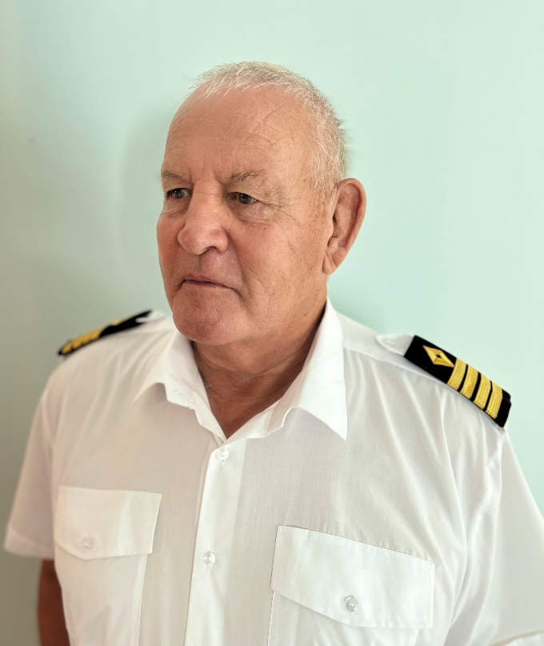

Profile
I would like to introduce myself. My name is Geoffrey Renouf and was born in Guernsey, Channel Islands. My DOB is 11/08/1949. I have a current passport and fully vaccinated against Covid. Non-smoker and no tattoos. I have my STCW95 certificate and I have a current medical certificate (Valid until October 2024).
At the age of 16 I joined the Merchant Navy through a sea school and started work as a Deck Boy, working my way up to 1st Officer. On leaving the Merchant Navy I went ashore to pursue shore-based work including owning a company, but at the same time enjoying cruising around the many Channel Islands and France on various boats that I owned. These included a Fairline Targa 32, a Fairline Phantom 42, a Fairline Targa 43 then a Fairline Squadron 58. During these times I did a few delivery jobs for customers and ended up doing a delivery to Croatia where I remained working doing various charters and deliveries and studying for my master’s certificate. In 1980 I passed my Masters Category B 3000GT ticket.

Objectives
Take responsibility as Captain or First Mate of vessels and leverage my decades of experience to ensure safe, punctual, professional operation of ship and crew. I am now living and working in Thailand and would like to continue working on Motor Yachts and am willing to travel anywhere.

Maritime qualifications

Masters 3000gt
STCW95
Norwegian Medical Certificate
Efficient Deck Hand Certificate
Lifeboat Certificate
Helmsman Certificate
Certificate of Competency as AB

Career Highlights

1965 Represented Merchant Navy in Cenotaph Parade
1971 Rescued a drowning woman from Auckland Harbour
1980 Obtained Masters Category B Certificate

Maritime Experience

2020 – Present Living in Hua Hin, Thailand. Looking for employment but difficult because of Covid. In the meantime kept my self by doing drone work and editing for various people. Got an up-to-date medical certificates and STCW95.
September 2019 – December 2019 Employed as Captain by a Mr. Jim Pardue to deliver a 65ft Princess yacht from Racer Marina, Prachuapkhirikan to Phuket. Taking responsibility of all crew and navigation, Bunkering and supplies and clearance.
January 2019 – September 2019 Moving to Thailand as a full-time resident,
March 2018 – September 2018 Employed as Captain on mv Onwai, an 80-meter Motor Yacht on charter in the Mediterranean sea.
May 2017 – October 2017 Employed as a Captain on a delivery from Guernsey to Naples, Italy
June 2016 – October 2016
May 2015 – September 2015 Employed as Captain on Lady Beatrice, a Princess 85ft Motor Yacht owned by Mr D Cameron for a family vacation from the Hamble to the Mediterranean Sea and Greek islands. My duties included Navigation,] Safety and welfare of all passengers and crew
March 2014 – October 2014 Employed as Captain on La Donna Louise a 100ft Motor Yacht owned by Dr Wilkes-Green. My duties were getting yacht ready after re furbished. Ordering all supplies and Navigation from Guernsey, Channel Islands through Bay of Biscay to Palma, where family came on board. Cruising the Mediterranean Sea and returning to Palm where the family departed by air and myself and crew returned back to Guernsey

1981 – 1994 Shore based work
1997 – 1980 Working on various boats for agencies to obtain my Masters 3000gt certificate
1997 Employed as First Officer on MV Cynderella for delivery to Croatia
1976 – 1977 Employed as First mate on MV Kaimana doing charter work around the Channel Islands
1972 – 1976 Employed as First Office on board MV Ronez a bulk carrier and HSC Condor 3 a cross channel Hydrofoil
June 1971 – March 1972 Employed as Handyman/OOW on MV Oratava Bridge
November 1970 – May 1971 Employed as Bosun/Handyman on RMS SA Vall
May 1970 – October 1970 Employed as Able seaman on mV Carnatic
March 1969 – March 1970 Employed as First mate on MV Commodore Goodwill (Coaster)
May 1968 – January 1969 Employed as Efficient Deck Hand om MV Icenic
March 1968 – May 1968 Employed as Efficient Deck hand on Ss Reina del Mar
January 1968 – March 1968 Employed as Efficient Deck Hand on MV SA Oranje
December 1967 – January 1968 Employed as Efficient Deck Hand on MV British Cormorant
November 1967 – December 1967 Employed ae Senior seaman on SS Edinburgh Castel
May 1967 – November 1967 Employed as Senior Seaman on MV British Hazel
January 1967 – June 1967 Employed as Junior Seaman on SS Windsor Castle
August 1966 – November 1966 Employed as Deck boy on SS Caronia
March 1966 – August 1966 Employed as Deck boy on RMS Queen Elizabeth
December 1965 – February 1966 Employed a Deck Boy on RMS Queen Mary
October 1965 – December 1965 Attended Gravesend Sea school to work in the Merchant Navy

Non Maritime Experience

1981-1984 Logistics Heavy goods transportation to UK mainland and Europe
1984-1986 Supervisor R &amp; A Le Page - Site Agency Contractor / Paint /
1986-1991 Manager English Courtyards Ltd, Guernsey - Construction of new
developments / refurbishing old buildings / liaising with building inspectors and architects
1991-1994 Company Director Gillingham Pools Ltd, Guernsey - Designed and built
above and in ground swimming pools
1994-1999 General Manager J&;S Rabey and Sons Ltd - Major building contracts (one
million pounds+), ordered materials, liaising with sub-contractors, staff allocation / Directed 60 tradesmen.
1999-2011 Sole Trader Terra Firma - Designed and completed domestic and commercial contracts, often working with architects to ensure our 15 tradesmen delivered first class construction and landscaping.
2012 Manager Ginetta Racing / Century Racing - Responsible for management and delivery of high-end race cars to circuits in the UK and Europe. Maintained inventory of racing equipment, tires, fuel, and managed delivery fleet maintenance. Partnered with Public Relations Team to help sales agents succeed with clients and guests.

Education

Vale Primary school
Elizabeth College Junior and senior schools

Interests

I have always loved sports including Rugby, Hockey, Badminton, Squash and Cricket. As soon as I was introduced to Rugby found out this was my favorite sport ‘ It was fulfilling to achieve 1st XV and played regularly in the Hampshire League gaming several promotions. I then took and passed my Level 2 Coaching badge and became Director of Guernsey Rugby Academy.
My other interests included travelling and cruising around the Channel Islands and France on one of my 4 Motor Boats I owned,

