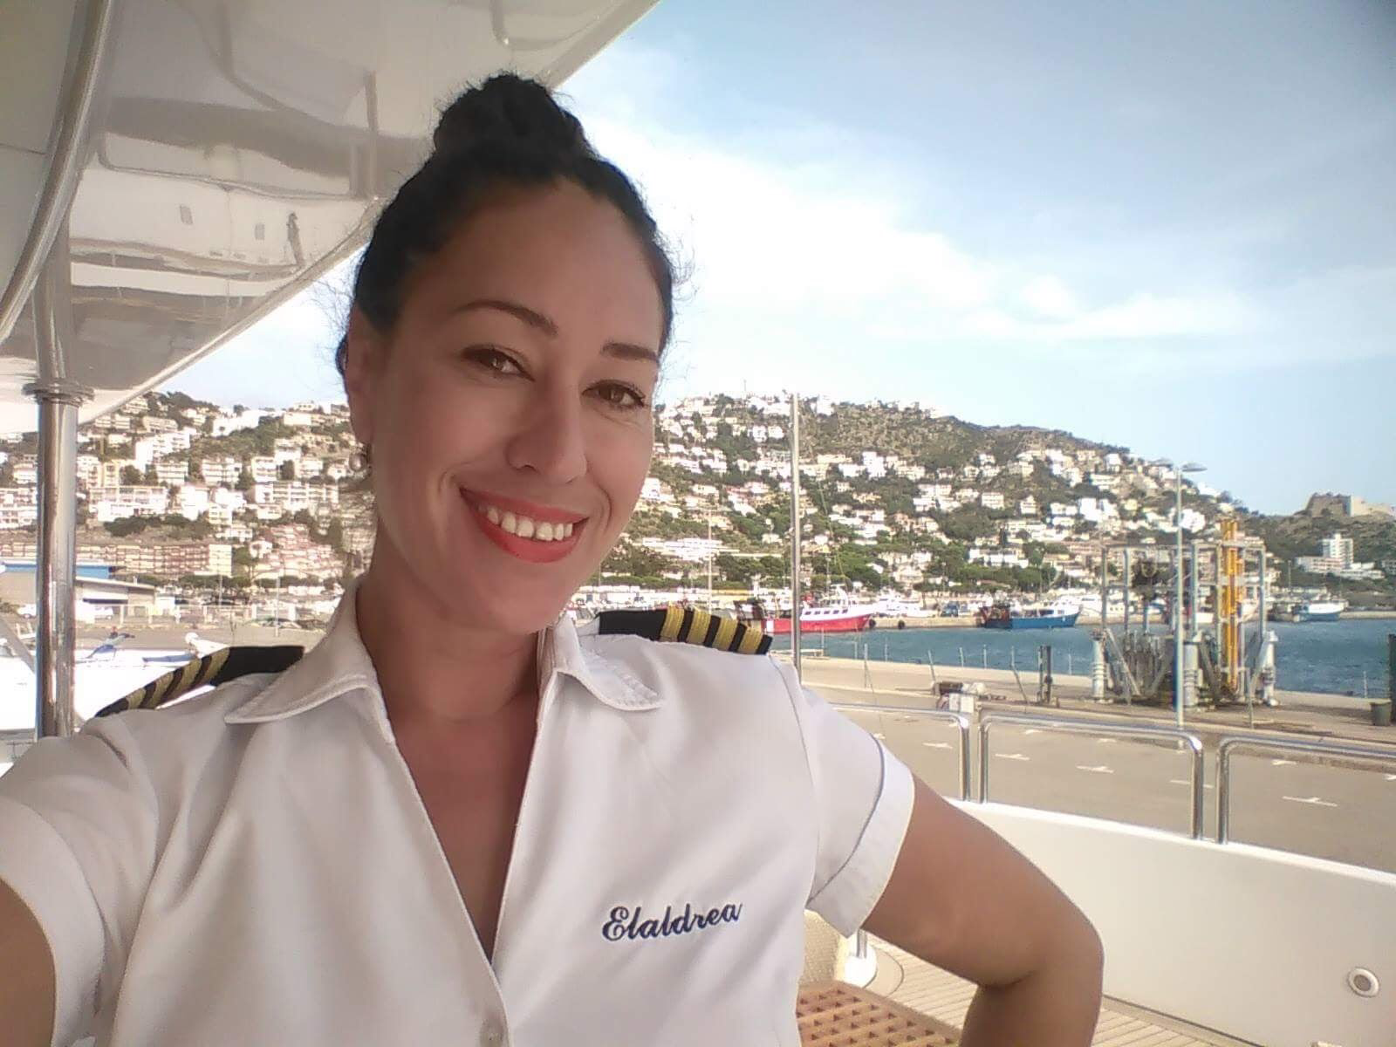
Curriculum Vitae
LEILANI BENNETT
Chief Stewardess
Mobile: (808) 781-7613
Email: bennettstew@gmail.com
STCW ‘95, Silver Service, ENG 1,
US Passport

CAREER OBJECTIVES
Secure a challenging leadership position by applying creative problem solving and fine management skills with a growing company to achieve optimum utilization of it’s resources and maximize profits. My objective is to leverage my experience while continuing to be challenged.
CERTIFICATIONS
- STCW ‘95
- Food Safety Certificate
- Able Seaman Merchant Mariner’s document
- Seaman's Book
- Advanced Fire Fighting Training
- Silver Service Certified
- Bachelors in Communications
- Associates in Hospitality & Hotel Management
- International Yacht Training School
- PADI Open Water Diver
QUALIFICATIONS
- 15 years hospitality in 5-star, 3 diamond Hotel, Spa & Resorts
- Creative with Floral & Dining arrangements
- Sommelier and Fine Cuisine knowledge
- Deck skills, line & fender handling, and Tender driving
- Experienced in boating and ocean activities, surfing, sailing, diving and fishing
- Nanny and Au pair skills.
- Computer Savvy.
Administration and Concierge
- Rotuman, Fijian - fluent. Mandarin Chinese, French Japanese, and Spanish- conversational

MARITIME EXPERIENCE
- April-June 2022
I Love This Boat 150Ft Christensen. Heavy Charter
Freelance Chief Stewardess
Bahamas
- November 2021-April
Pour Another 120ft Benetti
Private/Charter
Relief Chief Stewardess
Florida, Bahamas
- August 2019 – May 2020.
Cinque Mare 90ft Feretti
Heavy Charter
Sole Stewardess
Miami
- February 2018 – June 2019
Island Adventures Charter Fleet
Chief Stewardess / Shipyard period Project Manager
Florida, Bahamas
- Jan. 2017- Dec. 2017.
Elaldrea 115ft Benetti
Private
Chief Stewardess
Mediterranean
- Jan 2016 – Dec. 2016.
Redemption 130ft Westport
Charter Chief Stewardess Mediterranean, Caribbean
- Mar 2014– Sept. 2015.
Arthur’s Way 87ft Oceanfast Private Solo Stewardess
New York, Miami
- Feb-July 2013.
Lady Joy 160ft Christensen
Private 2nd Stewardess
Mediterranean, Caribbean
- Jan. 2011-Dec. 2012.
Belle Aimee 180ft Amels
Private 2nd Stewardess
Panama, British Columbia
- 2001-2005
Norwegian Cruise Lines
- Banquet Waitress, Maitre D’, Concierge (Hawaii)
- J24 Racing Participant (Newport, RI)
- Outrigger Canoe World Sprints Participant (Fiji, New-Zealand, Hawaii)
- National Hobie 16 Race Participant (Fiji)

LAND-BASED EXPERIENCE
1997-2002 Four Seasons Hotel Spa & Resort Waialea, Maui, Hawaii
Bartender, Waitress, Butler, Front Desk
2002-2009 Halekulani Hotel Waikiki, Oahu, Hawaii
Concierge & Guest Services

AFFILIATIONS
PADI
Royal Suva Yacht Club
Royal Honolulu Yacht ClubOutrigger Canoe Club
Fiji Surfing Association Pacific Voyaging
Fiji Hobie Club
Seafarer's Union

EDUCATION
1987 International School, Hsinchu, Taiwan
1991 International Secondary School, Suva, Fiji
1995 Senior College of New-Zealand, Auckland, New-Zealand
2001 Able Seaman’s Merchant Mariners Training School, Hawaii
2007 Heald College (Associates degree Hospitality Industry) Hawaii
2010 International Yacht Training School, Ft. Lauderdale

PERSONAL INTERESTS
- Water-oriented sports, surfing, diving, fishing, outrigger paddling
- Traveling, photography, and learning new cultures and cuisine
All letters of references upon request
PROFESSIONAL REFERENCES
Capt. Rafe Palledino
Email: capt@ladyjoy.com
M/Y Lady Joy
Mobile: (954) 322-4005

Capt. Kim Thomas Email: kimfly1@aol.com
Island Adventures Bahamas Mobile: (630) 327-8071

Peg Garvia Email: peg1122@gmail.com
Yacht Crew Placement Agent Mobile: (954) 536-1680

Olga Polinkas Email: olgapolinkasone@aol.com
Fleet Crew Manager
Mobile: (954) 817-9102

PERSONAL REFERENCES
Johnathan Luszcz
Email: fishbait1186@gmail.com
Chief Engineer
Mobile: (401) 640-1256

Kara Bredenkamp
Email: karab@gmail.com
Chief Stewardess
Mobile: (561) 713-6735

Erin Finlen
Email: erinfinlen@hotmail.com
Maritime Attorney
Mobile: (334) 524-6744

