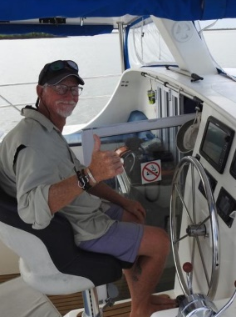 | IAN PRICE  Durban, KZN, South Africa  +27 76 905 6962  thehomehero@yahoo.com  Executive Summary  Seeking employment in the yachting industry or on a Charter boat. My experience as a handy man will be helpful for maintaining the yacht and my knowledge in deep sea fishing to run a charter vessel, my developing sailing skills will also assist together with my completed 100 tone/ 24 M sail and power Coastal Skippers ticket.
Fully vaccinated with booster  ( Pfizer)  Hobbies and Interests  Fishing and yachting  Completed SAS coastal skipper’s ticket 100 tone,  Sail and Power working towards offshore Masters  7 189 nautical miles  On Sail and approximately  33,600 hours spent on ocean over the 30 years fishing  Deep sea fishing for 30+ years catching  Pelagic , Ground fish and some marlin  Motor vessel Skippers ticket surf launch under 9m & 100ton or 24 M vessel , VHF operator’s license | Employment History  May – August 2022  Captain on Kaysal 57 Yacht doing charters in Quelimane to the Premier Banks for a week at a time, this yacht had 2 x 140 Nannie motors and was de-masted to allow for more fishing space. Have also sailed the Knysna 500 SE with full rigging, except no boom and main sail due to been used for fishing charters. The river to the Premier banks is approximately 160 nautical miles for every trip done.  Duties included: Making sure yacht is prepped and well stocked for Charter, checking all safety on board, maintenance, shopping for food and beverages, liasing with chef, collecting of clients at airport and assisting clients whilst fishing. The fishing was more vertical jigging and popping for G&T and other pelagic fish in the area. We would measure the fish and return to the sea.  Was incharge of 2 staff on board, one been the chef and the other the deckhand, did 2869NM  April 2021 – March 2022  Sailed a 34FT Cat up and down the Durban coastline for the owner Dean Obrien, did 700NM.  Sailed a 43FT Ferro Cement mono hull from Durban to Richards Bay a few times for owner Cyril Foley, did 600NM.  Delivered a 32FT Van Der Stand from Durban to Richards Bay with the owner, 100NM.  Sailed a Maxim 380 from Durban to Knysna with the owner Sean Wisedale and his family, did 680NM.  Sailed a 38FT self built Seawind design from Durban to Cape Town which is owned by Dave Deller, did 840NM.  Have assisted Off Shore Sailing Academy on their L34 Tiller doing mileage runs for students from Richards Bay to Durban with owner Werner De Kock, did 200NM.
The Home Hero / Business Owner / February 2019 – March 2021

General home maintenance, carpentry, plumbing, electrical, painting and small building alterations.

Skye Telecoms / Senior Project Manager / August 2009– January 2019

Laying of Fibre Optic Networks for Telkom, Clear line Pty Ltd (DFA – Dark Fibre Africa), safety, bill of quantities and making sure jobs are executed as per specification and time frames.
Planning before it is uploaded on the system by the planner.
Handling any engineering difficulties and resolving same on site.
Dealt with the driller and other aspects of the jobs, making sure drill plans were in place together with the way leaves.

Please contact for further information/references.
Thank you for your time!

