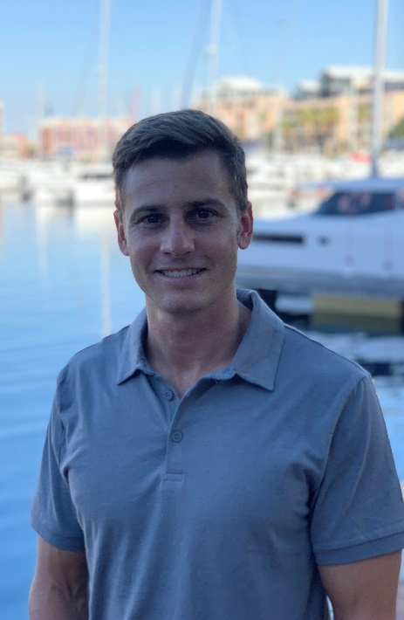
Personal Information
Position: Deckhand
Date of Birth: 21 September 1993 (Age: 29 Years)
Visas: B1/B2 Exp 04 June 2027, Canada V-1 Exp 03 November 2023
Nationality: South Africa
Language: English & Afrikaans
Location: South Africa, Pretoria
Health: Physically Fit, Healthy-Lifestyle, Non-Smoker, No Tattoos, Height - 170cm (5,57ft)
Contact details: 📞+27 827 722 035 WhatsApp
Skype: mbloemhof2@gmail.com @: mbloemhof2@gmail.com

Objective
I am seeking permanent job on a Superyacht as a Professional Deckhand. Confident in my ability to give excellent service. Efficient worker with an eye for neatness and perfection, making sure duties are met.

Qualifications/Permits

- Designated Security Duties
- Elementary First Aid
- Fire Prevention & Fire Fighting
- Personal Safety and Social Responsibility
- Personal Survival Techniques

- Super yacht Deckhand
- Personal Watercraft
- RYA Power Boat Level 2
- International driver’s license
- Padi Open water driver’s license
- USA Social Security Card

Industrial related experience:
Daywork: “Cape Town Yacht Services” @: ctyachtservices@gmail.com 📞: Tel: +27 (0) 72 688 1444

- Stainless polish
- General deck wash
- Race boat preparation
- Charter prep and pack away
- Stock take
- Engine room clean
- New boat hand over clean
- Deckhand for re-fuelling

Work experience:

General understanding of mechanic’s
Engine overhaul’s
Clutch and brake overhaul’s
Full knowledge of motor vehicle’s

Manager skills
High end detailing
Making sure deadlines are met
Client service

