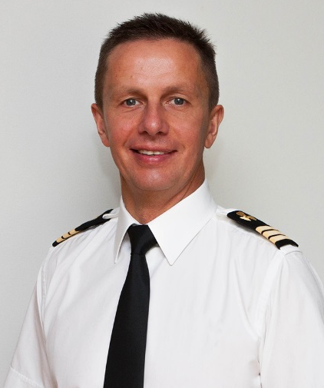
Certifications
RIII/1 EOOW (Unlimited),
Basic Safety Training, Survival Craft,
Advanced Fire Fighting, ENG 1,
Medical First Aid, Security Awareness,
Engine Room Resource Management,
Certificate of Operator/Technician SeaTel TxRx&TVRO Antenna Systems

Personal Status
Nationality: Latvian Resident Age: 58 EU resident passport Exp.2024 Driving License: B Location: Riga, Latvia Health: Fit,Sporty,Active Non Smoker | No Tattoos Marital status: Married Visas: B1/B2 Exp.2027

SERGEJS DULEPOVS
Languages
Russian – fluent, English - fluent

Contact Information:
Mob/WhatsApp +371 26 673673 mail: sergejsdulepovs@gmai.com
Yacht Skills
CATERPILLAR (ME, AE) HEM (Water Maker) Hamann (STP) Leroy Somer (Alternator) AMS Rockson ETB (Soot Burner) Westfalia (Separators) BoschResroth (ME Control) Quantum (Stabilizers) ZF (Gearbox)

Education
Diploma as Welding Technician, Shipyard College, Gorkiy, Russia, 1979-1983
Diploma as Ship Electrical Engineer, Engineering Academy, 1987-1992
Diploma as Ship’s Engineer, Liepajs Marine College, Latvia, 2013-2017

Yacht Experience
2nd Engineer/ETO
M/Y Kaiser | 60m | Private
Europe / Med
December 2012 – December 2022
- Performed Engine Room duties
- Responsible for all machinery, electrical and electronic equipment, including laundry.
- VSAT TxRx&TVRO system, AV/IT

ETO/Engineer
M/Y Vive La Vie | 60m | Private
World Wide
January 2010 – December 2012
- Performed Engine Room duties
- Responsible for all machinery, electrical and electronic equipment, including laundry.
- VSAT TxRx&TVRO system, AV/IT

Hobbies & Interests
Reading | IT technology| Sports |

VSat SeaTel TxRx&TVRO Crestron AppleTV, AirPlay Microsoft Server 2016 VMWare, Kerio IP TV, IP Phone System Panasonic PBX EIB KNX CCTV Media Server CISCO

Objective
Seeking Engineering position aboard private or charter motor/sailing yacht, furthering my skill and experience in a strong team. I am strongly individual, fast learner and very hardworking person with super positive attitude and keen eye for detail. My previous yachting and commercial experience have given me strong multitasking and organizational skills that makes my job done quickly and efficiently.

Other Experience

ETO
Tanker Pacific, Singapore
December 2002 – December 2009
Working on board VLCC vessels, operating on 440Volt ac, total plant circa 6000kVA ETO Irving Oil, Canada May-2002 – December 2002 Working on board VLCC vessels, operating on 440Volt ac, total plant circa 6000kVA ETO Universal Seaway, Germany October 1998 – May 2002 Working on board L.P.G. vessels, operating on 440Volt ac, total plant circa 4000kVA ETO SKIBSAKSJESELSKAPET SOLVANG, Norway October 1996 – October 1998
Working on board L.P.G. vessels, operating on 380Vac, total power of plant circa 3000kVa
ETO
Bergesen ASA, Norway May 1996 – October 1996
Working on board L.P.G. vessels, operating on 380Vac, total power of plant circa 3000kVa
Electrician
Latvian Shipping Company August 1986 – October 1996
This company operated a mixed fleet of Oil Tankers, Product Arctic Tankers, General Cargo, Container & Ro-Ro Vessels. Experienced service on all types of vessels, operating on 380/440Vac, total power of plant circa 2800kVa
Shipyards experience:
2020-21 Refit (M/Y “Kaiser”, 5 months) 2019-20 Refit (M/Y “Kaiser”, 3 months) 2018-19 Refit (M/Y “Kaiser”, 2 months) 2017-18 Refit (M/Y “Kaiser”, 3 months) 2015-16 Refit (M/Y “Kaiser”, 4 months) 2013 Overhaul (M/Y “Kaiser”, 3 months) 2011 Overhaul (M/Y “Vive la Vie”, 2months) 2005 Overhaul (VLCC “COURTENAY BAY”, 5 weeks) 2002 Overhaul (VLCC “IRVING PRIMROSE”, 4 weeks) 2002 Refit (LPG/C “IGLOO STAR”, 2.5 months) 2000 Overhaul (LPG/C “IGLOO MOON”, 5 weeks) 1996 Refit (LPG/C “CLIPPER SEA”, 3months)

References
Lovre Sasso Semjon Kuryshev
Chief Engineer | M/Y Clio Chief Engineer | M/Y Kaiser
lovresasso@hotmail.com ksemjon@gmail.com
+385911511870 +37256844445

