APLICATION FORM
 | 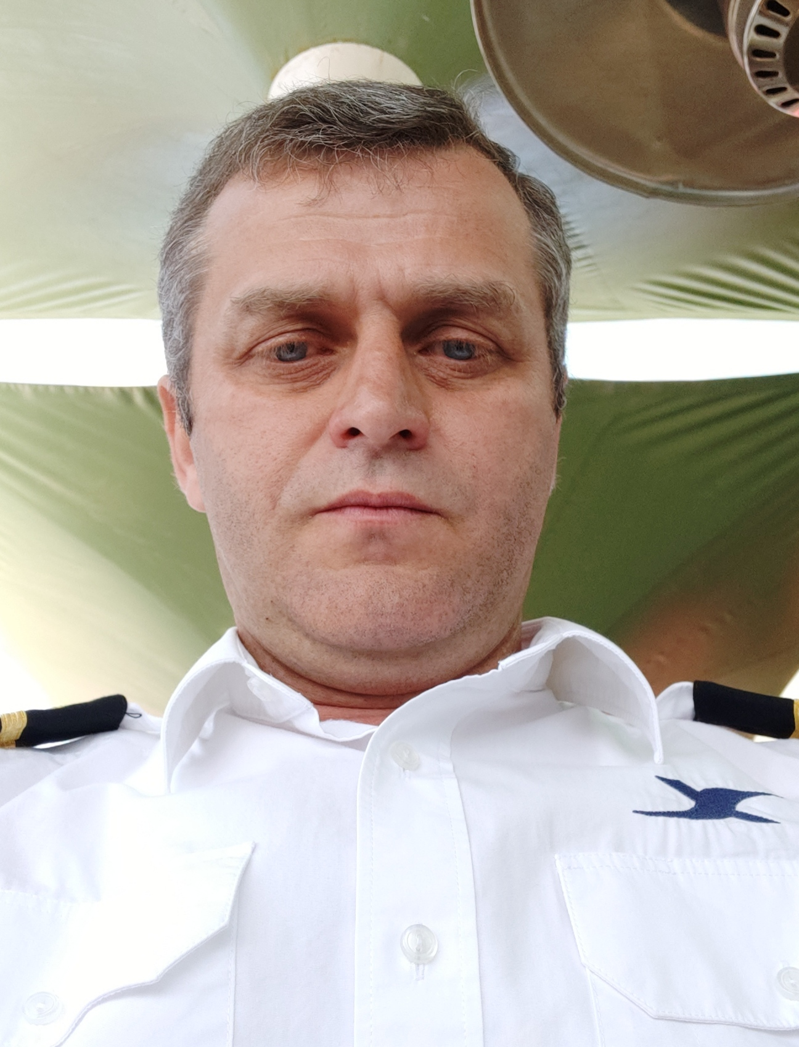
  Position: | 2ND ENGINEER | Citizenship: | AZERBAIJAN
  Last name: | KOZIKOV | Marital status | MARRIED
  First name: | ALEKSANDR | Children: | 2 HAVE CHILDREN
  Middle name: | YEVGENYEVICH | Nationality: | AZERBAIJAN
  Birth date: | 26.01.1980 | Birth place: | AZERBAIJAN,BAKU
  Home address: | AZERBAIJAN,BAKU | Phone mobile: | +994 50 343 23 04  What’s App
  Home address: | AZERBAIJAN,BAKU | E-mail: | kozikov.a.e@gmail.com

Passports& Seaman’s Book
Title | Number |  | Place of issue |  |  | Issued |  | Valid
PASSPORT | AZE C01811308 |  | Baku, Aze |  |  | 11.05.2018 |  | 10.05.2028
SEAMAN’S BOOK | DQK 005941 |  | Baku, Aze |  |  | 07.11.2019 |  | 07.11.2024
SEAFARERS ID DOCUMENT | AZE 020294 |  | Baku, Aze |  |  | 07.11.2019 |  | 07.11.2024
Certificates
Title |  | Number |  | Place of issue | Issued |  | Valid
CERTIFICATE OF COMPETENCY AND ENDORSEMENT  SECOND ENGINEER OFFICER 3000 KW OR MORE |  | ID № 0004653  000775/19 |  | Baku, Aze | 07.11.2019 |  | 06.11.2024
- Has successfully completed following safety familiarization basic training and instruction for all seafarers courses which has been developed in accordance with the mandatory minimum requirements of Regulation VI/I of the international Convention STCW- 78. As amended and of the Section A-VI/I 0f STCW Code and on programmer approved by the State Maritime Administration:  -safety familiarization training  (STCW-78, A-VI/I pa.1)  -personal survival techniques  (STCW-78, A-VI/1 pa.2.1.1)  -fire prevention and fire fighting  (STCW-78, A-VI/1 pa.2.1.2)  -elementary first aid  (STCW-78, A-VI/1 pa.2.1.3)  -personal safety and social responsibilities  (STCW-78,A-VI/I pa.2.1.4) |  | № SO-2630-19 |  | Baku, Aze | 27.10.2019 |  | 27.10.2024
- Proficiency in Survival Craft and Boats Other Than Fast Rescue Boats  (STCW Code, A-VI-2, Pa.1, Pa.2, Pa.3 and Pa.4 ) |  | № SL-1310-19 |  | Baku, Aze | 24.10.2019 |  | 24.10.2024
-Training For Seafarers With Designated Security Duties  (STCW Code , A-VI/6, Pa.6 to Pa.8 ) |  | № SH-1366-19 |  | Baku, Aze | 24.10.2019 |  | 24.10.2024
- Medical First Aid  (STCW Code A-VI/4,Pa.1,Pa.2 and Pa3:) |  | № SN-0738-19 |  | Baku, Aze | 31.10.2019 |  | 31.10.2024
- Engine Resource Management |  | № ER-0204-19 |  | Baku, Aze | 31.10.2019 |  | 31.10.2024
- Training in Advanced Fire-Fighting  (STCW Code A-VI/3,Pa.1,Pa2,Pa.3and Pa.4) |  | № SJ-0927-19 |  | Baku, Aze | 25.10.2019 |  | 25.10.2024
- Leadership and Teamwork. |  | № DL-0318-19 |  | Baku, Aze | 29.10.2019 |  | 29.10.2024
- Updating |  | № XS-0211-19 |  | Baku, Aze | 06.11.2019 |  | 06.11.2024

Medical Information
Tide | Number | Place of issue | Issued | Valid
-Extraction From Seafarers Medical Certificate | ----------------- | Baku, Aze | 24.08.2022 | 24.08.2024
-COVID -19 SINOVAK Vaccination  3-Dose |  | Baku, Aze | 06.12.2021

Knowledge of other Languages
1.Azerbaijan | 2.Turkish | 3.English | 4. Russian
Good | Good | Middle | Good

Biometrics
Sex : Male | Height : 171 sm | Overall size : M
Eyes color : Blue | Weight : 70 kg | Shoe size : 40

Next of Kin
Next of kin : | Son | Kin phone : | +994 50 333 48 25 What’s app
Kin name, surname : | Kozikov Anar | Kin address : | Azerbaijan, Baku

Name of Vessels

Name of vessel | Flag | Vessel’s Type | DWT | Rank | From d/m/y | To  d/m/y
ISRAFIL HUSEYNOV | AZERBAIJAN | CRANE VESSEL | 7211 t | Oiler-Electric | 05.05.2000 | 01.09.2008
AYDIN MAMEDOV | AZERBAIJAN | CRANE SHIP | 380 t | 3 rd Eng | 15.09.2008 | 15.12.2008
ISLAM.KERIMOV | AZERBAIJAN | CRANE SHIP | 457 t | 3 rd Eng | 15.01.2009 | 15.09.2009
AZERBAIJAN | AZERBAIJAN | CRANE SHIP | 5923 t | 2 nd Eng | 15.10.2009 | 01.11.2010
ARAZ | AZERBAIJAN | CREW BOAT | 93 t | 2 nd Eng | 01.12.2010 | 24.08.2011
SEDATION | AZERBAIJAN | YACHT | 225 t | Chief Eng | 25.08.2011 | 25.12.2022

