Joseph M. Bittman
Joseph.M.Bittman@gmail.com
Telephone: (772) 408-7879
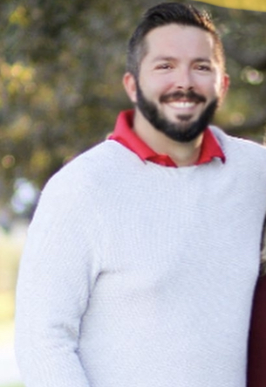
Objective:
I am as hard working as they come and my love of the water runs very deep. The objective of this resume is to inform potential employers of my extensive seamanship background, and that I am a very driven individual. The people closest to me would describe me as a perfectionist and someone that would stop at nothing to achieve my goals.

Experience:
-Boat Captain/Property Manager
45’ Grady white and 23’ Grady white Center console
Based out of Palm Beach, FL January 2022- October2022

-Captain M/Y Safe Passage 64’ Grand Banks
Based out of Stuart, FL March 2020-December 2021

-Captain M/Y Pardi Princess 70’ Neptune
Based out of Jupiter, Florida January 2019-March 2020

-First Mate M/Y Season’s of the Sun 112’ Ocean Alexander
Based out of Sailfish Point, FL January 2019

-First Mate M/Y My Girl 110’ Westport
Based out of Jupiter, FL March 2015-2019
Served Under Captain John Dunlap

Siebert Yacht Management
Yacht Detail Manager
October 2014-September 2015
-Detail Manager, In charge of invoices,detailing boats, and Managing other detailers

-Captain: M/Y Bye Luv Ya Sea Ya, 85’ Marlow
Based out of Stuart, FL September 2013
Owner: Rex Ranking III

-First mate M/Y Acquaviva, 82’ Monte Fino
Based out of Stuart FL, February 2012- March 2014
Served under Capt Rick Robson
Owner Dr. Paul Elliott/ Suzann Elliott

-First Mate M/Y Tivoli, 92’ Doggersbank
Based out of Antigua, September 2011- January 2012
Owner Operator: John Speilenhower II
Special Training:
-Petty Officer 2nd Class United States Coast Guard
Based out of New Orleans LA,
August 2007-May 2010
Served under: Petty Officer 1st Class Whitener

Licensing/ Certificates:
Chapmans School of Seamanship
USCG Master 100 ton
Yacht master, Offshore
USCG Coxswain School
Coast Guard Coxswain Certificate
USCG Rescue Diver School
Rescue diver

