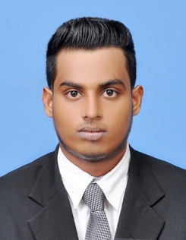
CURRICULAM VIATE
Tharaka Dinuwan Imbulana
+94712977420 / +94768145480
imbulana1998@gmail.com
Personnel Information

- Name :-Imbulange Don Kuruwita Arachchige Tharaka Dinuwan Imbulana
- N.I.C :- 980500055v
- Passport No :- N667191
- Address :- No.229,Jambugahawatta ,Delduwa ,Wadduwa
- Gender :- Male
- Civil Status :- Married
- Religion :- Buddhist
- Date of Birth :- 19/02/1988
- Age :- 22 Years
- Nationality :- Sri Lanka
- School Attended :- WP/K.ST John’s College , Kalutara
educational qualification

- Passed G.C.E. Ordinary Level (Sinhala Medium) 2014
Subject | Grade | Subject | Grade
Buddhist | B | English | S
Sinhala | S | 1st sub Gr. | S
Science | S | 2nd sub Gr. | S
Maths | S | 3rd sub Gr. | B

other qualification

- I will training 6 month in international Cookery of Asian Lanka Vocational and Tanning Center
- I have Driving License for the post four years (B3280497)

other qualification
- I have been six month experience who was working as a cook in South Lanka Resort in Koggala. since 15/08/2016 up to 10/02/2017
- I am working 3rd commies chef in sun hill hotel in mount Lavonia .since 15/02/2018
- Now i am doing a temporary van hire for a Garment Factory the past two years.

sports and activities

- I was an active member of school football Team -2011
- Indo-Sri Lanka international Football Champianship-2011
- International Yogasana seminar and training Program-2012

I do here by certify that the above particulars are true and accurate to the best of my knowledge.

……………………..... ………………………
Date Signature

