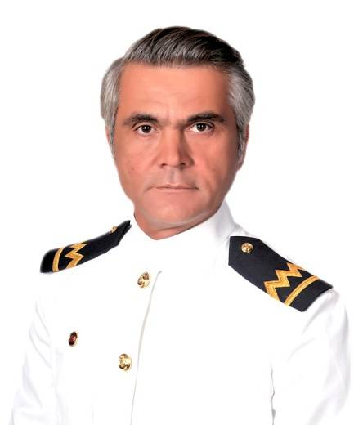
Nationality: Turkish
Visas: Italian Schengen Date of Expiry 12th Aug 2018
D.O.B.: 05.May.1973
Email: husmen_captain@hotmail.com
Phone: +90 5315922901
Languages: English, Turkish
Whatsapp : +90 5315922901
Marital Status: Single
Health: Good, non-smoker, current ENG1 medical cert.
Current Location: Istanbul, Turkey
Availability: from March 1.2022

Objective:
I am an enthusiastic, reliable and friendly individual who works hard to achieve his goals. I have good communication skills and the ability to speak other languages. I am also a fast learner who is always seeking opportunities to expand my skills and experience. I work well in teams as well as individually. I can work as Captain, 2nd Officer, 3rd Officer, Radio Officer and Ship Security Officer.

Main Qualifications
Master on Ships less than 500 Gt on Near Coastal Voyage Restricted Master 17.09.2025
Ship Security Officer (2013-43-53564) 17.09.2025
Electronic Chart Display and Information System (ECDIS) Training 2013/N/A
Bridge Resource Management (BRM) Training 2013-N/A
GMDSS (GOC) 23.09.2025
Medical Examination for Seafarers Certificate 11.03.2024
Passport/no.U26366384. 29.APR.2032

Maritime / Professional Yachting Experience:
Captain M/Y ALARA Azimut Ultra 78
08.09.2021 01.02.2022

Captain M/T ORBAY
09.11.2019 01.08.2021
Marmara Sea
Water Berge 25 mt 148.66 grt
Owning Company : Melisa Denizcilik

Captain M/Y CALLIOPLE from 6th August 2018 to 10th August 2018
Marmara sea,Aegeansea,Mediterranean sea
Private Motor Yacht 33 m, 300 grt
From Turkey/Istanbul To Italy/Scillia only delivery

Captain M/T ORBAY January 2016-November 2017

Marmara sea
Water Barge 25m 148,66 grt
Owning company: Melisa Denizcilik

Captain D.S.V KALYONCU 1 May 2013 – July 2015
Black Sea and Marmara Sea.
Diving Support Vessel 25m, 92.16gt
Owning company: Dalgiclik Denizcilik ve Sualti Hizmetleri Tic.Ltd.Şti

Captain S/Y La Capria May 2012 – Sept 2013
Mediterranean Sea and Aegean Sea.
Commercial Sailboat 21.8m 72gt
Owning company: ARX DESIGN GROUP, LA CAPRIA SUITE HOTEL

3rd Captain M/V BUĞRA TOMBA Dry Cargo Aug 2010 –Nov 2011
Also Radio Officer and Ship Security Officer.
Atlantic Ocean and Mediterranean Sea.
DRY Cargo 90m 2701gt

Captain D.S.V RAMANLI Feb 2009 –July 2010
Aegean Sea, Marmara Sea and Mediterranean Sea.
Diving Support Vessel 15.3m, 24.95gt
Owning company: İstanbul Dalgiclik Denizcilik ve Sualtı Hizmetleri Tic.Ltd.Şti

Captain Passenger Ship Balikli 1 May 2008 –Jan 2009
Marmara Sea.
Passenger Ship 25m 96gt

Captain M/Y Slovol June 2004 –Mar 2008
Marmara Sea and Aegean Sea.
Private Motor Yacht 25m 80gt

Radio Officer Zeki Güçlü Shipping Jan 2003 – Mar 2004
Mediterranean Sea, Marmara Sea, Aegean Sea.
Dry Cargo 65m 999gt

Further Certification:
Designated Security Duties Certificate 2013-N/A
Security-Related Familiarization Certificate 2013 – N/A
Security Awareness Certificate 2013-N/A
Proficiency in Survival Craft and Rescue Boats (Other Than fast Rescue Boats) Certificate 17.09.2025
Navigational Watch Keeping Certificate 2013-N/A
Radar Observation and Plotting Training Certificate 2013-N/A
The Operational Use of Automatic Radar Plotting Aids (ARPA) Training Certificate 2013-N/A
First Aid Training Certificate 2013-N/A
Medical Care Training Certificate 2013-N/A
Advanced Fire Fighting Training Certificate 17.09.2025
Oil Tanker Familiarization Certificate 17.09.2025
Specialized (Advanced) Training Program on Oil Tanker Operations Certificate 17.09.2025
Chemical Tanker Familiarization Certification 17.09.2025
Specialized (Advanced) Training Program on Chemical Tanker Operations Certificate 17.09.2025
Proficiency in Fast Rescue Boats Certificate 02.02.2023
Liquefied gas Tanker Familiarization certificate 17.09.2025
Personal Survival Techniques Training Certificate 17.09.2025
Elementary First Aid Training Certificate 17.09.2025
Fire Prevention and Fire Fighting Training Certificate 17.09.2025
Personal Safety and Social Responsibility Training Certificate 17.09.2025

Interests:
Salsa dancing, swimming, travelling and cinema.
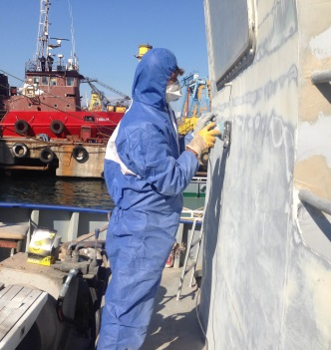
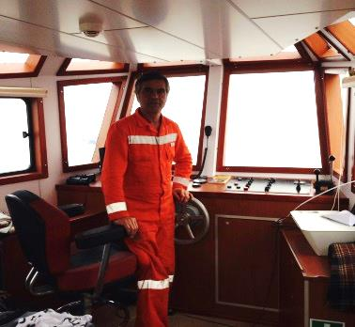

Referees:
Mr. Demir Kunter M/Y ALARA phone : +90 5527770777

Mr. Toni Haapala Master Email: toni.haapala@live.com
what's app is: +46 70 423 2993

Mr. Omer Uzun General Manager,Melisa Shipping
Phone : +90 5415723131 Email: info@melisadenizcilik.com.tr

Mr. Bülent Ermurat, General Manager, Istanbul Diving and Maritime Corporation
Phone: +90 5322447555 Email: info@istanbuldalgıclik.com

Mr. Игорь Марков Owner Phone:0031623013904

Mr. Mete Nisari, Owner, Arxdesing Company M/S La Capria
Phone : +90 232463 51 97 Email: info@arx-design.com

Mr. Çağatay Ayvalı, Unlimited Master, Sanmar Shipyards
Phone: +90 5302378667 Email: cayvali@yahoo.com

Mr.Hilmi Hece, GMDSS Instructor, Pirireis Maritime School
Phone: +90 5367118718 Email: hilmiece@gmail.com

Mr.Ali İhsan Çelik, GMDSS and ARPA RADAR Instructor, Ekol Maritime School
Phone: +90 5357394916 Email: aliihsan54@hotmail.com

