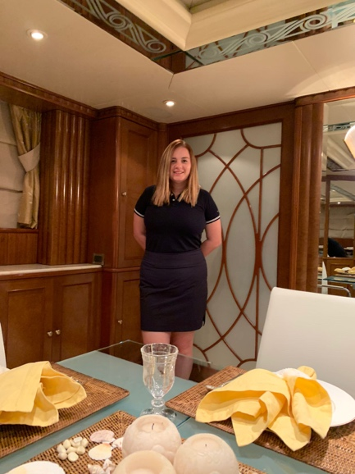

YVETTE JÍLKOVÁ
STEWARDESS

PERSONAL INFO

DOB: March 30, 1993
Nationality: Czech/EU Passport
Visa: B1/B2 (Jan 2029)
C1/D (Jan 2024)
Location: Greece
Driving license: International

English Language: Fluent
Russian Language: Basic

CONTACT INFO

) +420 722 049 050 (WhatsApp)

* yvett.jilkova@gmail.com

CERTIFICATES

- STCW ‘10
- Seafarers Medical Certificate (ENG1)
- Food Safety & Hygiene level 2
- Security Awareness (PSA) and PDSD
- Crowd & Crisis Management
- PWB level 2
- Online Superyacht Stewardess101 Course by
Chief Stew Georgia Rex

PROFILE

I am active, honest & smile crew and looking for new challenging stewardess role, preferably on charter boat. I bring a very positive attitude to my work, attention to detail, hard work and flexible approach to all that I do. I am happy to work in a team and understanding the balance of individual responsibilities. I’d like to show that I can become a great asset to your team with my real passion of providing highest and unforgettable standard of guest service and developing crew environment.

PROFESSIONAL SKILLS
- Boat Detailing  - Housekeeping  - Laundry Procedures  - Time Management  - Events Catering  - Fender Maneuvering  - Watch keeping | - Silver Service  - Fine Dinning  - Food & Drink Service  - Barista & Tea Service  - Basic Cocktails  - Cooking Skills  - Table Settings
YACHT & VESSEL EXPERIENCE
STEWARDESS – M/Y MERCURY 50M – CHARTER Jun 2022 – Sep 2022 | Med – Seasonal position
Commercial yacht with busy charter season where I work in a team of 4 on rotation position in an interior with mainly focus in housekeeping and laundry.
- Ensure all aspect of the interior are in the highest standard at all time
- Laundry & Flower Care
- Food & Drinks service, table settings
- Provisioning for crew
2nd STEW/COOK – M/Y BLUE NIGHT 50M - PRIVATE Feb 2021 – Oct 2021 | Greece – Seasonal position
I worked in a team of 3 during the season on rotational position between housekeeping, laundry and service.
During the winter season or when the boat was not in use by the owner, I worked with a team of 2 to keep the boat clean and tidy all the time and cook lunch and dinner for crew.
- Ensure all aspects of the interior are maintained, including guests cabins & area, crew area, galley, bridge and Captain quarters
- Crew mess organizing and cleaning
- Provisioning within budget - crew food, hygiene supplies and cleaning products
- Cooking for crew of 6 -8 on daily basis
- Shipyard experience
- Helping on deck with wash down & maneuvering
PERSONAL QUALITIES

- Responsible
- Strong Work Ethic
- Organized

- Self-Motivated
- Sense of Humor
- Easy Going

- Eye for Details
- Loyalty
- Self-Discipline

REFERENCES

- Captain Michael Polatch
M/Y Mercury, 50M
Captain.mercury@expersea.com

- Captain Nigel Bigwood
M/Y Blue Night, 50M
njbigwood@gmail.com
+33 788 136 941

- Captain Kostas Chaviaras
M/Y Babousha, 37M
kchaviaras@gmail.com

- Chief Stew Hollie Noades
M/Y Bash, 56M
+44 7377 413 723

- Consensio - Chalet La Roche & Lotse
info@consesniopartners.co.uk
+44 2078 310 254

HOBBIES & INTEREST

- Active lifestyle
- Summer & Winter Activities
- Yoga & Exercise
- Adventures
- Exploring
- Self-Educating
- Reading

2nd STEWARDESS - M/Y BABOUSHA 37M - PRIVATE Sep 2020 – Oct 2020 | Greece – Seasonal position
I worked with a team of 2, assisting to the Chief Stew on rotational position between cabins, laundry and service.
- Ensure all aspects of the interior are cleaned and maintained including galley, crew area, Captain quarters, guest cabins & area
- Watch keeping duties
- Prepared the yacht for winter season
STEWARDESS - M/Y BASH 56M BENETTI - CHARTER Aug 2020 | Athens, Greece – Temporary Day work
I was hired as a temp day worker during their busy season.
- Detailing of the boat and all guest ́s cabins
- Crew mess cleaning and organizing
- Laundry duties
SERVICE STEW - M/V SILHOUTTE 315M CELEBRITY CRUISE LINE
Jan 2019 - Apr 2020 |Miami, USA
I worked in Dining Room and provided service up to 20 guests in a team of 2 at the same time and later I’ve got promoted as a Service Stew in a Specialty Restaurant on board – Italian cuisine.
- Responsible for all front of house responsibilities including greetings guest, setting table, food & drinks service and after cleaning & sanitizing assigned workstation (USPH)
- Regular safe training and drills
SHORE BASED EXPERIENCE
SENIOR HOST – VIP SKI CHALET LA ROCHE & LOTSE Nov 2021 – April 2022 | Val D’Isère, France – Seasonal position
I work closely with a chalet manager to run the properties smoothly in highest standard of service up to 14 guests.
- Providing exceptional Food & Beverage service including table setting, coffee & tea, cocktails and wine
- Leading junior staff in HK and service
- Responsible for all housekeeping duties
- Making guest reservation (activities & restaurant), Driving
FREELANCE SERVICE STAFF - CITY CENTRE-HOSPITALITY Jan 2017 - Dec 2018 | Bournemouth, UK
I was performed in a multi hospitality positions as a bartender/barista, waitress and housekeeper in all star hotels, restaurants and events. I was responsible for all above duties.

