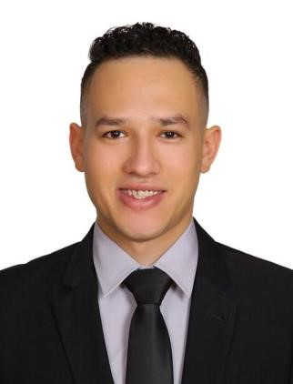
Ibrahim Alaa Hassan C.V.

IBRAHIM ALAA HASSAN
Personal Data:
- Full Name : Ibrahim Alaa Hassan.
- Date of Birth : Jan 31st , 1995 o Nationality : Egyptian o Marital Status : Single.
- UAE Driving License: Valid until 2026 o Contact No. : (Mob: +20128984471)

o E-Mail : hassanibrahim432@yahoo.com

Objective:

To obtain a position that will enable me to use my skills and experiences and educational background, and ability to work well with people.

Academic Qualification:
- License of Law.
- Mansura University.
- Year of Graduation : 2016 ◻ General Grade: Good

Languages:
- Arabic: Native Language.
- English: Good in written and spoken English.

Computer Skills& Courses:
- English Beginners & Advanced Courses 2017.

SCOPE OF WORK RECORD EXPERIENCE:
• July 2011 till March 2016:

Working for Fuego Sushi, Cairo Egypt.
Sushi Chef
- Prepared and presented all food items, hot and cold as per sushi outlet standards and norms. - Contributed largely in entire program focusing on sanitation and hygiene.
• April 2016 till 2018:

Working for Mori Sushi, Dubai Downtown, UAE. Sushi Chef
• May 2018 till 2020:
Working for Canvas Hotel , UAE Head Sushi Chef

August 2020 till April 2021:

Working for Play Restaurant H hotel, UAE Sushi Sou Chef
May 2021 till present

Working for Shima Japanese cuisine, Egypt Head Chef

- Prepared and presented all food items, hot and cold as per sushi outlet standards and norms.
- Provided training and guidance to staff members regarding sushi culinary cooking procedures and plating.
Communication.
My time working on a variety of different jobs has taught me the importance of explaining ideas simply and not to be ambiguous in what I'm trying to communicate.

