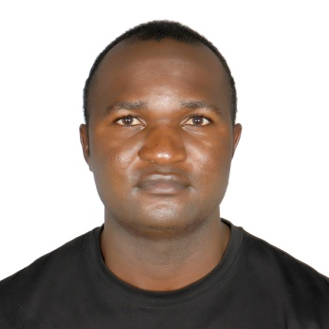
SHEY PROSPER
MANCHESTER TOWER DUBAI MARINA.| +971554912237 | sheyandy10@gmail.com
Personal Details
Nationality: Cameroonian
Date of Birth: 1st April 1987
Language: English and French
Smoking: Non-Smoker
Tattoos: No visible Tattoos

Professional Summary
I am a great problem solver and energetic personality with a professional attitude at all times by offering my experience working on board. Also proud of what I believe in and stand up for my values as I attain the highest standards in discharging my duties.
Certificates
- IYT Powerboat Certificate Level 2./DMCA
- . RYA Powerboat advanced certificate 24M, JLS UAE
- RYA Powerboat intermediate certificate 24M, JLS UAE.
- VHF/SRC Radio course.
- STCW FROM GTSC (Abu Dhabi).
- Seaman Book (yes)
- Engine 1 Fitness Certificate (yes)
- Proficiency Certificate in Management.
- SIRA certificate (Security industry regulatory Agency) Dubai.
- Medical fitness certificate-MED2.
- SAFER (fire fighting and safety protection).
- Computer CERTICATE MICRO SOFT AND XCEL.
Work History EVENT SUPERVISOR/DECKHAND Oct 2019(Xclusive Yachts Charter) Dubai U.A.E
- Assist in boarding and disembarking of passengers.
- Work as a supervisor on events planning, setup, and supervise all the activities on board.
- Managing 12 crew in 125ft, making sure all the clients get good service.
- 5 STAR deckhand and VIP deckhand xclusive yachts.
- Assisting in customer service.
- Planning event aspects, such as venue, seating, dining, and guest list.
- Immerse ability to understand and carry out oral and written instructions.
- Able to understand and use electronic equipment’s of the yachts such as Ray marine and Garmin.
- Cleaning the interior and exterior of the yacht.
- Answering question about the company’s product or services
BOAT CAPTAIN AT XCLUSIVE YACHTS/PRESENT LY WORKING ON THIS ROLE
- Dock and undock the boat, sometimes navigating through tight spaces.
- Plan roots based on weather conditions to keep the BOAT and passengers safe.
- Maintain the boat inspection log book period and after each trip to ensure efficient and safe operation of the boat.
- Direct supervisor for crew.
- The captain is responsible for every aspect of the voyage and vessel.
- They set course and speed, direct crew members
- Ensure that proper procedures are followed
- keeping logs and records of the boats movements at sea
- Supervising the loading and unloading of cargo and passengers.

Education:
High school Cameroon, Yaoundé
Oxford comprehensive high school
West African Examination Council
Center region in Yaoundé
First School Leaving Certificate

SKILLS:
- Time Management
- Boat Navigation
- Communication
- Costumer service
- Guest relations
- Setting of budgets and budget management.
- Make a good standard of the crew and maintenance, repairs on board.

HOBBIES:
- Skating
- Reading
- Movies
- Swimming

REFERENCE
CAPTAIN JAMES
Email: jamesalvior1980@gmai.com
Tell :+971568798076

