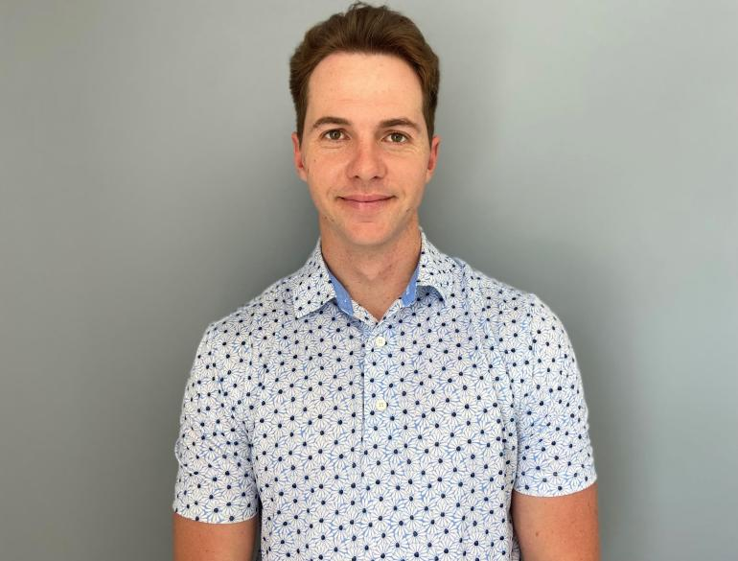
JADE BUITENDAG
DECKHAND

DECKHAND

INSIGHT
I have been a professional golfer for the last 13 years who is dedicate and disciplined to my responsibilities.I have good social skills and very easy to get on with. I really enjoy being outside and working with hands. I am driven by goals and learning new skills. Loyalty and trust is very important to me. I see myself as a valuable member of my future crew and look forward to my new journey in the yachting industry.

OBJECTIVE
I am seeking a permanent position as a deckhand on board a private or charter M/Y or S/Y. I have recently obtained my Maritime Qualifications and I am looking to build a long-term career in the fascinating industry of yachting. I have experience in professional sport and the service industry. I am excited to utilize the knowledge and skills that I have gained, in my new career.

LAND-BASED EXPERIENCE
- Kei Mouth Hardware Store (2022-2023)
Counter sales
Customer service
Product service
Stock collection

- Professional Golfer (2014-2022)
Represent South Africa (2014-2016)
International Golf Tour (2016-2017)
Sunshine Tour (2017-2019)
Big Easy Tour (2019-2022)

- Q8 bar (2014-2015)
Bar tender
Cash ups

PERSONAL PROFILE
Contact: (+27) 790232823
Email: jadebuitendag@gmail.com
Date of Birth: 28 December 1994
Nationality: South Africa
Languages: English
Marital Status: Single
Health: Excellent/ Non smoker
Tattoos: None
Vaccinated: Yes
ENG 1 Medical: Yes (Valid: 2024)
Driver’s License: Yes
Current Location: South Africa
Availability: Immediately

LICENSES/ CERTIFICATES
- STCW Basic + PDSD
(Valid: 2027)
- RYA Powerboat Level II
- RYA Diesel Engine
- RYA Radar
- RYA VHF Radio
- RYA PWC
- RYA Tender Operations
- SAMSA Seaman’s Book: Application in process
- Matric certificate with Bachelor’s degree eligibility

Page 1 of 2

OUTDOOR ACHIVEMENTS
- Completed half marathon 2013
- First place at Kenako World Junior Golf Championship 2013
- Participated in the Polish World Junior Championship 2014
- Represented South African Golf zone 6 2015 in Uganda
- Represent South African Golf in international test matches against Scotland, England, Australia, in Scotland 2015
- Represented South Africa in all Africa Teams Championship in Kenya 2016
- Competed I the South African Open
- Sunshine Tour Card 2017
- Sunshine tour Card 2018
- Big Easy Tour Card 2019
- Big Easy Tour Card 2020-2022
- Travelled to 20 + Countries

Instagram JadeBuitendag
Facebook Jade Buitendag

SKILLS
- Golfing Industry for 13 years
- Golf Swing technical analysis and teaching
- Professional Golf caddy
- Knowledge on Physical training and dietary needs
- Tender driving and watercraft operations
- Motivator
- Drama free
- Problem solving and Adaptation
- Time management
- Solo and International travel

HOBBIES & INTERESTS
Travelling in Nature, Family, Hanging out with friends, Golf, Teaching golf, Hiking, Meditating, Physical training, Fishing, Snorkelling, Music, Camping, River Rafting, Snooker, Running

REFERENCES
International Golf Tour
(+27) 78300440
admin@igtgolf.com
Sunshine Tour
(+27) 218506500
info@sunshinetour.com
Rosann Buitendag | Kei Mouth Hardwear store
(+27) 438411344
Rosann@eci.co.za

Page 2 of 2

