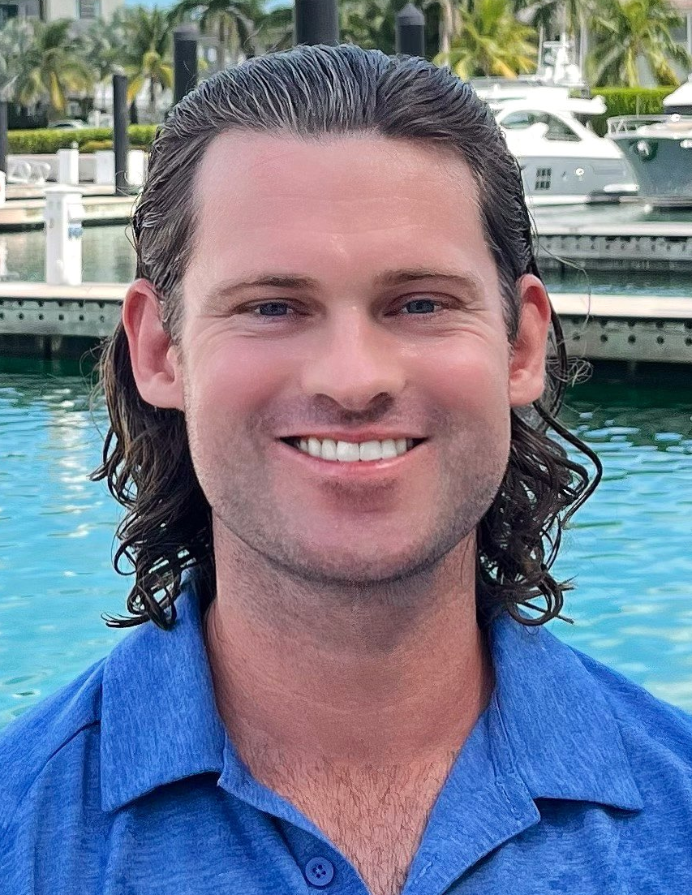



M/Y INEVITABLE | 35M
MATE/DECKHAND | FORT LAUDERDALE/MIAMI
Sep 2022 - Nov 2022
- Assisted the crew of the 35M, Montego Bay registered, privately owned and operated motor yacht named “Inevitable”, as a Dayworker/Deckhand during a major refit in Fort Lauderdale.
- Tasks included painting, sanding, teak repair, installing deck hardware, detailing cockpit and lazarette, wash-downs, stainless, davit operations, overall maintenance of the vessel, launching the boat, lines & fenders, and docking the boat.
- Travelled with the yacht to one of the owners residences in Miami and continued to assist the boat until departure for Bahamas.
- Responsible for stowing and moving items from storage onto the boat, relaying important information to the crew, maintaining ship equipment, assisting with watch-keeping duties, and ensuring the general upkeep of the vessel.

M/Y SEALYON | 35M
mate/DECKHAND | FORT LAUDERDALE/BAHAMAS
Jun 2022 - Sep 2022
- Assisted the crew of the 35M, George Town registered, privately operated motor yacht named “Sealyon”, as a Dayworker/Deckhand during a major refit in Fort Lauderdale, Florida and in the Bahamas.
- Tasks included polishing, wash-downs, stowing and moving items from storage onto the boat, assisted with installing deck hardware, assisting the engineer, detailing the garages and lazarette.
- Travelled with the yacht to the Bahamas and continued to assist us in getting the boat ready for the Owners.
- Responsible for loading and unloading cargo or luggage, relaying important information to the crew, maintaining ship equipment, assisting with watch-keeping duties, and ensuring the general upkeep of the vessel.
DOB: October 11, 1996
Nationality: American
Current US Passport Exp. 2024
Non Smoker | No Tattoos
Drivers License
Location: Fort Lauderdale, FL
Languages: English, Basic Spanish
PERSONAL PROFILE
+1 619-990-7888 elvisrhys@gmail.com
PROFESSIONAL BACKGROUND

6 years serving at sea as an Operations Specialist Second Class in The United States Navy.

Experienced with Staff Support, Risk Management, Trouble Shooting, Equipment Management, Quality Assurance, Training & Development, Coaching & Mentoring, Interpersonal Communication, Microsoft Office Suite.

Computer literacy includes Word, Excel, Pages, and Adobe.

Extensive Hospitality, Restaurant, and Lifeguarding Experience.

KEY ATTRIBUTES

Detail Oriented, Reliable, Strong Communications, Guest Focused, Discreet, Resourceful.

HOBBIES & INTERESTS

Water Polo, Excellent Swimmer, Surfer, Health & Fitness Focused, Diet/Exercise, Basic Woodworking, Basic Painter, Sailor, Water Survival Skills/ Techniques & Tactics.
Seeking a full-time Deck position onboard a charter or private motor yacht where I can use my current deck and hospitality experience and knowledge to build a career in the yacht industry. Looking forward to helping deliver a quality guest experience while working alongside a great crew.
DECKHAND
ELVIS F. RHYS
STCW | Personal Survival Techniques | First Aid/ CPR | | PSSR
Entry Level Deck Week | PDSD | VPDSD | Powerboat L2/ Handling
HILTON HOTEL | HOTEL DEL CORONADO
Recreation DEPARTMENT | Coronado, CA
Sep 2021 - May 2022
- Greeted guests and attended to their pool-related needs including, but not limited to, replenishing fresh towels, relocating chairs and/or umbrellas, confirming registration and issuing recreational equipment.
- Cleaned the pool area including, but not limited to, ashtrays, furniture, tables, decks, pool tiles, shower tiles, slide tiles, rocks and cabanas.
- Maintained equipment and inventory of all pool items.
- Monitored facility use and addressed and/or reported potential hazards.
- Responded to guest inquiries and service issues in a timely, friendly and efficient manner.

USS Leyte Gulf | CG-55
TICONDEROGA-CLASS GUIDED MISSILE CRUISER IN THE UNITED STATES NAVY
Operations Specialist 2nd Class | VA/MED/MIDDLE EAST/ASIA
Mar 2019 - Sep 2021
- Deployed with Warship from Norfolk Virginia to Mediterranean and Middle East/ Asia.
- Operated on Radar Scopes/ Navigation systems.
- Functioned as Plotters, radio-telephone and command and control sound-powered telephone talkers and maintained combat information center (CIC) displays of strategic and tactical information.

USS Harpers Ferry | LSD-49 | MEDIUM SIZED WARSHIP
lead ship of her class of landing ship dock of the United States Navy
Deck seaman | HAWAII/PACIFIC OCEAN
Jan 2017 - Feb 2019
- Handled provisioning for all sailors onboard.
- Supervised maintenance of ship inside and out.
- Stood watch as lookout.
- Maintained inventory of all the interior and exterior equipment of ship.
- Repaired, maintained, and properly stowed equipment.
- Trained, directed and supervised ship’s maintenance personnel.
- Assisted with mooring ship and anchoring.

Yacht club
SERVER/FOOD RUNNER/BUSBOY | Coronado, CA
Mar 2015 - Sept 2015
- Served tables food and cleaned tables afterwards in upscale establishment.
- Helped support other restaurant staff members by cleaning, clearing, and setting tables for guests, stocking supplies, and attending needs of guests.
- Cleared and reset tables for customers, prepared place settings, restocked napkins, straws, and other items, and cleaned up after guests have finished their meals.

Coronado beach
BEACH/POOL LIFEGUARD | Coronado, CA
Jun 2014 - Aug 2014
Sean D. Cary
CW03/SEAL (Retired) Special Operations Command (NSWC)
619-829-9291
sean.d.cary133@gmail.com

Captain Ben Whitehead
M/Y Sealyon
+12425564645
captain@sealyon120.com

Captain Tony Pullar
M/Y Inevitable
(954) 303-3466

REFERENCES
Boat Navigation
Operating Radar Equipment
Small Craft/ Tender Coxswain
Davit Operations
Sailing & Sail Rigging
Watersports Instruction
Fishing Tackle Set Up
Dive Programs & Dive Gear Maintenance
Anchor Procedures
Mooring
Safety Drills
Detailing
Refit/Yard Period Management
Harness Work
Varnishing
Lines & Fenders
Stainless
Teak Repair
PWC/Watercraft Maintenance
Inboard/Outboard Maintenance
Bartending & Food Service
Video Editing
Drone Pilot/Operations
ADDITIONAL SKILLSETS

